* In this query I am trying to return the salary of an employee by using Function ,so we can reuse this function inside any other pl sql blocks or packages.

Function name : return_emp_salary

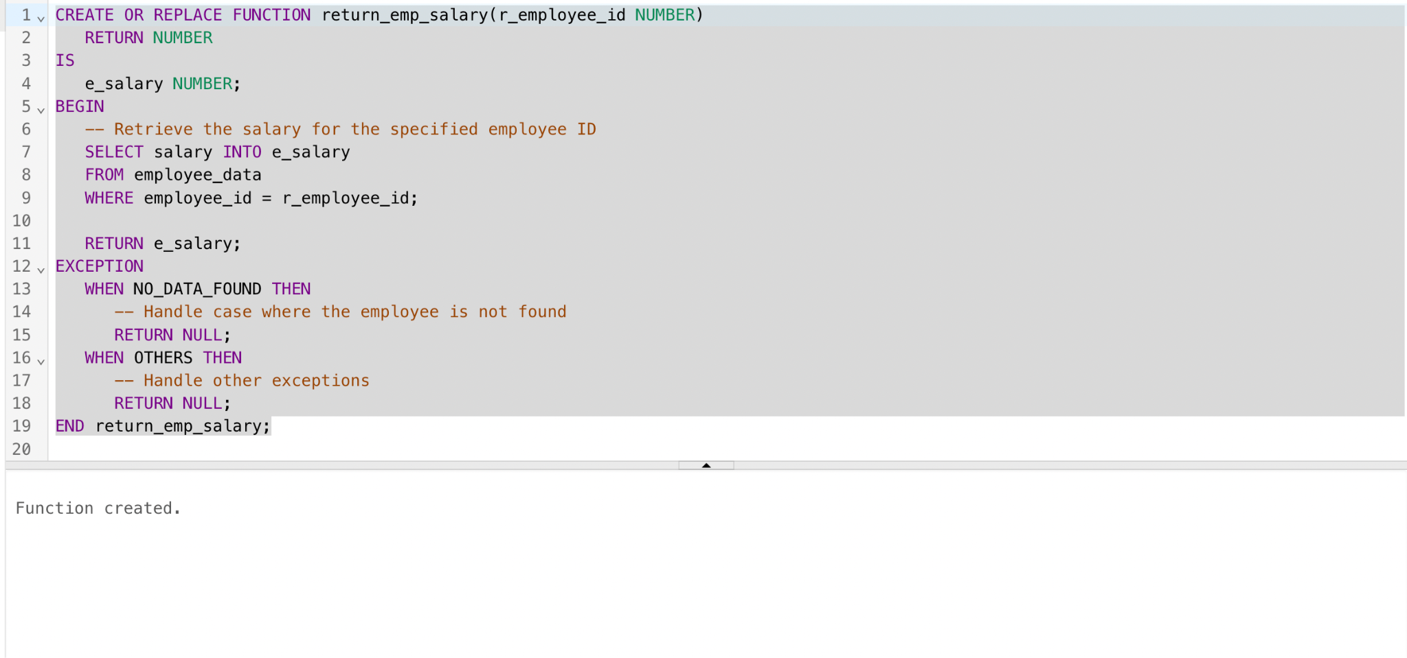

* I am calling the above function by providing the employee_id ,of which we need the salary details.

