* Procedure is created which holds the logic to fetch employee details according to the given department id. As we have created procedure, we can fetch details for any department.

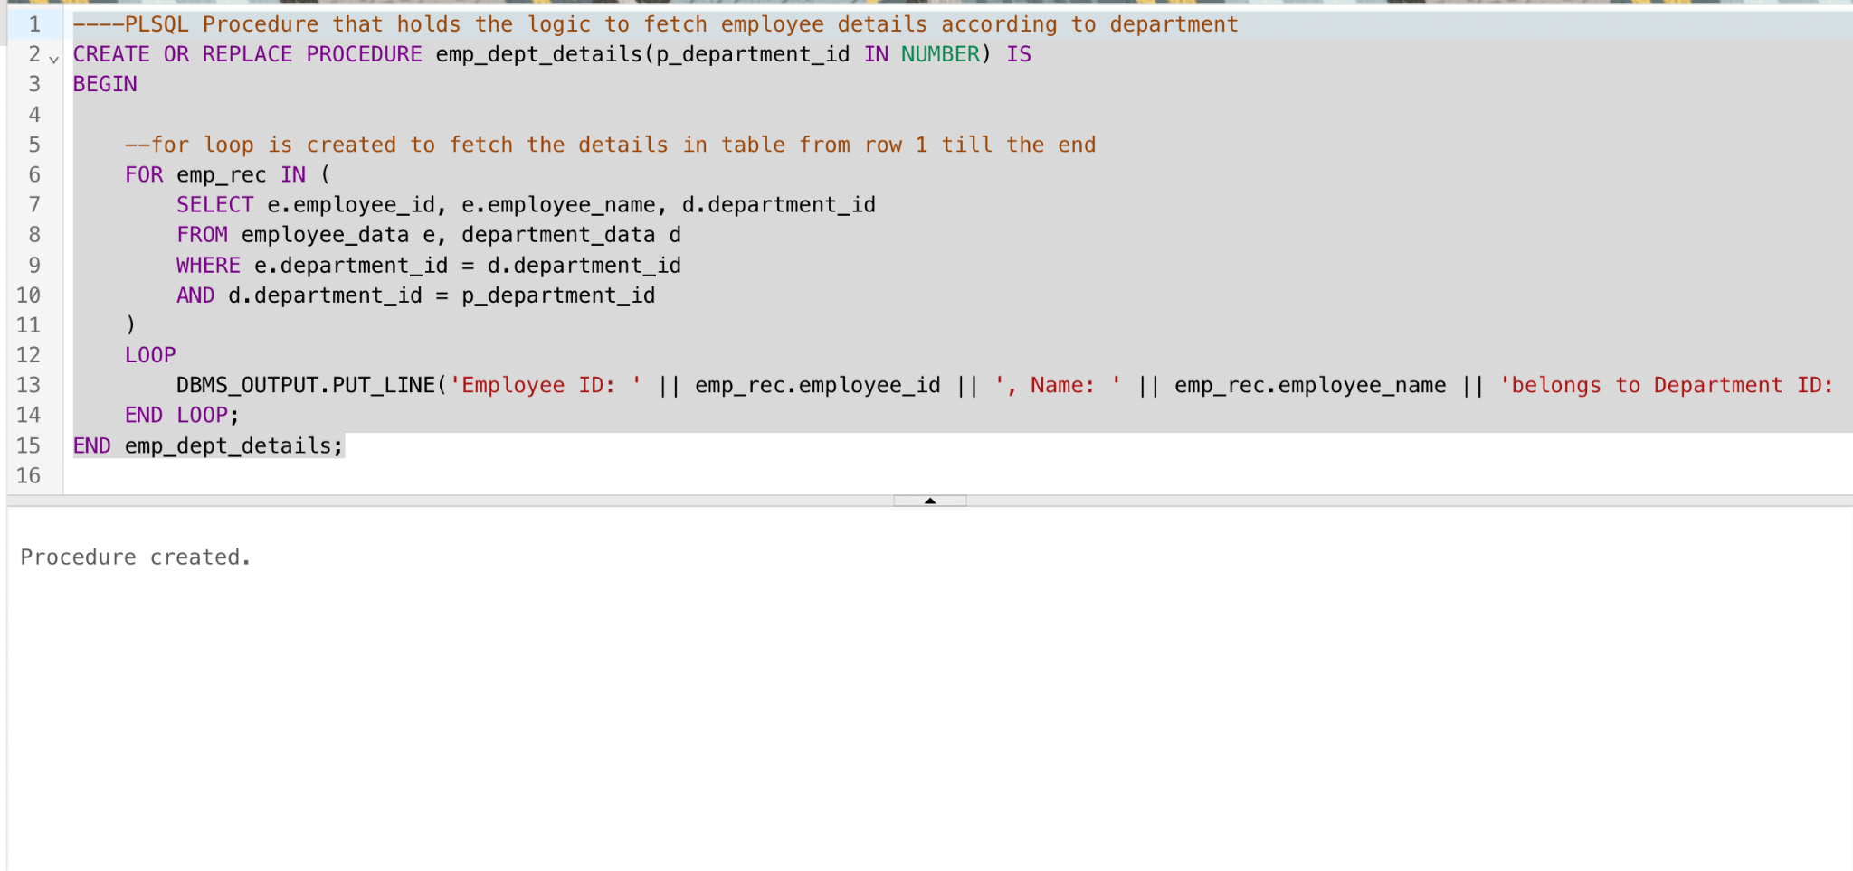

* By passing the department_id as an argument , we can call the above procedure. In this block we are fetching details for department_id = 1.

