**LAPTOP REQUEST CATALOG ITEM**

**Team Size : 4**

**Team ID : NM2025TMID18446**

**Team Leader : BHAVANI M**

**Team Member : JEEVITHA P**

**Team Member : DIVYA A**

**Team Member : SINDHUJA S**

Problem Statement : Laptop Request Catalog Item

**TASK** **INITIATION**

**Milestone** **1** : **Create Setting up ServiceNow Instance**

Activity 1 : Setting Up ServiceNow Instance

1. Open ServiceNow Developer Site <https://developer.servicenow.com> and Sign in.
2. After sign in, The welcome interface opens and click on Request instance and click on start building.

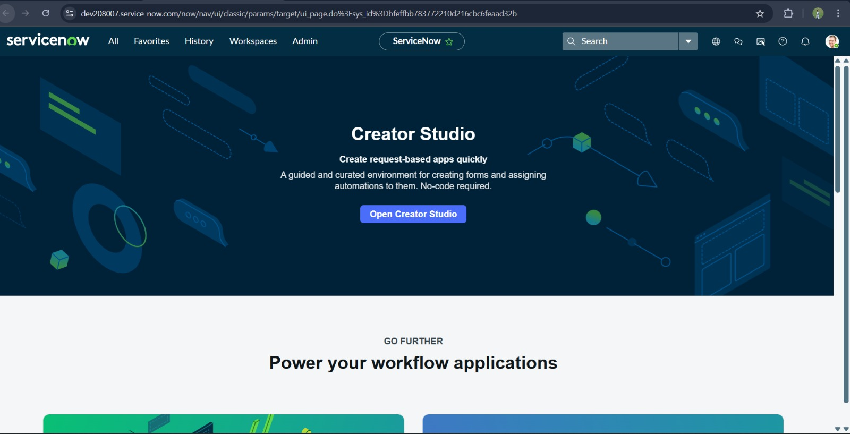

**Milestone** **2** : **Create Local Update Set**

1. In the opened instance Click on All>>search for update sets and under system update sets.

2. click on new

3. fill the following details to create a update set as: “Laptop Request”.

4. click on submit and make current.

5. By clicking on the button it activates the update set .

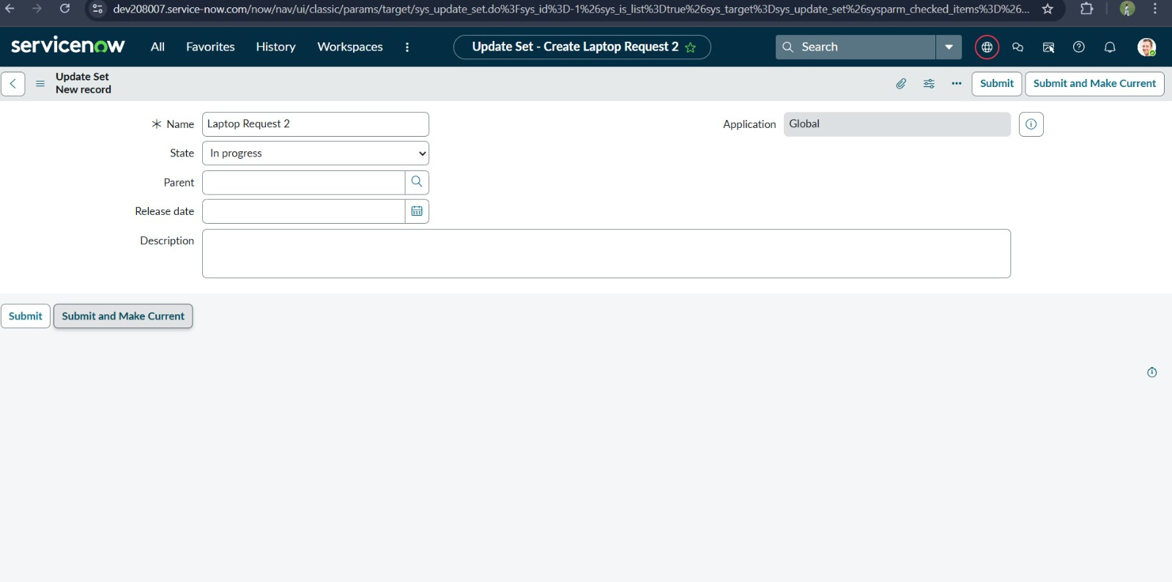

**Milestone 3**: **Create Service Catalog Item**

1. Open service now.

2. Click on All >> service catalog

3. Select maintain items under catalog definitions.

4. Click on new.

5. Fill the following details to create a new catalog item that are provided.

6. Click on ‘SAVE

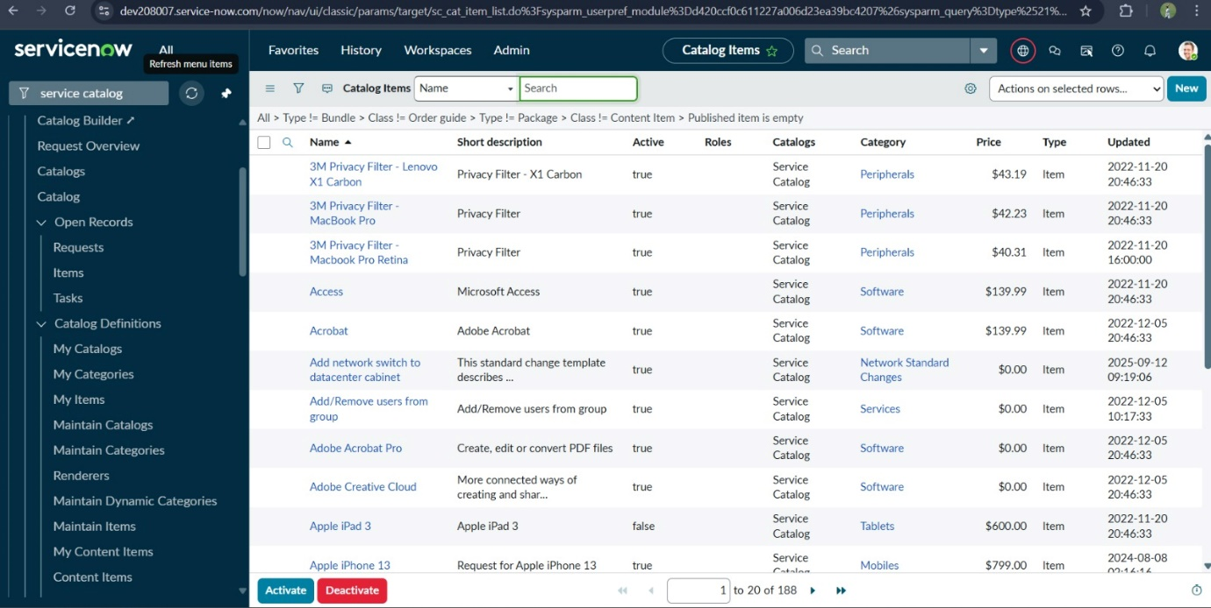

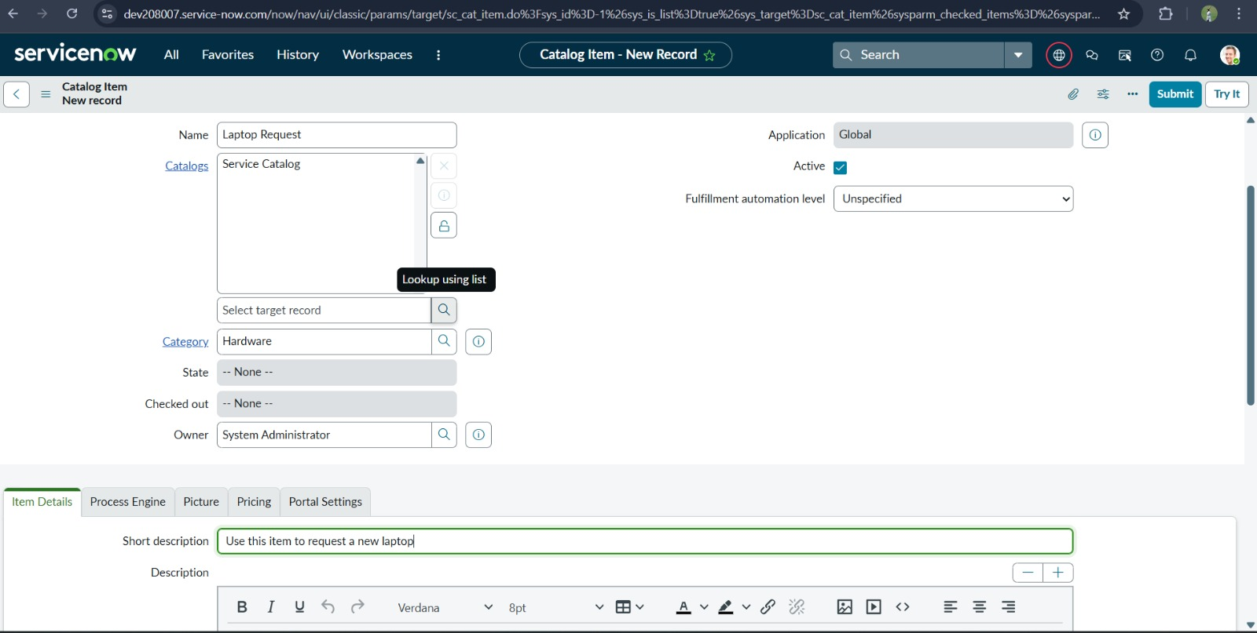

**Milestone 4: Add Variables**

1. After saving the catalog item form scroll down and click on variable(related list)

2. Click on new and enter the details

3. Click on submit

4. Again click on new and add Remaining variables.

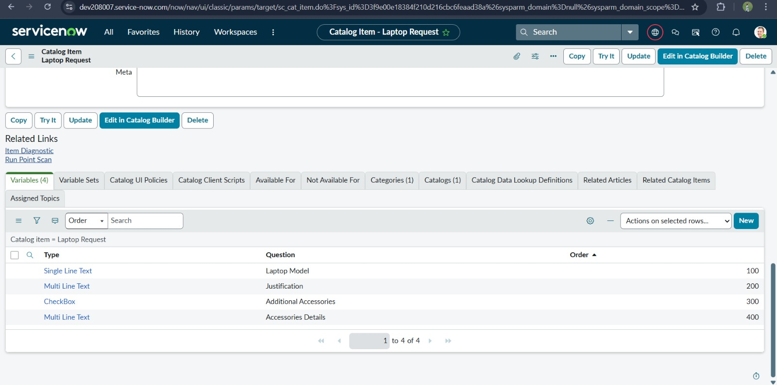

**Milestone 5: Create Catalog Ui policies**

1.Navigate to All>>Search Service Catalog under catalog definition.

2. Search for ‘laptop request’ which is created before and scroll down to select Catalog UI Policies and click on new.

3.set the condition and enter the short description and save then click on UI Action and new then fill the varaiables.

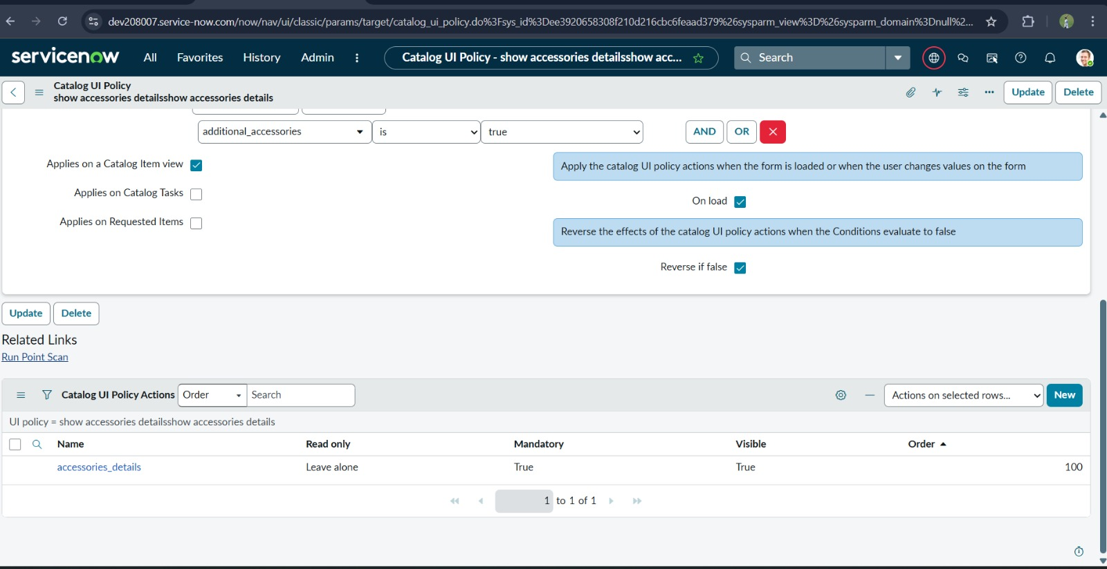

**Milestone** **6** **:** **Create** **UI** **Action**.

1. Open service now.

2. Click on All  >> search for ui action and under system definition

3. Click on new

4. Fill the following details to create ui action

5. Save the link that appear.

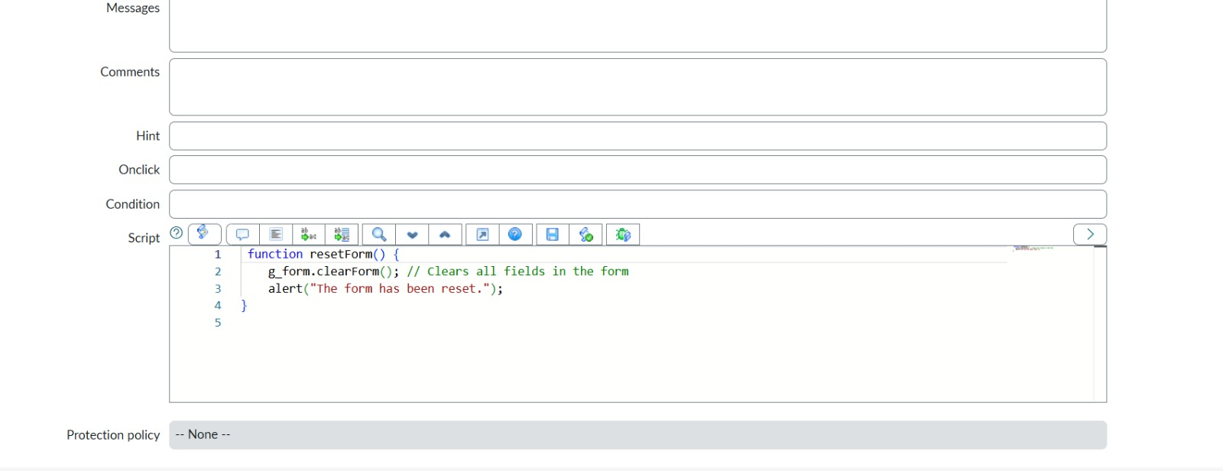

**Milestone 7: Exporting changes to another instances**

1. Go to All >> Search and open Update Sets.

2. Select the Local Update Set.

3. Change the Update set State >> Complete.

4. Open the update set’s Related >> Update tab to review included changes.

5. Click Explore >> XML to download the update-set file.

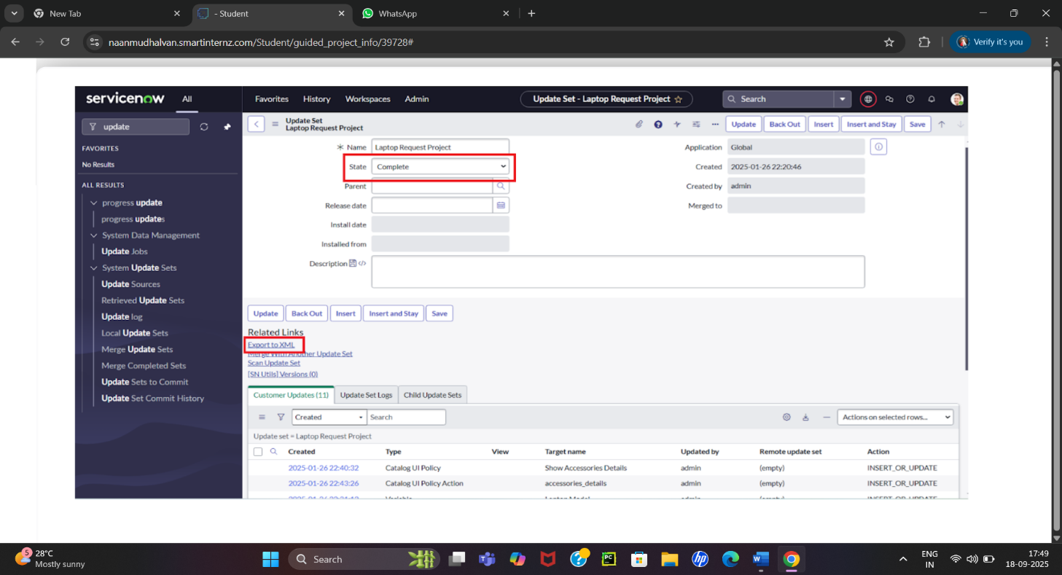

**Milestone 8: Retrieving the update set**

* 1. Open instance in incognito >> Login.

2. Go to System Update Sets >> Retrieved Update Sets.

3.Click Import Update Set from XML**.**

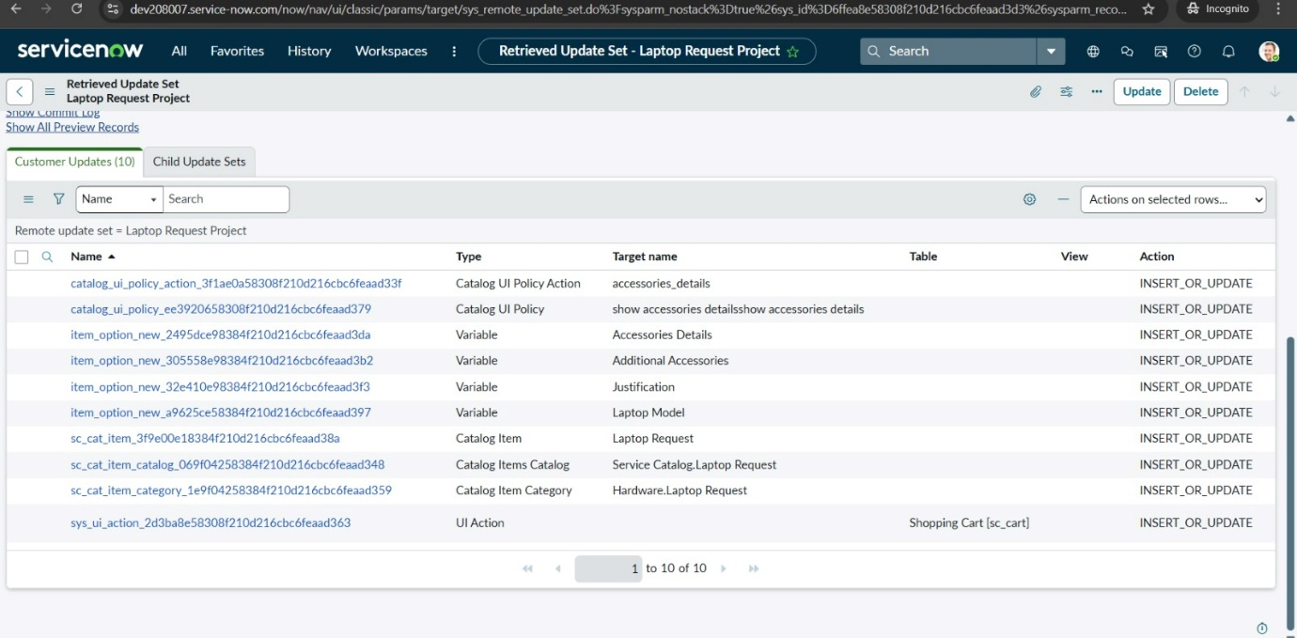

4. Open Retrieved Update Set and Click on Preview Update Set.

5. Click on Commit Update Set.

6.Check Related Tab Updates.

7. Update are applied in the new instance.

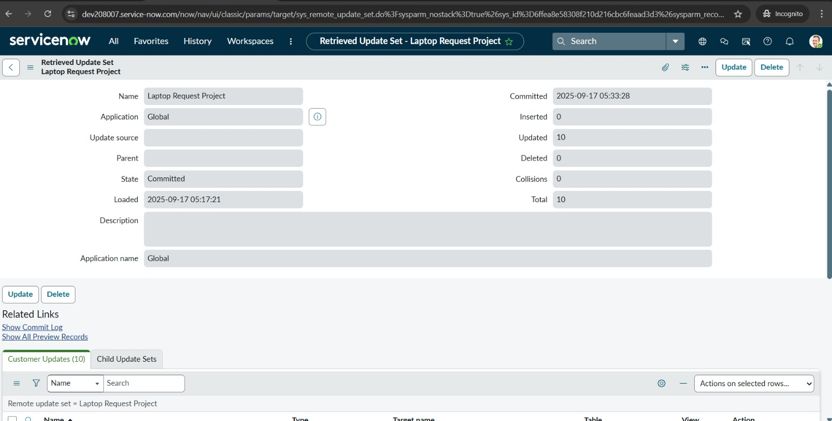

**Milestone 9 : Test Catalog Item**

1.Search Service Catalog in the application navigator.

2.Open Service Catalog >> Catalog.

3.Go to hardware category and find “Laptop Request”.

4.Open the Laptop Request item.

5. Confirm it displays three variables only.

6. As per our scenario, when we click on additional accessories checkbox then accessories details fields is visible and that should be mandatory

7. Now  see the results,it fulfills our requirements.

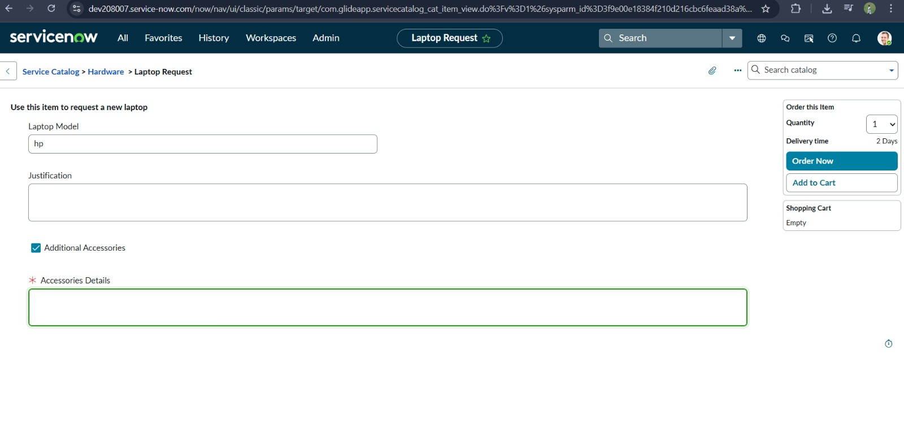

**Conclusion :**

The Laptop Request Catalog Item project successfully streamlines the process of requesting laptops within the organization by leveraging ServiceNow's Service Catalog capabilities. Through the implementation of a dynamic catalog item, the project ensures that users have an intuitive and user-friendly interface, reducing errors and improving efficiency.This project demonstrates how ServiceNow can be used to replace manual, error-prone processes with automated, efficient, and user-centric solutions. It not only improves service delivery but also enhances employee satisfaction by providing a modern and streamlined request experience.