Module-2 : exercise solutions

Inventory test:

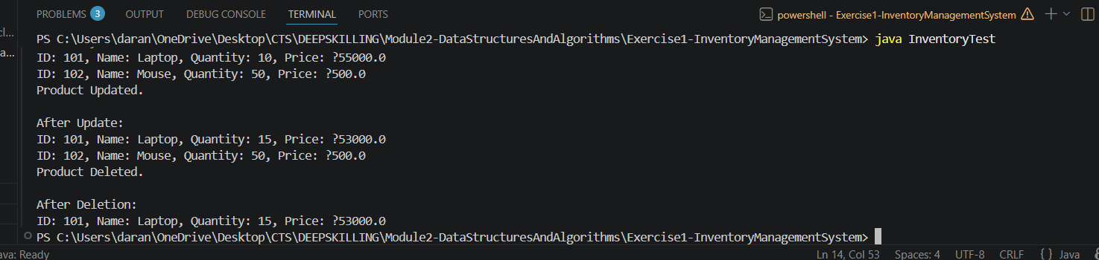

E- commerce search test:
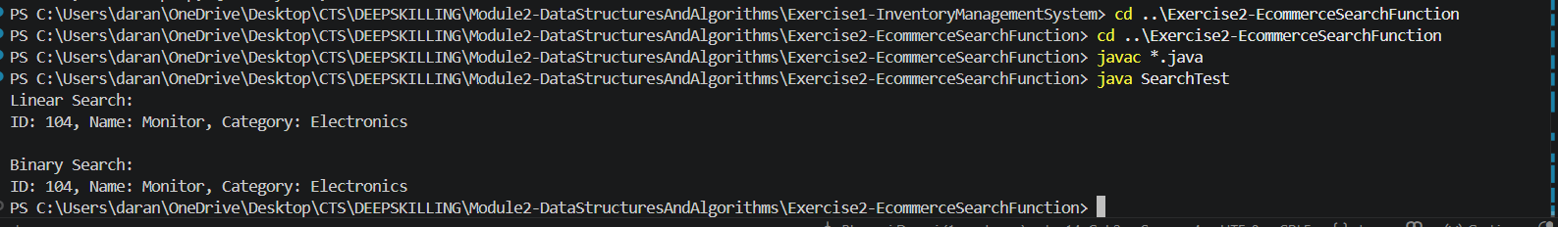

Sorting Customer Orders:
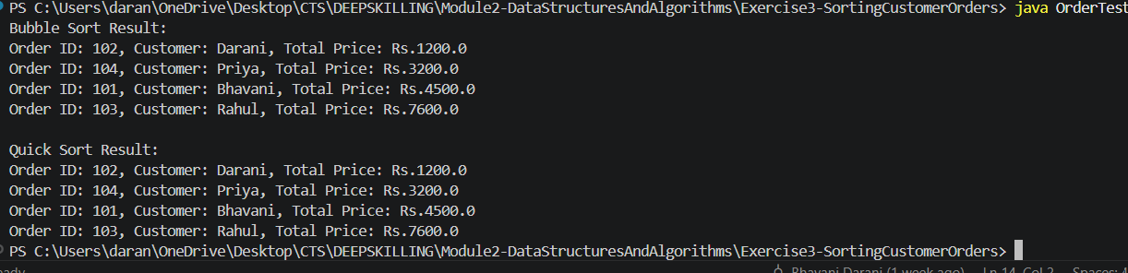
Employee Management System:
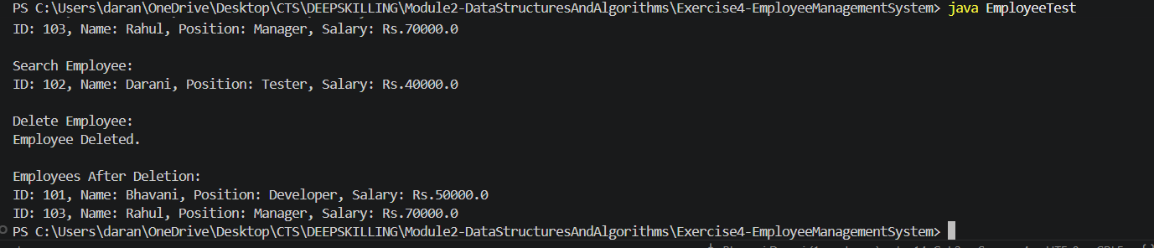

Task Management:
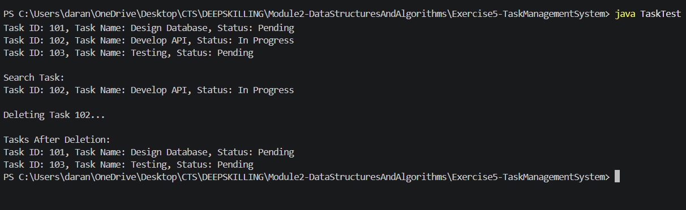

Library Management System:
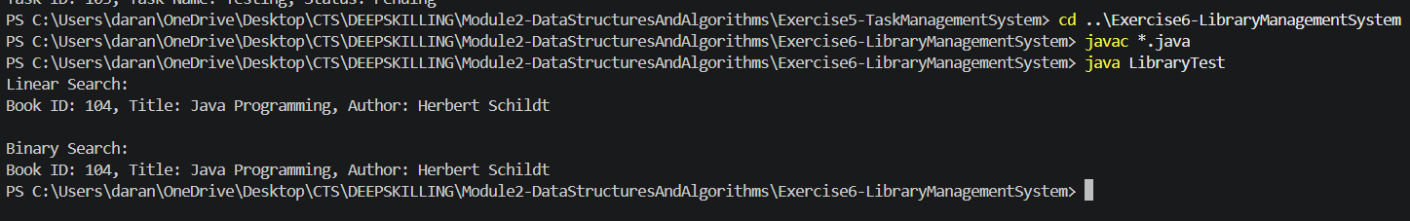

Financial Forecasting:

