SOLUTION SCREEN SHORT OF MODULE 1 EXERCISES
Adapter pattern:
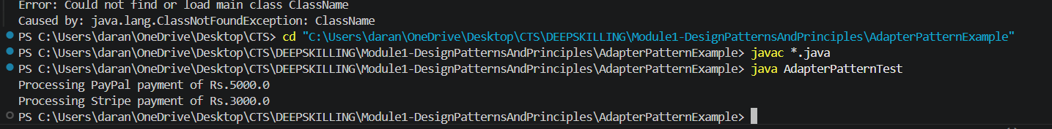

Builder test pattern:
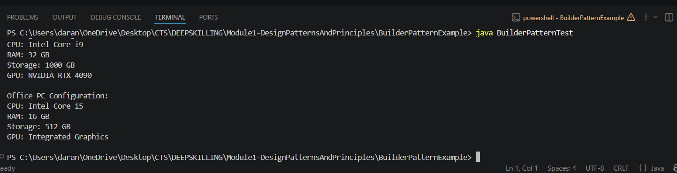

Factory method test:

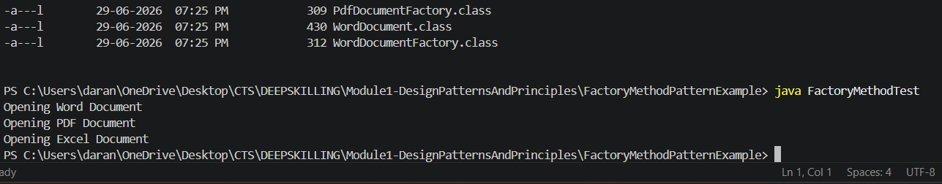
Command Pattern Test:

Dependency Injection Test:

MVC Pattern Test:

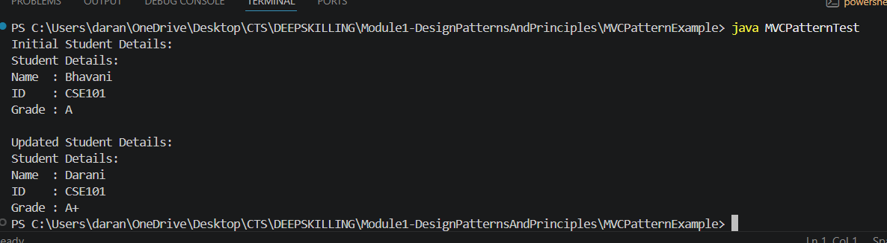

Observe pattern test:
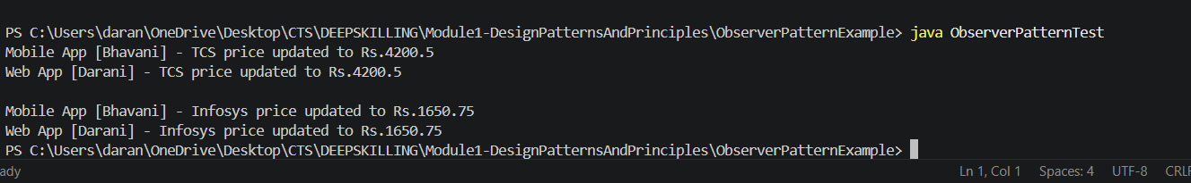

Singleton Test:
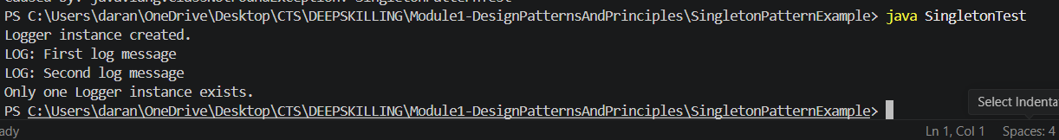
Strategy Test:

Email test:
