AICTE | IBM SkillsBuild
DATA ANALYTICS WITH AI INTERNSHIP 2026
AI-Assisted E-Commerce Data Analytics
& Customer Churn Prediction
Project Report
Submitted by
Akshith Reddy Kathulapalli
B.Tech — Computer Science Engineering
Mohan Babu University
September 2026

1. Abstract
This project applies the AICTE | IBM SkillsBuild Data Analytics with AI internship workflow to an e-commerce transaction dataset. The work progresses from data quality validation and cleaning, through exploratory data analysis and business insights, to a leakage-safe customer churn prediction model. The final workflow uses customer-level Recency, Frequency, Monetary and Average Order Value features with Logistic Regression to estimate future churn risk.

2. Problem Statement
E-commerce businesses generate large volumes of transaction data, but raw data may contain missing values, duplicate records, inconsistent labels, invalid dates and inconsistent currency formats. The objective is to transform this data into reliable analytical information, identify business patterns, and develop a simple predictive workflow that can help prioritize customers who may be at risk of future churn.

3. Objectives
- Clean and validate the supplied e-commerce transaction dataset.
- Define measurable business questions before analysis.
- Perform exploratory data analysis using five visualizations.
- Convert observations into data-supported insights, hypotheses and recommendations.
- Create customer-level RFM-style features.
- Build a leakage-safe future churn target.
- Train and evaluate a Logistic Regression model.
- Generate customer churn probabilities and risk levels.
- Translate model outputs into practical business actions.

4. Dataset and Data Preparation
The supplied practice workbook contained 2,000 raw transaction rows. The raw data included 23 duplicate rows. After removing duplicates, normalizing categories and regions, parsing dates and revenue values, and removing records that lacked essential analytical fields or contained non-positive quantities, the final analytical dataset contains 1,810 transactions and 408 unique customers.
Field | Meaning | Type
Order_ID | Unique transaction identifier | Identifier
Order_Date | Transaction date | Date
Customer_ID | Customer identifier | Identifier
Product | Product purchased | Categorical
Category | Product category | Categorical
Region | Customer/order region | Categorical
Quantity | Units purchased | Numerical
Revenue | Transaction revenue | Numerical
Profit | Transaction profit | Numerical

5. Data Quality Checks
Duplicate records: 23 duplicate rows detected and removed
Invalid dates: 24 invalid/unparseable date values identified
Negative quantities: 41 non-positive quantity records identified
Revenue formatting: Currency symbols, INR text and comma formatting normalized before numeric conversion
Category labels: Capitalization normalized, e.g. electronics / ELECTRONICS → Electronics
Region labels: Capitalization normalized and missing region values represented as Unknown

6. Exploratory Data Analysis
Five visualizations were produced in the notebook. The cleaned data contains 408 unique customers, of whom 317 are repeat customers (77.70%) and 91 are single-order customers.
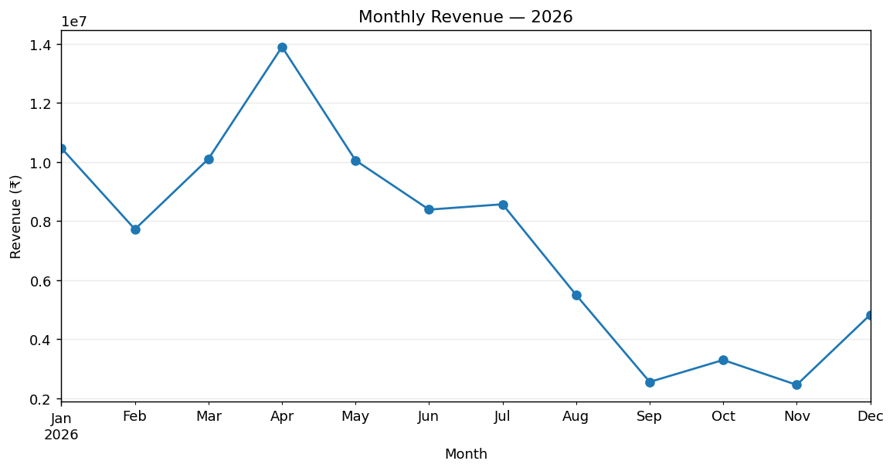
Figure 1. Monthly revenue
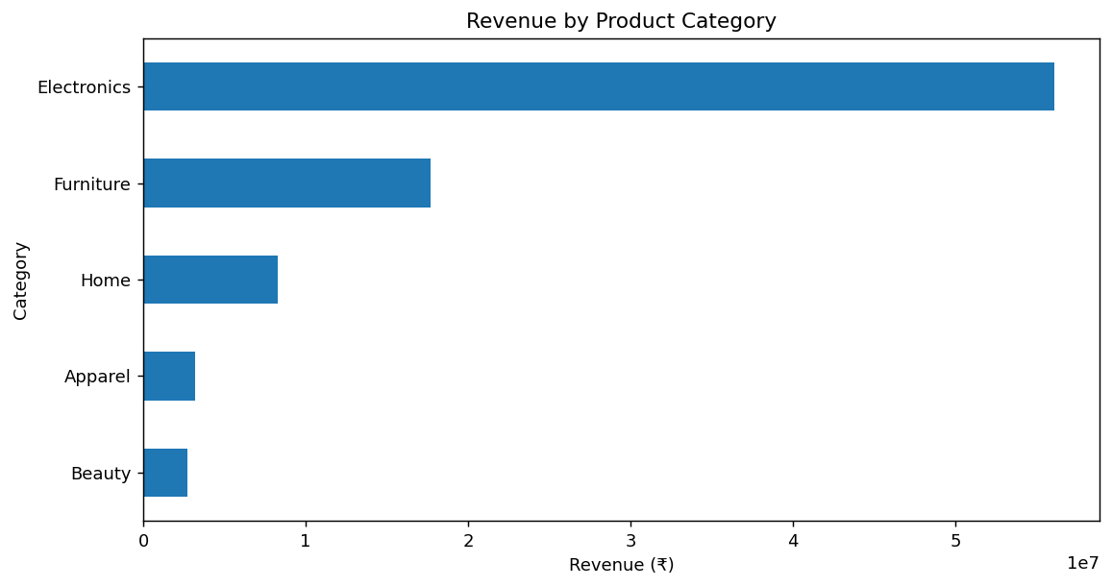
Figure 2. Revenue by product category
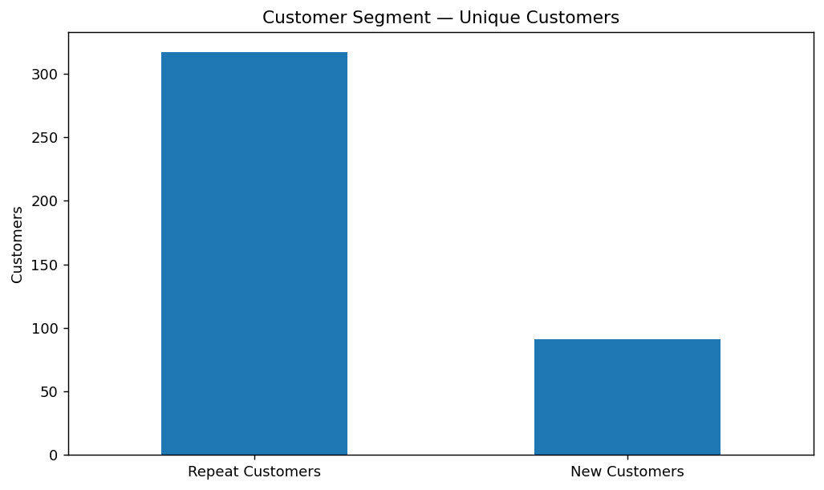
Figure 3. Customer segments
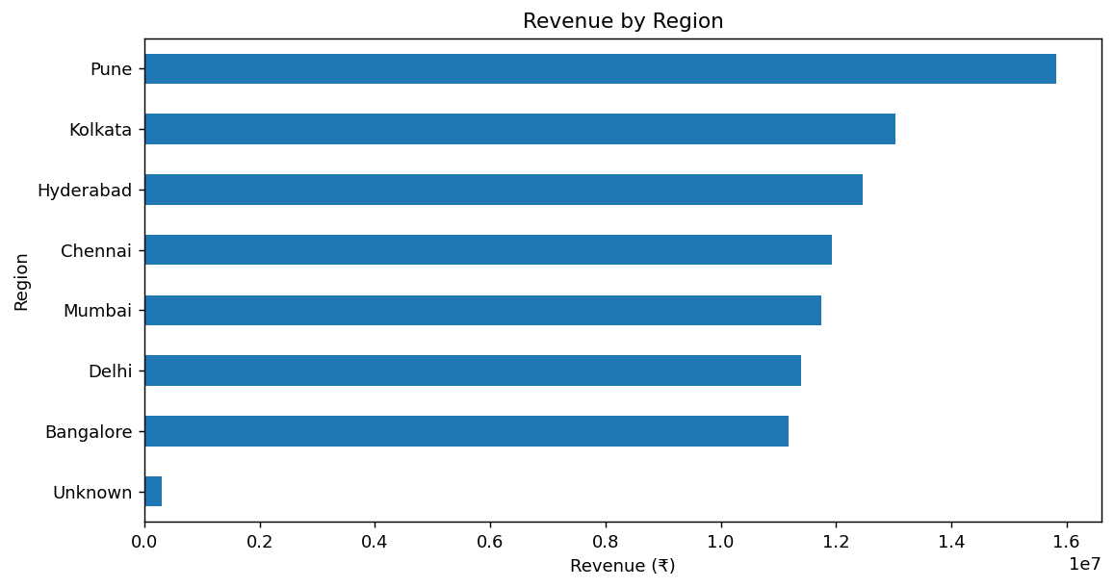
Figure 4. Revenue by region
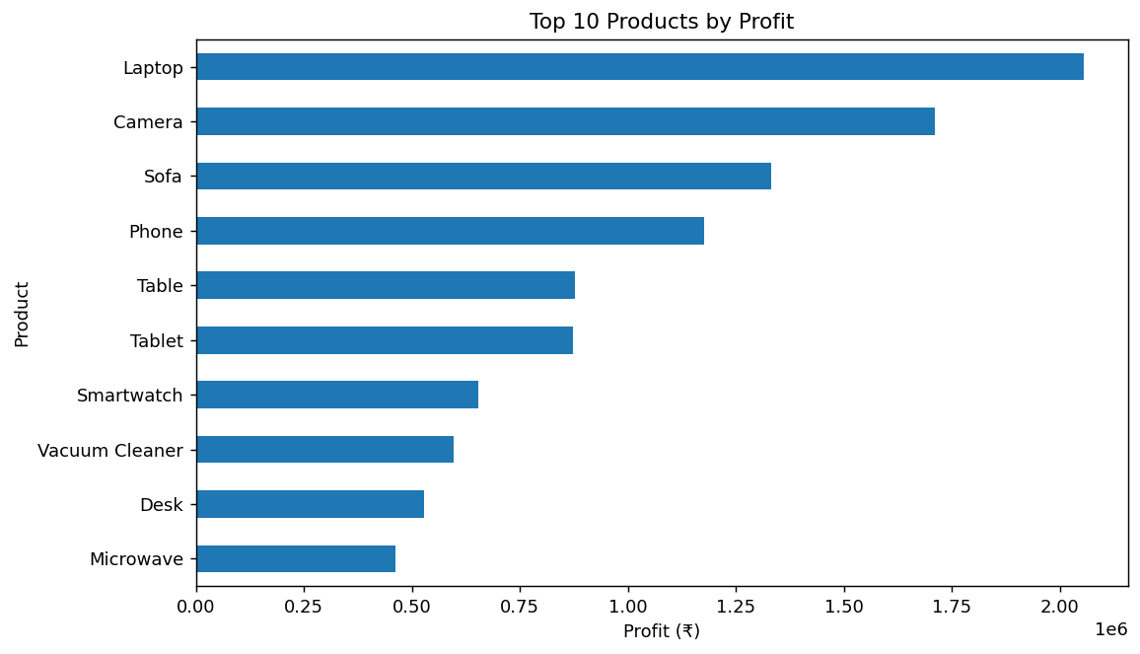
Figure 5. Top products by profit

7. Key Observations and Insights
- Monthly revenue is highest in 2026-04 at ₹13,897,274 and lowest in 2026-11 at ₹2,458,048.
- Electronics is the largest revenue category at ₹56,058,665.
- Repeat customers represent 77.70% of unique customers in the cleaned transaction data.
- Pune has the highest regional revenue among named regions at ₹15,818,354.
- Laptop is the highest-profit named product at ₹2,055,173.

8. Hypotheses and Recommendations
The following are hypotheses rather than proven causes:
- Marketing campaigns or seasonal demand may contribute to monthly revenue variation.
- Inventory availability may be associated with weaker revenue periods.
- Product launches, pricing or promotional changes may contribute to product/category performance.
Recommended actions:
- Plan inventory and operating resources around observed demand variation.
- Develop retention and repeat-purchase campaigns for the existing customer base.
- Monitor Electronics inventory and margins because of its large revenue contribution.
- Use product-level profitability to support merchandising and inventory reviews.

9. Customer-Level RFM Analysis
To avoid target leakage, historical customer features were calculated using transactions up to 31 Aug 2026. Recency is the number of days since the customer's last historical purchase, Frequency is the number of historical orders, and Monetary is historical total revenue. Average Order Value was retained as an additional feature.

10. Churn Target and Leakage Prevention
The Masterclass 3 workbook contains inconsistent churn instructions: one step describes 90 days, while later steps refer to 180 days. It also explicitly warns that using Recency to predict a target directly created from Recency would create target leakage. The supplied dataset ends on 8 Dec 2026, so this project cannot construct a full 180-day future observation period. Therefore, this implementation uses a transparent 90-day forward target from the 31 Aug 2026 historical cutoff: a customer is labeled churned when no purchase occurs during the following 90 days. Future transactions are used only to create the target, never as prediction features.

11. Predictive Model
A Logistic Regression model was selected as a simple, interpretable baseline. The input features were Recency, Frequency, Monetary and Average Order Value. Customer_ID and the target were excluded from the feature matrix. The dataset was split using a stratified 75/25 train-test split with random_state=42.
Metric | Project Result
Accuracy | 77.78%
Precision | 81.33%
Recall | 88.41%
ROC-AUC | 70.24%
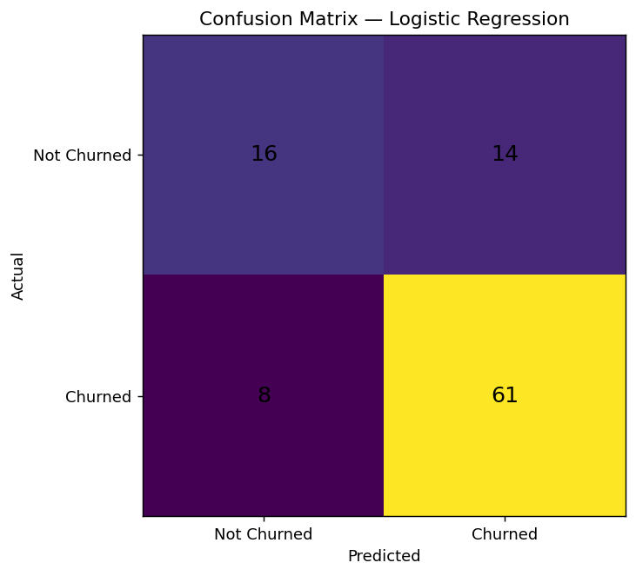
Figure 6. Confusion matrix for the test set

12. Customer Risk Scoring
The final model was fitted on the complete historical customer feature set to generate a prioritization table. Risk levels follow the Masterclass 3 workbook: below 40% = Low Risk, 40% to below 70% = Medium Risk, and 70% or higher = High Risk.
Risk Level | Customers
High Risk | 13
Medium Risk | 311
Low Risk | 70
Sample of the highest predicted-risk customers:
Customer | Recency | Frequency | Monetary | Churn Prob. | Risk
C339 | 122 | 1 | ₹373,970 | 82.8% | High Risk
C019 | 36 | 1 | ₹339,312 | 80.76% | High Risk
C022 | 150 | 1 | ₹297,340 | 79.78% | High Risk
C348 | 30 | 1 | ₹283,560 | 78.2% | High Risk
C240 | 35 | 1 | ₹272,964 | 77.74% | High Risk
C463 | 137 | 1 | ₹220,884 | 76.04% | High Risk
C109 | 109 | 1 | ₹211,650 | 75.33% | High Risk
C311 | 191 | 1 | ₹166,170 | 73.68% | High Risk
C084 | 134 | 1 | ₹131,802 | 71.25% | High Risk
C380 | 156 | 1 | ₹127,374 | 71.21% | High Risk

13. Business Actions
- Prioritize high-risk customers for retention outreach.
- Test personalized offers, replenishment reminders or relevant product recommendations.
- Combine model risk with transaction context before contacting customers.
- Track campaign responses and future purchases to evaluate retention effectiveness.
- Retrain and re-evaluate the model as additional future transaction data becomes available.

14. Limitations
- The source Masterclass 3 workbook contains conflicting 90-day and 180-day classroom churn definitions.
- The supplied transaction data ends on 8 Dec 2026, limiting the available future observation period.
- Logistic Regression is a baseline model; additional models and validation may improve predictive performance.
- Predicted churn risk indicates association and prioritization; it does not prove why a customer will churn.
- Production use would require ongoing monitoring, additional data and business validation.

15. Conclusion
The project demonstrates an end-to-end data analytics and AI workflow: raw transaction data is cleaned and validated, business questions are answered through EDA, findings are translated into insights and recommendations, and historical customer behavior is used to estimate future churn risk. The final output provides both analytical findings and a customer-level risk table that can support further retention analysis.

16. Technologies Used
- Python
- Pandas
- NumPy
- Matplotlib
- Scikit-learn
- Jupyter Notebook / Google Colab
- Logistic Regression

17. Project Files
- Akshith_ECommerce_Churn_Analysis.ipynb — complete executable analysis notebook
- requirements.txt — Python dependencies
- README.md — project overview and setup instructions
- data/cleaned_ecommerce.csv — cleaned analytical dataset
- data/data_dictionary.csv — dataset field reference
- data/customer_churn_features.csv — historical customer-level modeling dataset
- data/customer_risk_scores.csv — final customer risk output

