Name – M.Bhavani
Roll – 2403A54084
Batch – 03(Data science)
Task Assignment - 01
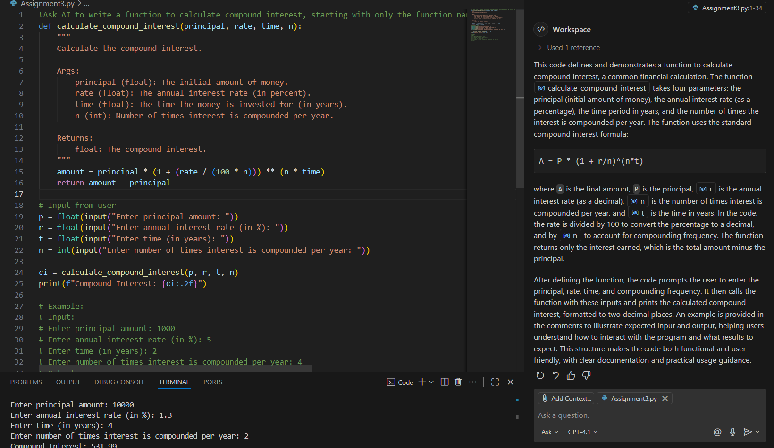
Task Assignment – 02:
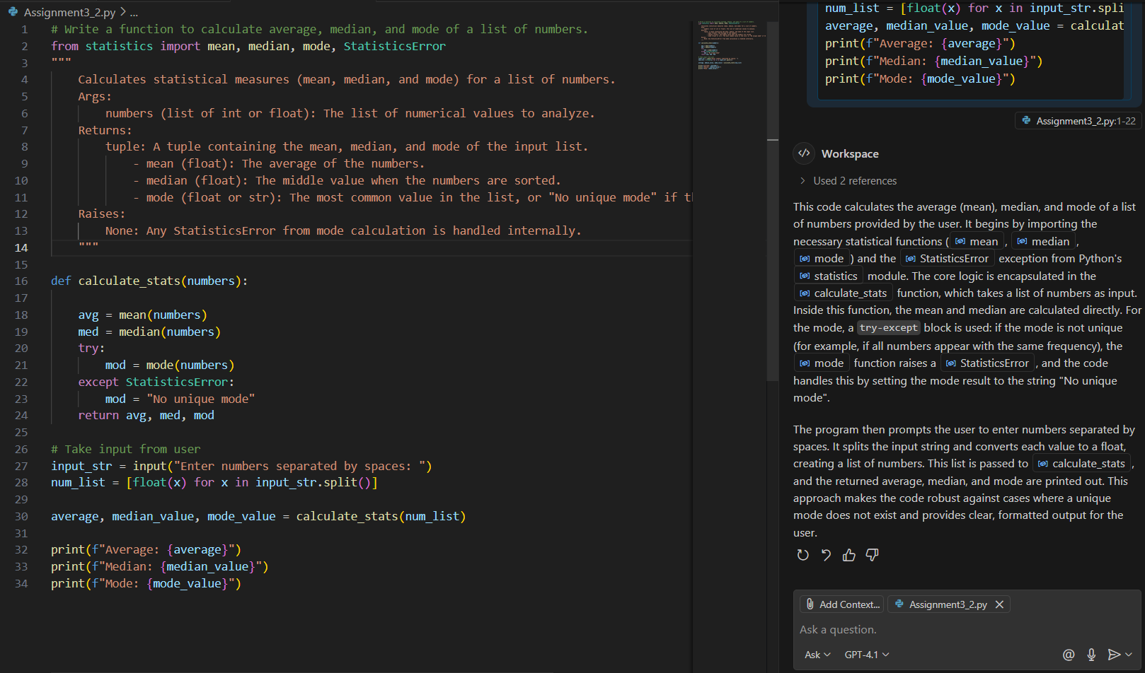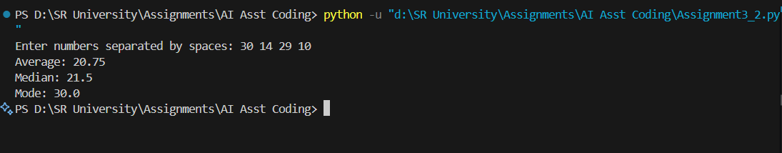

Task Assignment – 03:
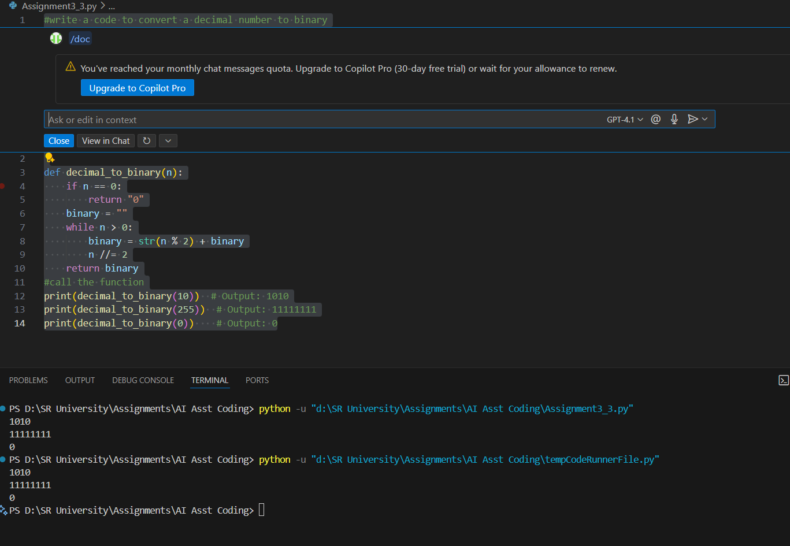

Tast Assignment – 04:
