-- task 1--

create database stylecarz_db;

use stylecarz_db;

--task 2—

-- table1--

create table salespersons

(salespersonid varchar(10) primary key not null,

salesperson_name varchar(100) not null,

salesperson_city varchar(20) not null,

commission_rate varchar(50) not null);

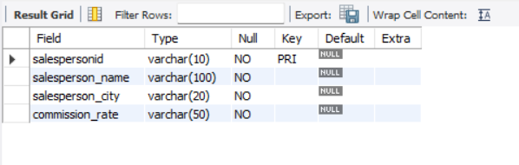

* --Table2--

create table custmoers

(customerid varchar(20) primary key not null,

customer_name varchar(10) not null,

customer_lastname varchar(29) not null,

customer_city varchar(10) not null,

customer_rating int not null);

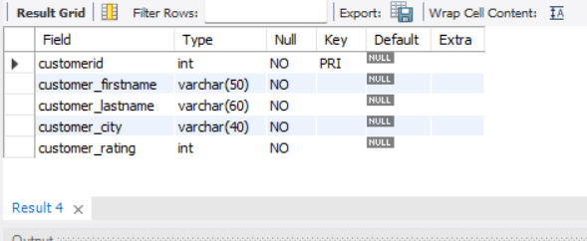

create table orders

(orderid int primary key,

amount int not null,

ordersdate date not null,

salespersonid int not null,

customerid int,

foreign key(salespersonid) references salespersons(salespersonid),

foreign key(customerid) references customers(customerid)

);

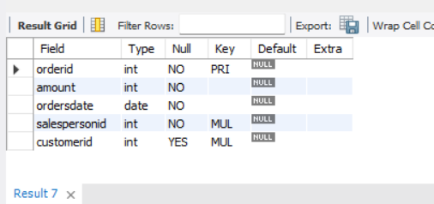

-- TASK 3

Insert into stylexcarz_db.salespersons values

(10001,"willian", "london", 12),

(1002, "liam", "san jose", 15),

(1003, "axelrod", "new york", 10),

(1004, "james", "london", 11),

(1005, "fran", "london", 26),

(1006, "oliver", "barcelona", 15),

(1007, "john", "london", 0),

(1008, "charles", "florida", 0);

select * from salespersons;

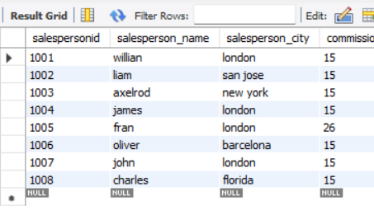

-- ADDING CUSTOMER VALUES

Insert into customers values

(2001, "hoffman", "anny", "london", 100),

(2002, "giovanni", "jenny", "rome", 200),

(2003, "liu", "williams", "san jose", 100),

(2004, "grass", "harrry", "berlin", 300),

(2005, "clemens", "john" , "london", 200),

(2006, "cisneros", "fanny", "san jose", 200),

(2007, "pereira", "jonathan", "rome", 300);

select * from customers;

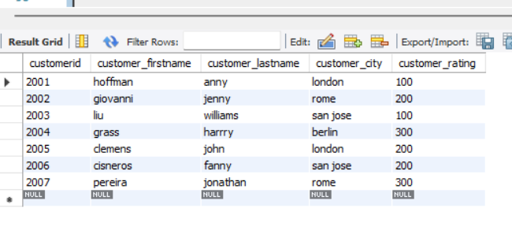

-- ADDING ORDERS VALUES

Insert into orders values

(3001,123,"2021-02-01",1001,2007);

Insert into orders values

(3002,100,"2021-07-30",1001,2007);

Insert into orders values

(3003,187,"2021-10-02",1001,2001);

Insert into orders values

(3005,201,"2021_10_09",1003,2003);

insert into orders values

(3007,167,"2021_04_02",1004,2002);

insert into orders values

(3008,189,"2021_03_06",1002,2002);

Insert into orders values

(3009,145,"2021_10_10",1009,2005);

Insert into orders values

(3010,200,"2021_02_23",1007,2007);

Insert into orders values

(3011,100,"2021_09_18",1001,2004);

select * from orders;

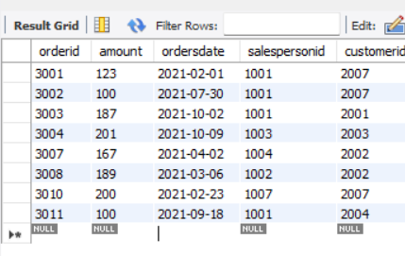

-- task4--

-- updating customer rating--

SET SQL_SAFE_UPDATES=0;

update salespersons set commission_rate= 15 where commission_rate between 0 and 13;

-- task5--

-- cloning orders table--

create table if not exists orders_bkp select * from orders;

select * from orders_bkp;

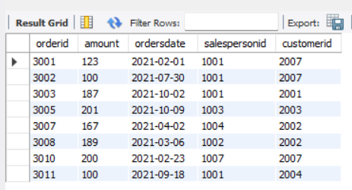

-- task6--

create table if not exists orders_plced_history select * from orders;

select * from orders_plced_history;

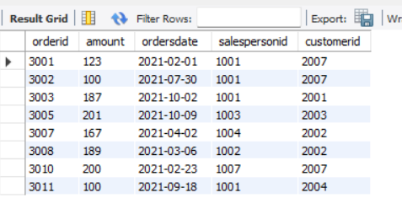

delete from orders_plced_history where orderid in (3003,3008);

delete from orders where orderid in (3005,3008);

select * from orders;

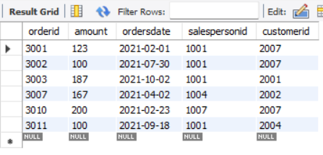

-- task7--

update customers set customer_rating=customer_rating+50 where customerid=2000;

update customers set customer_rating=customer_rating+50 where customerid=2007;

select * from customers;

