-- task 1--

create database techmac_db;

use techmac_db;

-- task2--

-- table1--

create table techhyve_employees

(

employees_ID varchar(30),

first_name varchar(20),

last_name varchar(20),

gender varchar(2),

age int

);

|  |  |  |  |  |
| --- | --- | --- | --- | --- |
| last_name | varchar(20) | YES |  |  |
| gender | varchar(2) | YES |  |  |
| first_name | varchar(20) | YES |  |  |
| employees_ID | varchar(30) | YES |  |  |
| age | int | YES |  |  |

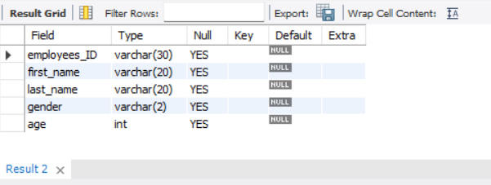

create table techcloud_employees

(

|  |  |  |  |  |
| --- | --- | --- | --- | --- |
|  |  |  |  |  |
|  |  |  |  |  |
|  |  |  |  |  |
|  |  |  |  |  |
|  |  |  |  |  |

|  |  |  |  |  |  |  |  |  |  |  |  |  |
| --- | --- | --- | --- | --- | --- | --- | --- | --- | --- | --- | --- | --- |
|  |  |  |  |  |  |  |  |  |  |  |  |  |
|  |  |  |  |  |  |  |  |  |  |  |  |  |
|  |  |  |  |  |  |  |  |  |  |  |  |  |
|  |  |  |  |  |  |  |  |  |  |  |  |  |
|  |  |  |  |  |  |  |

employees_ID varchar(30),

first_name varchar(20),

last_name varchar(20),

gender var

age int

);

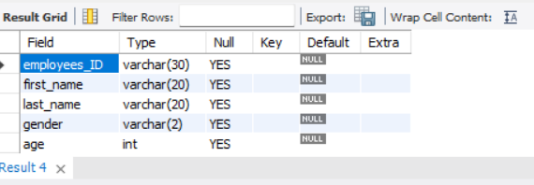

|  |  |  |  |  |  |
| --- | --- | --- | --- | --- | --- |
|  |  |  |  |  |  |
|  |  |  |  |  |  |
|  |  |  |  |  |  |
|  |  |  |  |  |  |
|  |  |  |  |  |  |
|  |  |  |  |  |  |
|  |  |  |  |  |  |

-- table3--

create table techsoft_employees

(

employees_ID varchar(30),

first_name varchar(20),

last_name varchar(20),

gender varchar(2),

age int

);

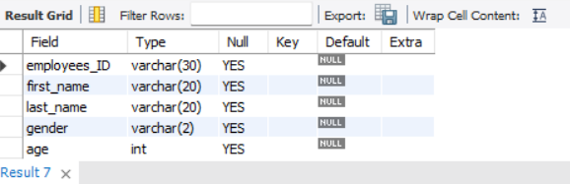

-- task3--

alter table techhyve_employees add proficiency_level int;

alter table techcloud_employees add proficiency_level int;

alter table techsoft_employees add proficiency_level int;

-- task4--

-- 4.1--

-- ID SHOULD BE UNIQUA ADD PRIMARY KEY--

alter table techhyve_employees add primary key(employees_ID);

alter table techcloud_employees add primary key(employees_ID);

alter table techsoft_employees add primary key(employees_ID);

-- 4.2--

-- PROFICIENCY_LEVEL SHOULD BETWEEN 1 QND 5 AND ADD CHECK--

alter table techhyve_employees add check(proficiency_level between 1 and 5);

alter table techhyve_employees alter prificiency_level set default 1;

alter table techcloud_employees add check(proficiency_level between 1 and 5);

alter table techcloud_employees alter prificiency_level set default 1;

alter table techsoft_employees add check(proficiency_level between 1 and 5);

alter table techsoft_employees alter prificiency_level set default 1;

-- 4.3--

-- EMPLOYEES AGE 21 AND 55--

alter table techhyve_employees add check(age between 21 and 55);

alter table techcloud_employees add check(age between 21 and 55);

alter table techsoft_employees add check(age between 21 and 55);

-- task 5--

-- INSERT DATA--

insert into techhyve_employes values('TH0001', 'ELI', 'EVANS', 'MALE', 26, 1);

insert into techhyve_employes values('TH0002', 'CARLOS', 'SIMMONS', 'MALE', 32, 2);

insert into techhyve_employes values('TH0003', 'KATHIE', 'BRYANT', 'FEMALE', 25, 1);

insert into techhyve_employes values('TH0004', 'JOEY', 'HUGHES', 'MALE', 41, 4);

insert into techhyve_employes values('TH0005', 'ALICE', 'MATTHEWS', 'FEMALE', 52, 4);

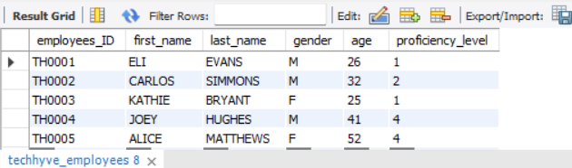

insert into techcloud_employees values('TC0001', 'TERESA', 'BRYANT', 'F', 39, 2);

insert into techcloud_employees values('TC0002', 'ALEXIS', 'PATTERSON', 'M', 48, 5);

insert into techcloud_employees values('TH0003', 'ROSE', 'BELL', 'F', 42, 3);

insert into techcloud_employees values('TH0004', 'GEMMA', 'WATKINS', 'F', 44, 3);

insert into techcloud_employees values('TH0005', 'KINGSTON', 'MARTINEZ', 'M', 29, 2);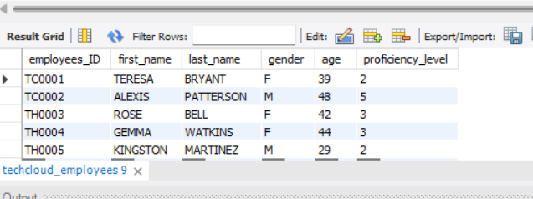

insert into techsoft_employees values('TS0001', 'PETER', 'BURTLER', 'M', 44, 4);

insert into techsoft_employees values('TS0002', 'HAROLD', 'SIMMONS', 'M', 54, 4);

insert into techsoft_employees values('TS00003', 'JULIANA', 'SANDERS', 'F', 36, 4);

insert into techsoft_employees values('TS0004', 'PAUL', 'WARD', 'M', 29, 2);

insert into techsoft_employees values('TS0005', 'NICOLE', 'BRYANT', 'F', 30, 2);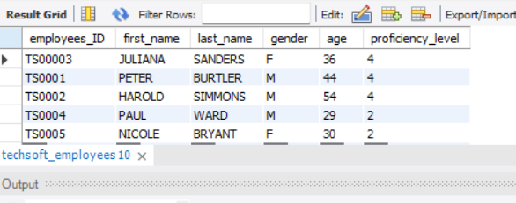

-- TASK 6--

create table if not exists techhyve_employees_bkp;

select * from techhyve_employees;

create table if not exists techcloud_employees_bkptechhyve_employees

select * from techcloud_employees;

create table if not exists techsoft_employees_bkp

select * from techsoft_employees;

-- task 7--

Delete from techhyve_employees where employees_ID= 'TH0003';

Delete from techhyve_employees where employees_ID= 'TH0005';

select * from techhyve_employees;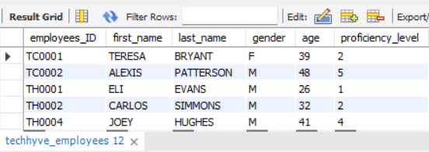

Delete from techcloud_employees where employees_ID= 'TH0001';

Delete from techcloud_employees where employees_ID= 'TH0004';

select * from techcloud_employees;

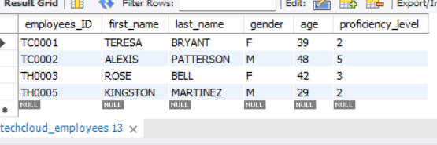

-- task 8--

create table if not exists techhyvecloud_employees like techhyve_employees;

insert techhyvecloud_employees select * from techhyve_employees;

insert techhyvecloud_employees select * from techcloud_employees;

desc techhyvecloud_employees;

select * from techcloud_employees;

