use hr;

-- task 1--

select employee_id, first_name, last_name,

(select department_name from departments

where employees.department_id=departments.department_id ) as 'dept_name'

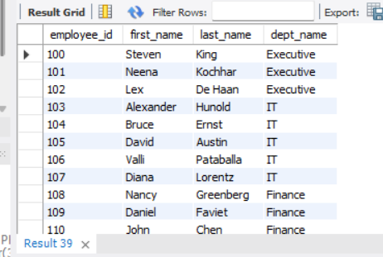from employees;

Conclusion:- According to their departments names.

-- task 2--

select first_name, last_name, salary from employees

where salary > (select avg(salary) from employees)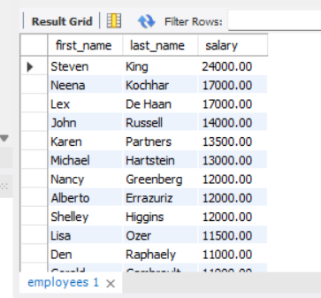 order by 3 desc;

Conclusion:-Employees salaries are greater than averge salary.

-- task 3--

select concat(first_name, ' ' ,last_name)"full_name", salary, department_name from employees,

(select department_name from departments) as dept_name

where salary < (select avg(salary) from employees) and department_name like "%sale%"

order by 2 desc;

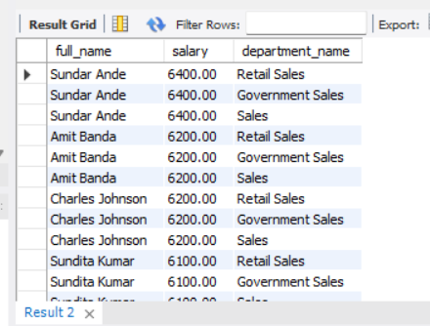

Conclusion:-Employees salary less than the average salary of their sales department.

-- task 4--

select first_name, last_name, salary from employees

where salary > (select max(salary) from employees where job_id ='IT_PROG')

order by 2 asc;

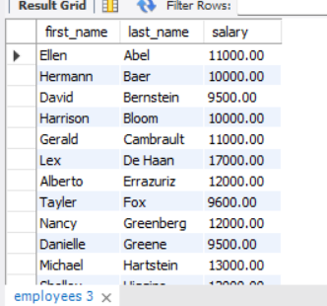

Conclusion:-Employees salary higher than the salary of all IT Programmers.

-- task 5--

select concat(first_name, ' ' ,last_name) "full_name", salary from employees

where (select min(salary) from employees)

order by 2 asc;

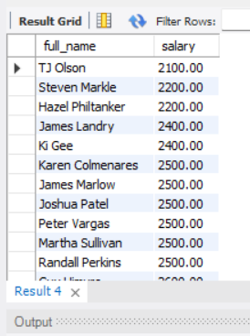

Conclusion:-The employee with the minimum salary.

-- task 6--

select concat(first_name,' ',last_name) as full_name,

a.department_id,

salary from employees a

inner join (select sum(salary)*0.6 as sum_salary,department_id from employees group by department_id) as b

where a.department_id = b.department_id and a.salary > b.sum_salary;

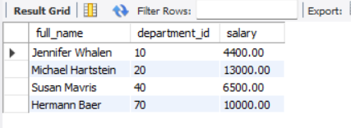

Conclusion:-All employees whose salary is greater than 60% of their departments total salary bill.

-- task 7--

select first_name, last_name, manager_id from employees

where department_id in

(select department_id from departments where location_id in

(select location_id from locations where country_id in

(select country_id from countries where country_name = 'united kingdom')));

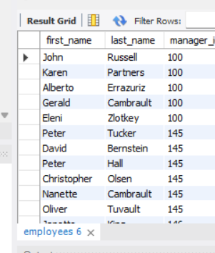

Conclusion:-The employee who have manager worked in UNITED KINGDOM department.

-- task 8--

(select first_name, last_name, salary from employees

order by 3 desc

limit 6)

into outfile

"C:\\ProgramData\\MySQL\\MySQL Server 8.0\\Uploads\\cnt_code2.csv"

fields terminated by '\t'

lines terminated by '\n';

show variables like 'secure_file_priv';

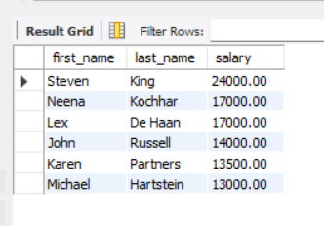

Conclusion:-Employees according to their highest paid.