use hr;

-- task 1--

select count(employee_id),

locations.city from employees inner join departments

on employees.department_id=departments.department_id

inner join locations on departments.location_id=locations.location_id



group by city

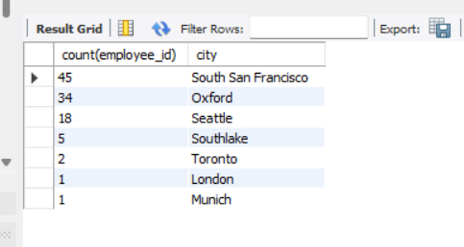

Conclusion

Popular cities where most employees like to do work

-- task 2--

create view my_view as

select city, count(city) from locations

inner join departments on departments.location_id=locations.location_id

join employees on departments.department_id=employees.department_id

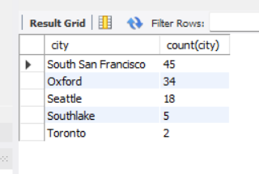group by city

order by 2 desc

limit 5;

select concat(first_name, ' ' ,last_name) as full_name,

country_name,

my_view.city,

salary,

department_name

from employees inner join departments

on employees.department_id=departments.department_id

join locations on employees.department_id=departments.department_id

join countries on countries.country_id=locations.country_id

join my_view using(city)

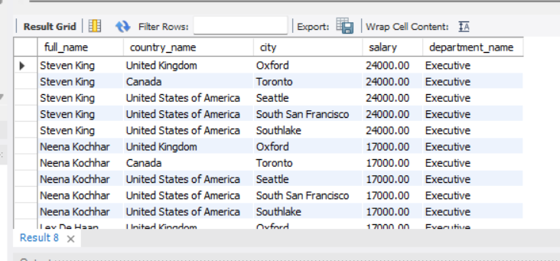order by salary desc;

Conclusio:- Employees are in top 5 cities

-- task 3--

select count(employee_id),

locations.city from employees inner join departments

on employees.department_id=departments.department_id

inner join locations on departments.location_id=locations.location_id

group by city

order by 1 desc

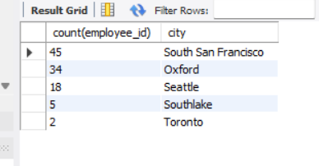

Conclusion:-The max no.of employees who are in top 5 cities.

-- task 4--

select employees.employee_id, employees.first_name, departments.department_name, (year(now())-year(hire_date)) >=10 as 'total experience'

from employees inner join departments on employees.department_id=departments.department_id

where (year(now())-year(hire_date)) >=10;

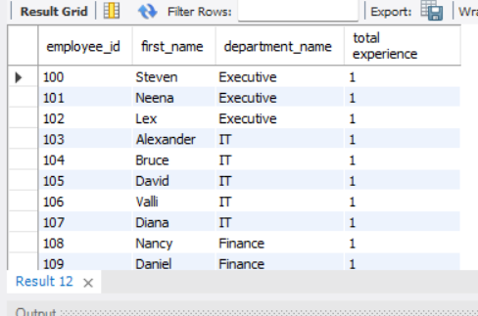

Conclusion:-Employees have complete 10 years in the Organizations. Employees got one-time bouns.

* Task 5--

create view manager as

select manager_id from employees

where (year(now())-year(hire_date)) >=10;

select * from manager;

select concat(first_name, ' ' ,last_name) as manager_name, employee_id as manager_id from employees

join manager

on employees.employee_id=manager.manager_id

group by manager_id;

Conclusion:-Those employees who have completed 10 yaers in Organizations. They would help formulate to new management policies.

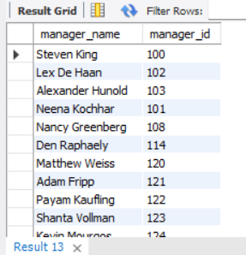

-- task 6--

select countries.country_name from employees

inner join departments on employees.department_id=departments.department_id

inner join locations on departments.location_id=locations.location_id

inner join countries on countries.country_id=locations.country_id

where (year(now())-year(hire_date))>=23

group by country_name

order by 1 desc;

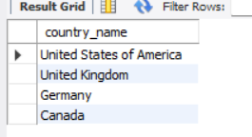

Conclusion:-Top 3 countries which has the employees are most loyal in specific countries.