use hr;

-- task 1--

select employees. employee_id, employees.first_name, departments.department_name from employees inner join departments

on employees.department_id=departments.department_id where departments.department_name='IT';

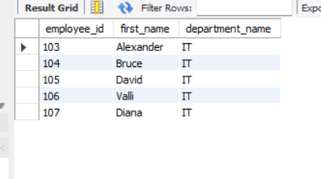

-- task 2--

select employees.first_name, jobs.job_id, jobs.job_title, jobs.min_salary, jobs.max_salary from employees inner join jobs

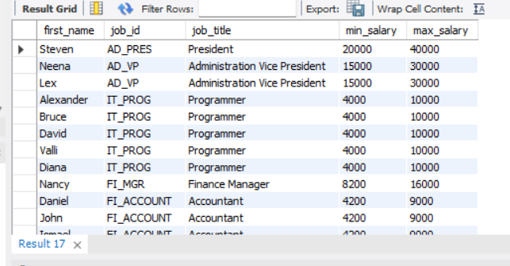on employees.job_id=jobs.job_id;

-- task 3--

select count(employees.employee_id), locations.city from employees

inner join departments on employees.department_id = departments.department_id inner join locations

on departments.location_id = locations.location_id

group by city

order by 1 desc

limit 10;

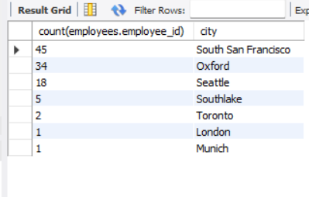

-- task 4--

select employees.employee_id, employees.first_name, job_history.end_date from employees inner join job_history

on employees.department_id=job_history.department_id

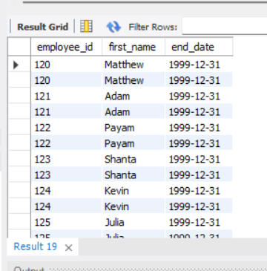where end_date like '1999-12-31';

-- task 5--

select

employees.employee_id,

employees.first_name,

departments.department_name,

(year(now())-year(hire_date)) as 'total experience'

from employees inner join departments on employees.department_id=departments.department_id

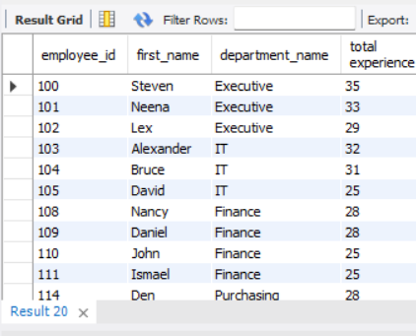where (year(now())-year(hire_date)) >=25;