use world;

-- task 1--

select code from country where code in('USA', 'GBR', 'ARE');

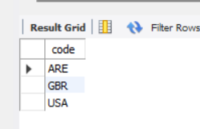

Conclusion:-Country names according to their code.

-- task 2--

select avg(sum_population_of_continent) as avg_of_sum_of_population_of_continent

from

(select continent,

sum(population) as sum_population_of_continent

from country

group by continent) as pop;

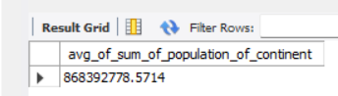

Conclusion:-The average of the sum of the continental population.

* Task 3--

select name country_name, Continent, language

from

(select name, continent, language

from country

join countrylanguage on country.code = countrylanguage.countrycode) as x

where continent like 'Europe'

and language like 'french';

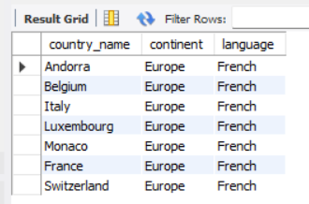

Conclusion:-The list of countries from the continent of Europe the French is spoken.

-- task 4--

create view view3 as select continent, max(population) as max_pop from country

group by continent;

select * from view3;

select name, country.continent from country join view3 on country.continent = view3.continent

and population =view3.max_pop;

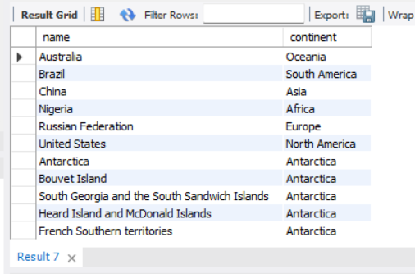

Conclusion:-Country from each continent according to their highest population.

use sakila;

-- task 1--

select movie_name,

count(counts) no_of_copies

from

(select title movie_name,

a.film_id counts

from inventory a

inner join film_text b on a.film_id = b.film_id) exp

where movie_name like 'BROTHERHOOD BLANKET'

or movie_name like 'SOUP WISDOM'

group by movie_name;



Conclusion:-The most popular and trending movies are “BROTHERHOOD BLANKET”, “SOUP WISDOM”.

-- task 2--

select name as genre, count(inventory_id) as x from category

join film_category using (category_id)

join inventory using (film_id)

group by category_id;

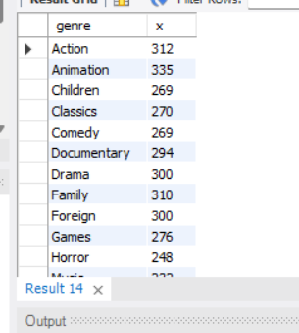

Conclusion:-The total no.of movies in each genre.

-- task 3--

select concat(first_name,' ',last_name) full_name,

c.actor_id x,

sum(replacement_cost) replacement_costs

from film_actor a

inner join film b on a.film_id = b.film_id

inner join actor c on a.actor_id = c.actor_id

group by x

order by replacement_costs desc

limit 3;

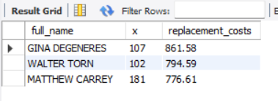

Conclusion:-Top 3 actors according to their highest replacement cost.

-- task 4--

select a.name movie_name,

sum(p.amount) total_sales

from category a

inner join film_category b

on a.category_id=b.category_id

inner join inventory c on b.film_id=c.film_id

inner join rental d on c.inventory_id=d.inventory_id

inner join payment p on p.rental_id = d.rental_id

group by name

order by total_sales desc;



Conclusion:-Total sales for each movie type.

-- task 5--

select a.name movie_name,

sum(p.amount) total_sales

from category a

inner join film_category b

on a.category_id=b.category_id

inner join inventory c on b.film_id=c.film_id

inner join rental d on c.inventory_id=d.inventory_id

inner join payment p on p.rental_id = d.rental_id

group by name

order by total_sales desc

limit 10;



Conclusion:-The board wishes to see the list of the top 10 genre.