use sakila;

-- task 1--

select concat(first_name, ' ' ,last_name) as name, avg(amount) as avg_amount, actor.last_update from film

join film_actor using(film_id)

join actor using(actor_id)

join inventory using(film_id)

join rental using(inventory_id)

join payment using(rental_id)

group by name, actor.last_update

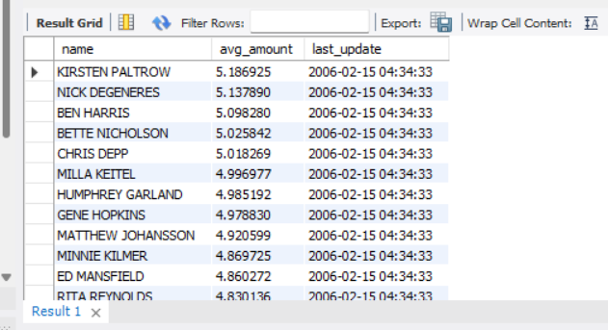order by 2 desc;

Conclusion:-The board member want to see the list of actor available on profit and last update.

-- task 2.1--

select first_name, last_name from actor

order by 1,2;

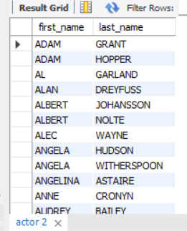

Conclusion:-Change in first_name and last_name.

-- task 2.2--

select concat(first_name, ' ' ,last_name)as name from actor

group by name

having count(name)>1;

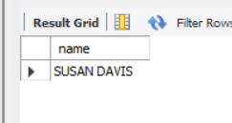

Conclusion:-same first_name and last_name of actors.

-- task 2.3--

select distinct(count(concat(first_name, ' ' ,last_name))) from actor;

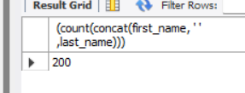

Conclusion:-Unique names of actors.

-- task 3--

select distinct(concat(first_name, ' ' ,last_name)) from actor;

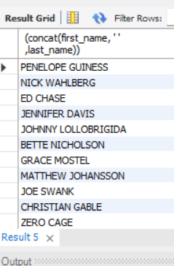

Conclusion:-The board want to know the list of actors whose names are repeated and who names are not repeated.

-- task 4--

select count(name), first_name as "actor_name", name "film_category" from

film join film_category using(film_id)

join category using(category_id)

join film_actor using(film_id)

join actor using(actor_id)

where name in ('Action', 'Romance', 'Horror', 'Mystery')

group by name, actor_name

order by 1 desc;

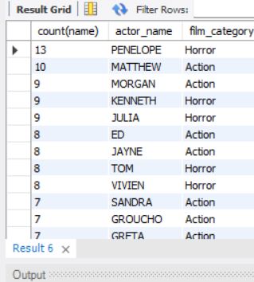

Conclusion:-Acotrs playing identify roles such as ‘action’, horror’, ‘romance’, and ‘mystery’ the board member want to have a detailed overview of film.

-- task 5--

select movie_name,

rating_category,

rating_description from

(select title movie_name,

rating rating_category,

case

when rating like 'G' or rating like 'pg' then 'suitable for kids'

when rating like 'R' then 'restricted for all under 16 unless accompanied by a parent'

when rating like 'nc-17' then 'restricted for all audiences under 18'

end rating_description

from film ) exp

where rating_description is not null

order by rating_category;

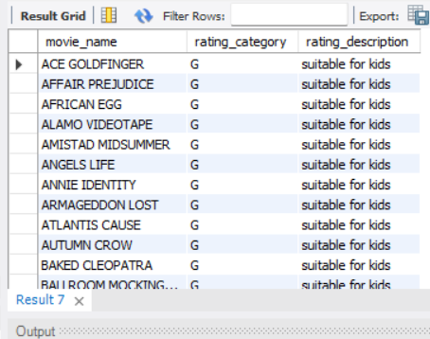

Conclusion:-The board want to know various rating categories with description.

-- task 6.1--

select title movie_name,

replacement_cost

from film

where replacement_cost <=9;

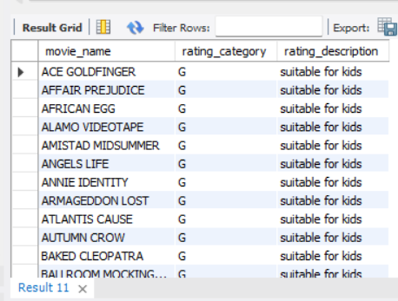

Conclusion:-The board members want to know the replacement cost <=9.

-- task 6.2--

select title, replacement_cost from film

where replacement_cost between 15 and 22;

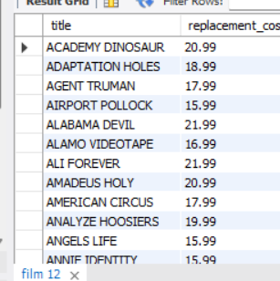

Conclusion:- The board members want to know the replacement cost between 15 and 20.

-- task 6.3--

select title ,

replacement_cost,

rental_rate

from film

where rental_rate =(select min(rental_rate) from film)

and replacement_cost=(select max(replacement_cost) from film);

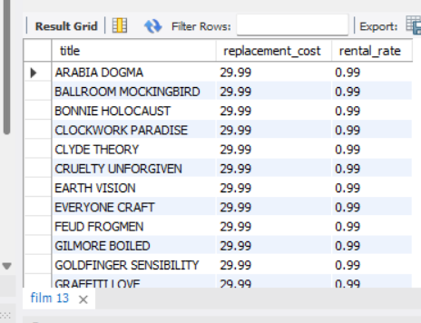

Conclusion:-The movie with the highest replacement cost and lowest rental cost.

-- task 7--

select title, count(*) as "actor" from film join film_actor

using(film_id)

group by title;

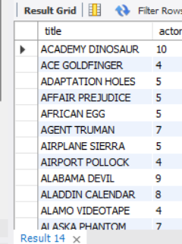

Conclusion:-The board member want to know the list all the films and no.of actors.

-- task 8--

select title movie_name, film_id

from film

where title like 'K%'

or title like 'q%';

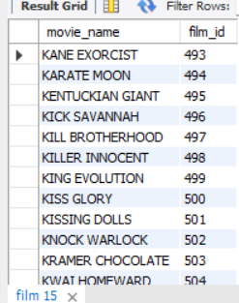

Conclusion:-The film starting with the letters ‘K’ and ‘Q’ have also soared in popularity.

-- task 9--

select first_name, last_name

from film join film_actor on film.film_id= film_actor.film_id

join actor on actor.actor_id=film_actor.actor_id

where title = 'agent truman';

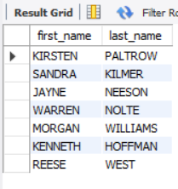

Conclusion:- AGENT TRUMAN is a great success and all actors who appeared in the films.

-- task 10--

select name as category, film.film_id, title as movies

from category join film_category on category.category_id=film_category.category_id

join film on film.film_id=film_category.film_id

where name = 'family';

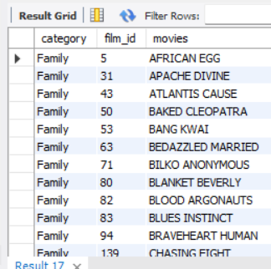

Conclusion:-The board member want to promote all family movies.

-- task 11--

select title, count(*) from film

join inventory using(film_id)

join rental using(inventory_id)

group by title

order by 2 desc;

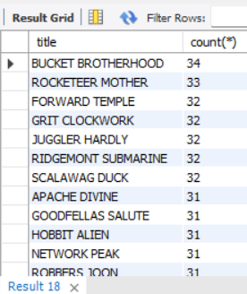

Conclusion:-The most frequently rented movie in descending order and more copies of movies.

-- task 12--

select category_name,

difference from

(select name category_name,

avg(replacement_cost) - avg(rental_rate) difference

from category a

inner join film_category b on a.category_id=b.category_id

inner join film c on b.film_id=c.film_id

group by category_name)exp

where difference >15

order by difference desc;

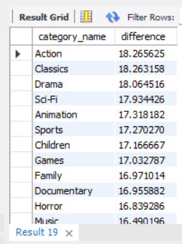

Conclusion:-The average difference btw the film replacement cost and rental rate is greater than 15.

-- task 13--

select category_name,

number_of_films from

(select name category_name,

count(title) number_of_films

from category a

inner join film_category b on a.category_id=b.category_id

inner join film c on c.film_id=b.film_id

group by name) exp

where number_of_films between 60 and 71

order by number_of_films;

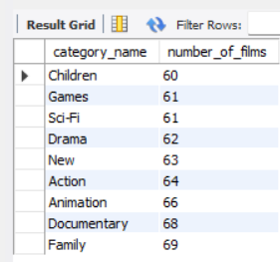

Conclusion:-Board member want to identify the genre s having 60-70 films.