use hr;

-- task 1--
select count(employee_id),
locations.city from employees inner join departments
on employees.departmentl_id=departments.department_id
inner join locations on departments.location_id=locations.location_id
group by city
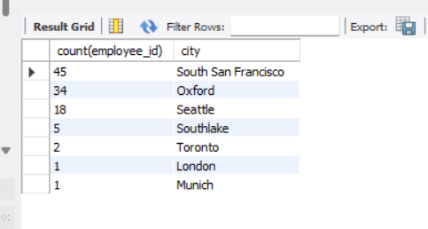

Conclusion
Popular cities where most employees like to do work

-- task 2--
create view my_view as
select city, count(city) from locations
inner join departments on departments.location_id=locations.location_id
join employees on departments.department_id=employees.department_id
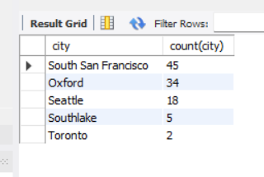
group by city
order by 2 desc
limit 5;

select concat(first_name, ' ' ,last_name) as full_name,
country_name,
my_view.city,
salary,
department_name
from employees inner join departments
on employees.department_id=departments.department_id
join locations on employees.department_id=departments.department_id
join countries on countries.country_id=locations.country_id
join my_view using(city)
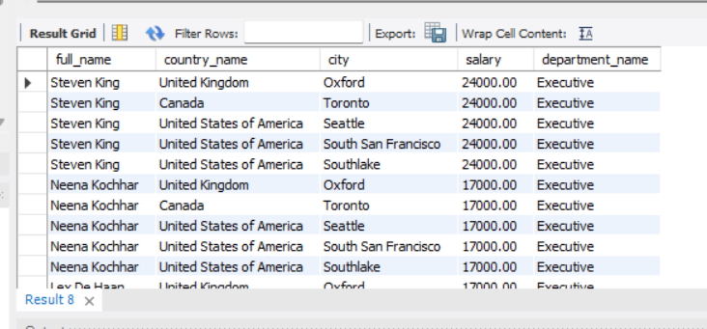
order by salary desc;

Conclusio:- Employees are in top 5 cities

-- task 3--
select count(employee_id),
locations.city from employees inner join departments
on employees.department_id=departments.department_id
inner join locations on departments.location_id=locations.location_id
group by city
order by 1 desc
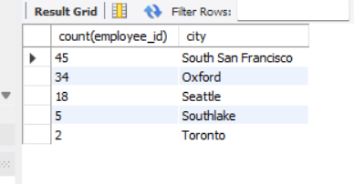

Conclusion:-The max no.of employees who are in top 5 cities.

-- task 4--
select employees.employee_id, employees.first_name, departments.department_name, (year(now())-year(hire_date)) >=10 as 'total experience'
from employees inner join departments on employees.department_id=departments.department_id
where (year(now())-year(hire_date)) >=10;
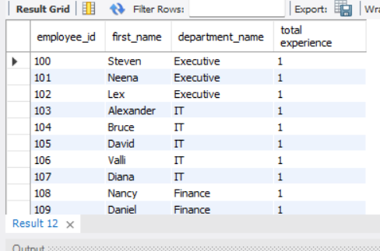

Conclusion:-Employees have complete 10 years in the Organizations. Employees got one-time bouns.
- Task 5--
create view manager as
select manager_id from employees
where (year(now())-year(hire_date)) >=10;
select * from manager;

select concat(first_name, ' ' ,last_name) as manager_name, employee_id as manager_id from employees
join manager
on employees.employee_id=manager.manager_id
group by manager_id;
Conclusion:-Those employees who have completed 10 yaers in Organizations. They would help formulate to new management policies.

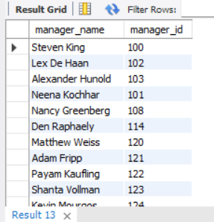

-- task 6--
select countries.country_name from employees
inner join departments on employees.department_id=departments.department_id
inner join locations on departments.location_id=locations.location_id
inner join countries on countries.country_id=locations.country_id
where (year(now())-year(hire_date))>=23
group by country_name
order by 1 desc;
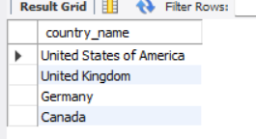

Conclusion:-Top 3 countries which has the employees are most loyal in specific countries.

