**Assignment2**

**1.Ackley’s fuction**

Task 1: Hill Climbing Search

I have written this program in c++ to execute it open CodeBlocks and run it there. Sample graph output:

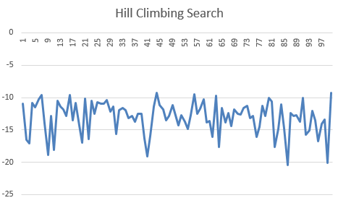

Task 2: Differential Evolution

I have written this program in python 3.5.2. To execute it open idle 3.5.2/notepad++ save it and run it.

Sample graph output:

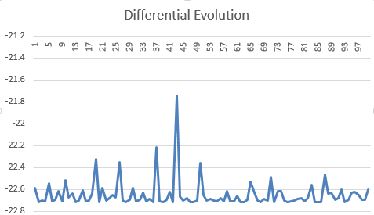

Task 4: Analysis

By comparing both the results (hill climbing search and differential evolution), I found that differential evolution gives accurate results.

In differential evolution all the search results are nearly equal to the minimum point, as we are finding the most optimized results for every iteration(i.e., all 100 iterations).

Hence the conclusion is differential evolution gives accurate and better results than hill climbing(althought hill climbing also provides results but not accurate in all of the iterations).

**2.N-queens Problem**

Task 1: Hill Climbing Search

I have written this program in c++. to execute, open CodeBlocks and run it there.

Sample output:

For 8 queens:

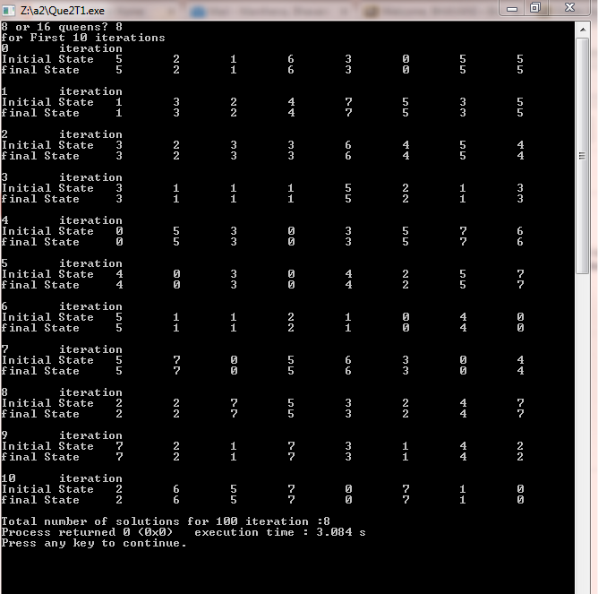

For 16 queens:

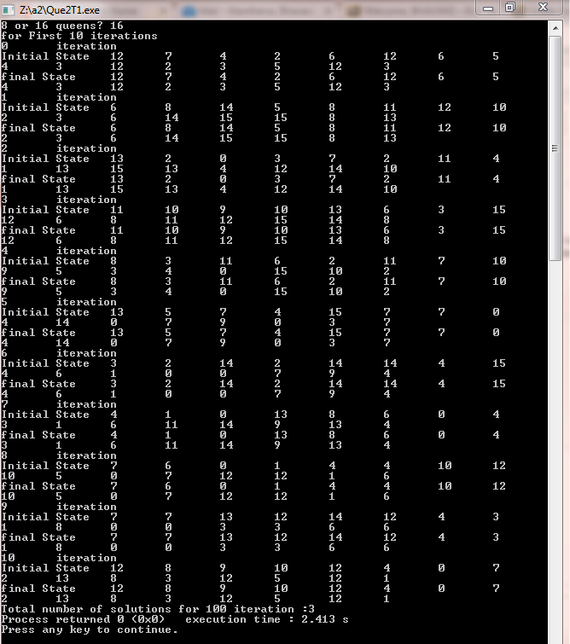

Task 2: Genetic Algorithm

I have written this program in python 3.5.2. To execute it open idle 3.5.2/notepad++ save it and run it.

Sample output:

