Assignment -3

**Language:** python 2.7

**Description**

Task 1: In this task1 I have implemented the crossword with the given dictionary of words, I have used backtracking here for the crossword where all the words are checked for the possibilities and finally the exact words are placed in the resultant dictionary. When you run the python file in command prompt the output is as follows.

The execution time is calculated as the final solution is obtained.

Run the code either in IDLE or command prompt for the result.

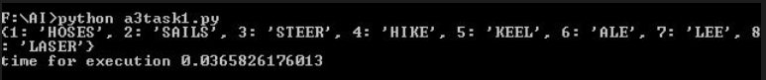Sample Output:

Output

| H | O | S | E | S |

| # | # | A | # | T |

| # | H | I | K | E |

| A | # | L | E | E |

| L | A | S | E | R |

| E | # | # | L | # |

Task 2: In this task2 I have tried to implement the crossword with the given pattern, I have successfully separated all the words into smaller dictionaries based on the word count, but the process of backtracking is bit harder always I try to execute the program it come up with a new problem and I could not figure out the exact logic for this crossword, since the output is not obtained, I have sent the code until the part done.

Language: python3.5.2