Image Forgery Detection Based on Fusion of Lightweight Deep Learning Models

In this paper to detect image forgery author has used fine-tuned features from light weight algorithms such as SqueezeNet, MobileNetV2, ShuffleNet and then extracted features are getting trained with SVM and then this SVM model is giving better prediction accuracy compare to light weight algorithms.

Due to increasing technology various tools exists to tamper image and then tampered image can cause serious issues in LAW and other fields and to detect such tamper many existing algorithms are available based on SURF, PCA, SIFT and many more but this existing technique detection accuracy is not good so author training all 3 algorithms on MICC-F220 FORGE and NORMAL images and then extract fine-tuned features from them and this fined tuned features can be classified with SVM as FORGE or NON-FORGE.

To implement this project we have designed following modules

1. Upload MICC-F220 Dataset: using this module we will upload dataset to application
2. Preprocess Dataset: using this module we will read all images and then normalize their pixel values and then resize them to equal size
3. Generate & Load Fusion Model: using this module we will train 3 algorithms called SqueezeNet, MobileNetV2 and ShuffleNet and then extract features from it to train fusion model. All algorithms prediction accuracy will be calculated on test data
4. Fine Tuned Features Map with SVM: using this module we will extract features from all 3 algorithms to form a fusion model and then fusion data get trained with SVM and then calculate its prediction accuracy.
5. Run Baseline SIFT Model: using this module we will extract SIFT existing technique features from images and then train with SVM and get its prediction accuracy
6. Accuracy Comparison Graph: using this module we will plot accuracy graph of all algorithms
7. Performance Table: using this module we will display all algorithms performance table.

In below screen code you can see how we are extracting features from all 3 algorithms and then building fusion model

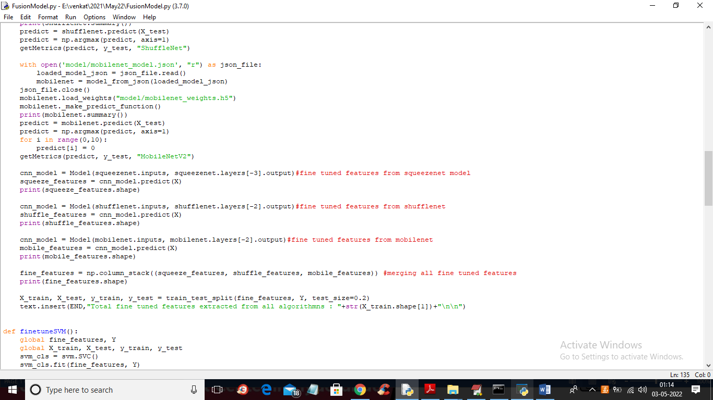

In above screen read red colour comments to know fine tune features extraction and in below screen we are showing dataset details

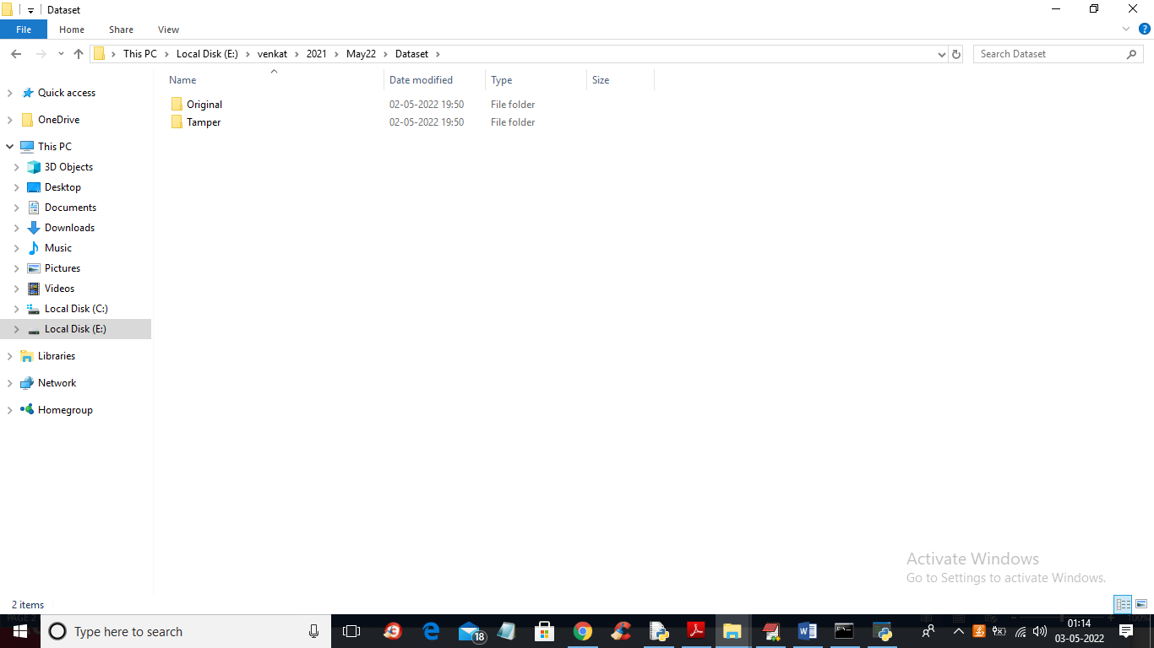

In above screen in ‘Dataset’ folder we have 3 folders where one contains original images and other folder contains TAMPER or FORGE images and just go inside any folder to view its images

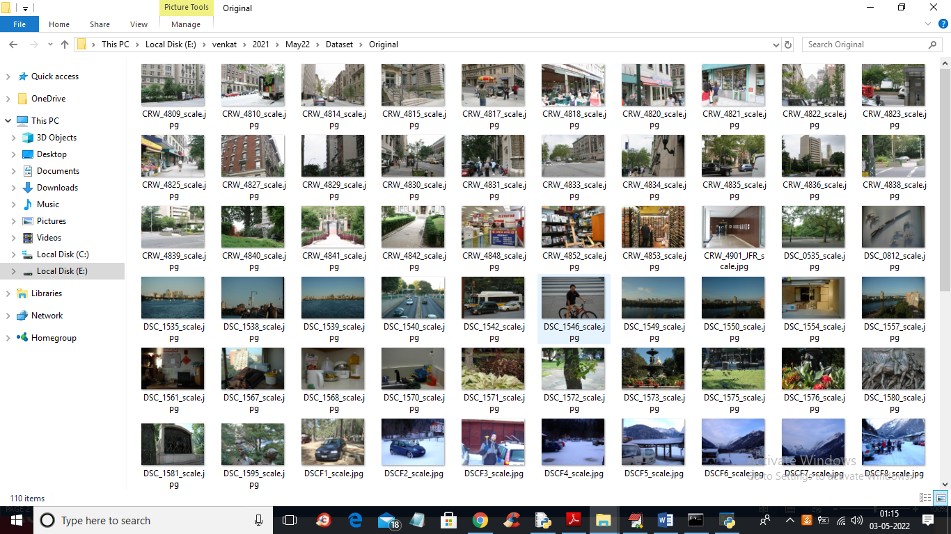

So by using above images we will train all algorithms and calculate their performances

SCREEN SHOTS

To run project double click on ‘run.bat’ file to get below output

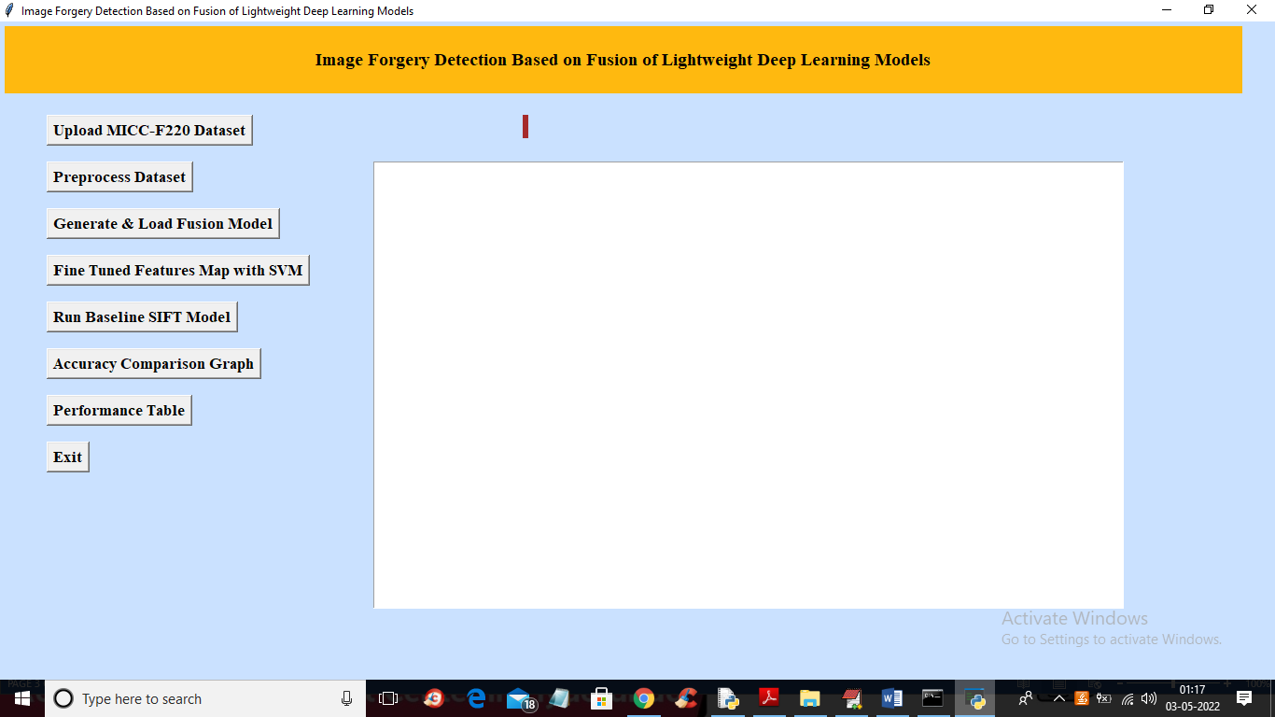

In above screen click on ‘Upload MICC-F220 Dataset’ button to upload dataset and get below output

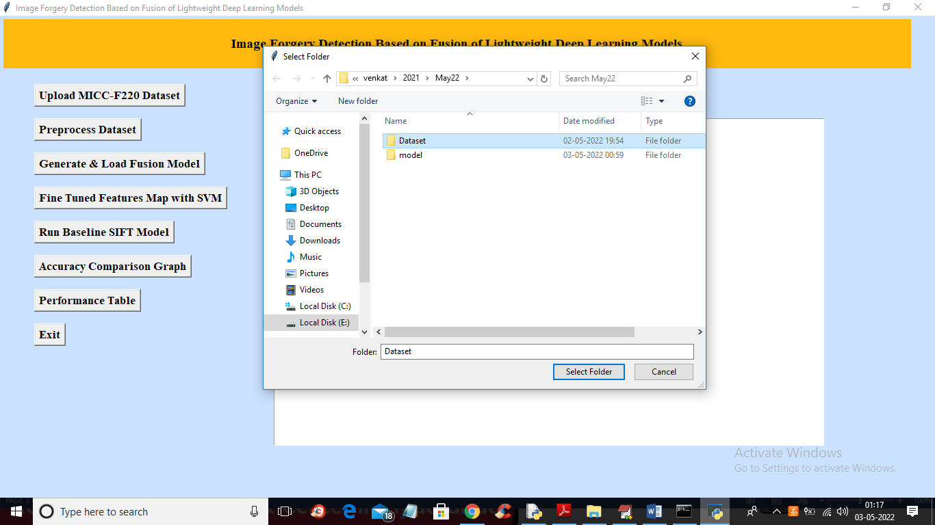

In above screen selecting and uploading ‘Dataset’ folder and then click on ‘Select Folder’ button to load dataset and get below output

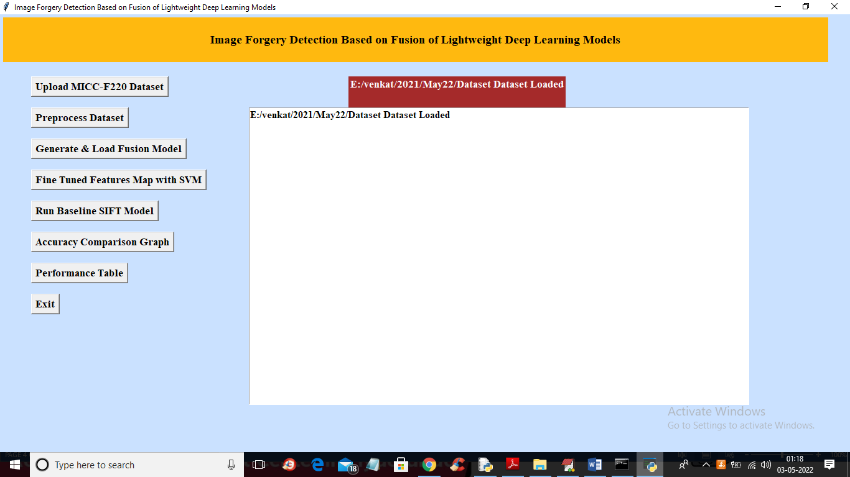

In above screen dataset loaded and now click on ‘Preprocess Dataset’ button to read all images and normalize them and get below output

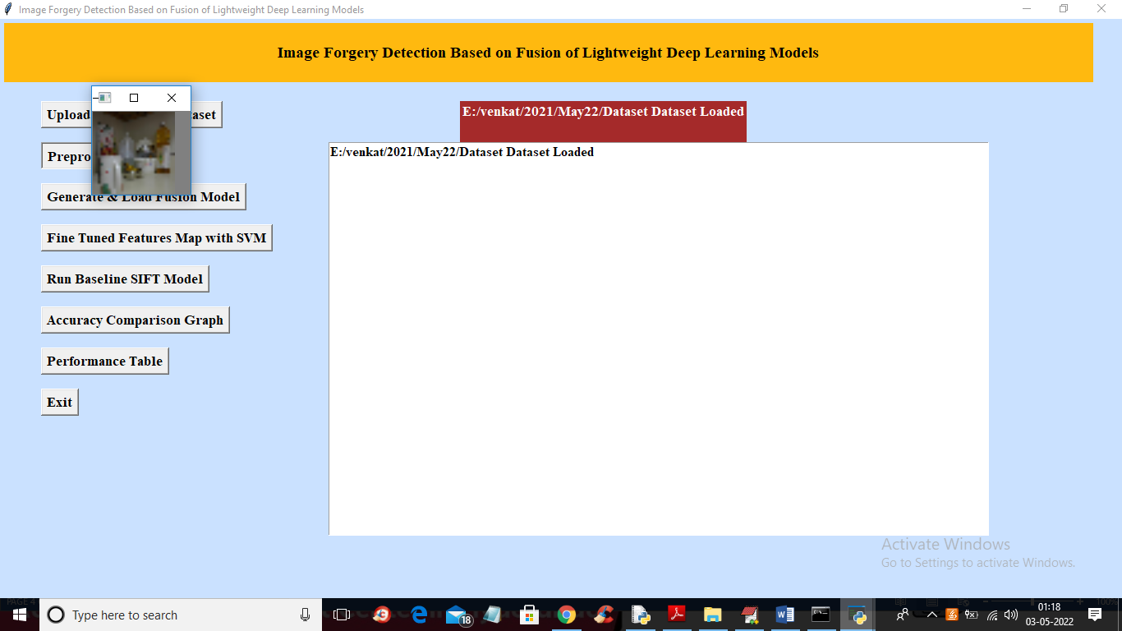

In above screen all images are processed and to check images loaded properly I am displaying one sample image and now close above image to get below output

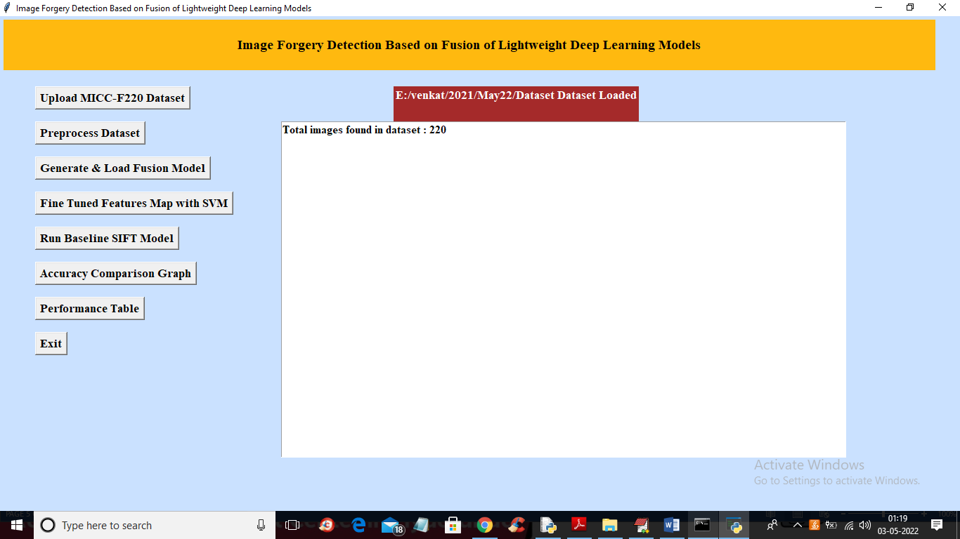

In above screen we can see dataset contains 220 images and all images are processed and now click on ‘Generate & Load Fusion Model’ button to train all algorithms and then extract features from them and then calculate their accuracy

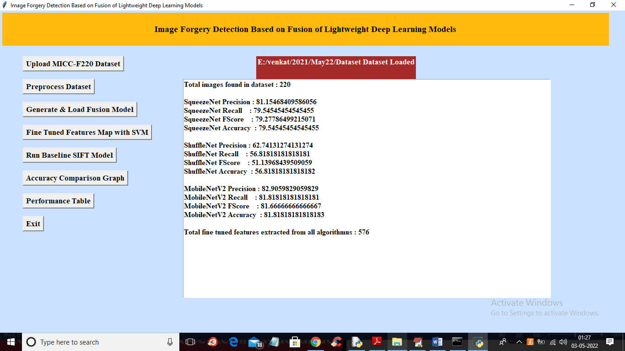

In above screen we can see accuracy of all 3 algorithms and then in last line we can see from all 3 algorithms application extracted 576 features and now click on ‘Fine Tuned Features Map with SVM’ to train SVM with extracted features and get its accuracy as fusion model

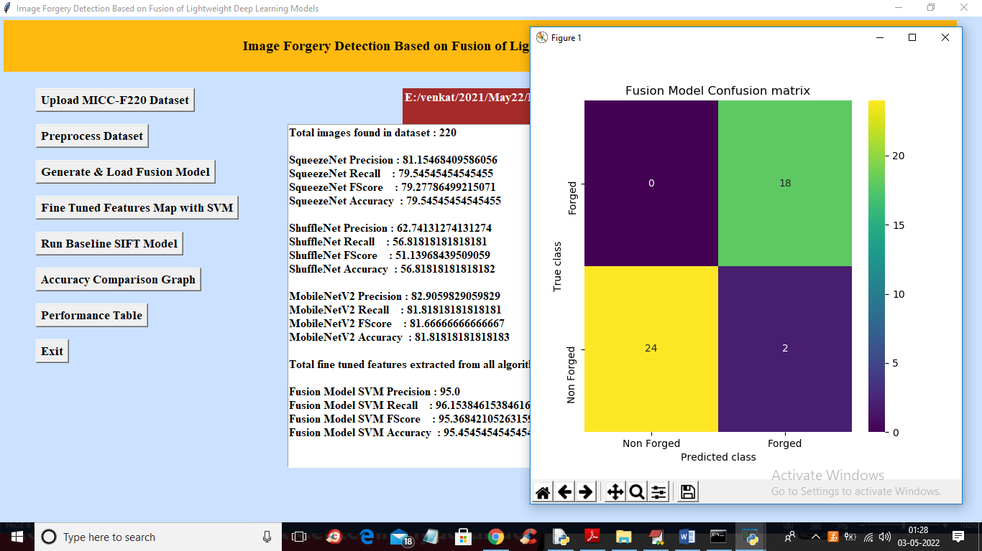

In above screen with Fine tune SVM fusion model we got 95% accuracy and in confusion matrix graph x-axis represents PREDICTED LABELS and y-axis represent TRUE labels and we can see both X and Y boxes contains more number of correctly prediction classes. In all algorithms we can see fine tune features with SVM has got high accuracy and now close confusion matrix graph and then click on ‘Run Baseline SIFT Model’ button to train SVM with SIFT existing features and get its accuracy

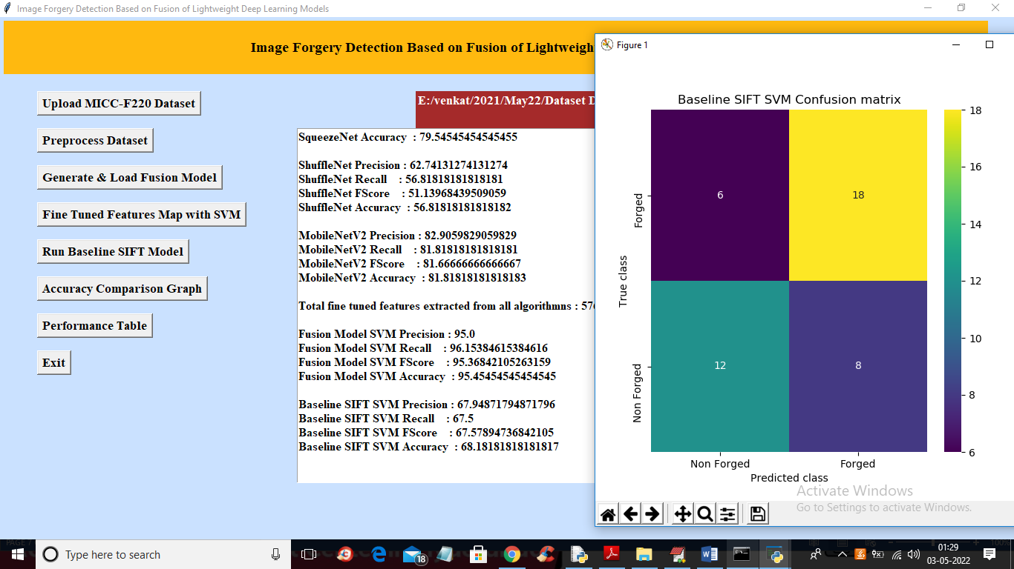

In above screen with existing SIFT SVM features we got 68% accuracy and in confusion matrix graph we can see existing SIFT predicted 6 and 8 instances incorrectly. So we can say existing SIFT features are not good in prediction and now close above graph and then click on ‘Accuracy Comparison Graph’ button to get below graph

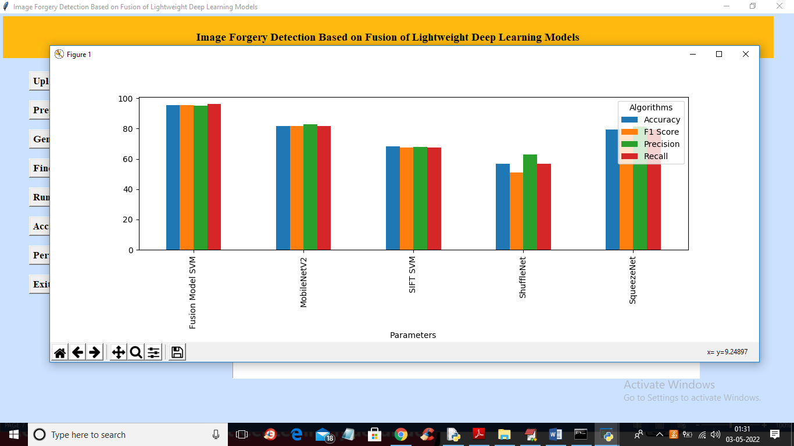

In above graph x-axis represents algorithm names and y-axis represents accuracy and other metrics where each different colour bar represents different metrics like precision, recall etc. Now close above graph and then click on ‘Performance Table’ button to get result in below tabular format

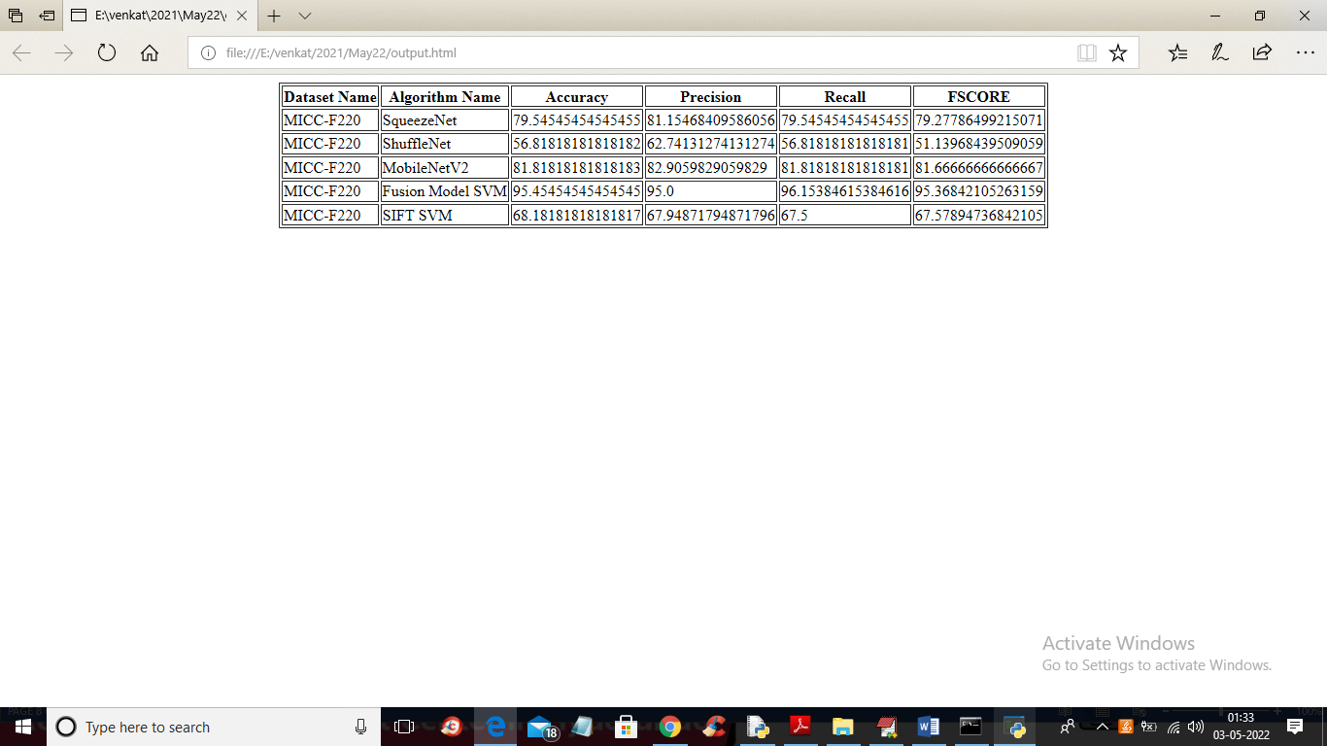

In above screen we can see propose fusion model SVM with fine tune features has got 95% accuracy which is better than all other algorithms