Module 2 – SCM with Git

Assignment:1

Done by : Bhavani Raju

Multiple Developers working simultaneously on the same block of code also caused problems. You are Mike, and your manager has given you the task of moving the company’s code base to git and Github.

**Action Items :**

•Create a local git repository and move the entire code base to it

* Cloned the repo from DevOpsClassCodes.git
* Copied the codes to my dir /root/sample-code

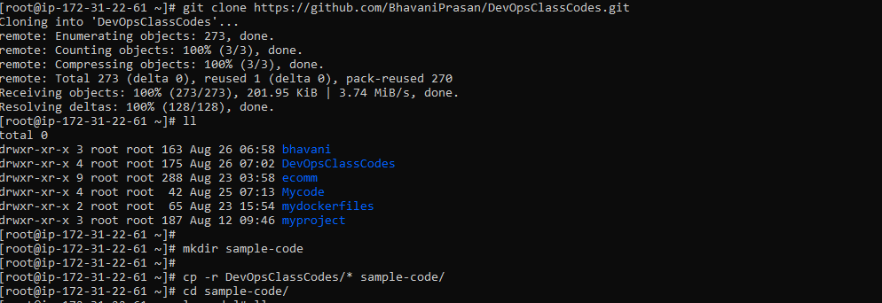



* Initialized my sample-code dir
* Added and committed it to local repo.

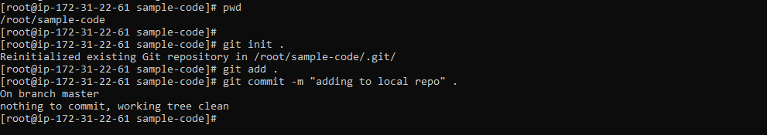

•Create a new branch for a new feature you want to add to the application

New Branch Name : **sample-code-dev** from master

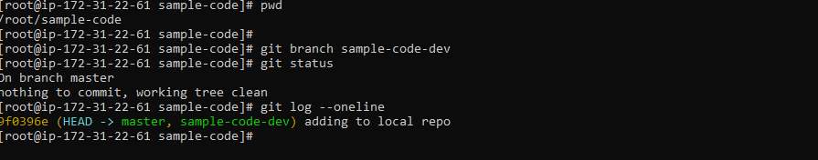

* Switched to dev branch
* Made some changes. Created new file. Committed the changes in local repo.

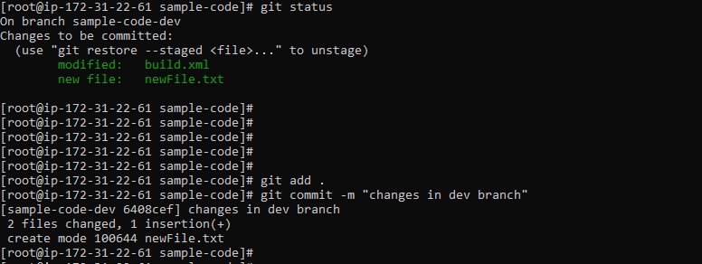

•Merge back the created branch with the master branch

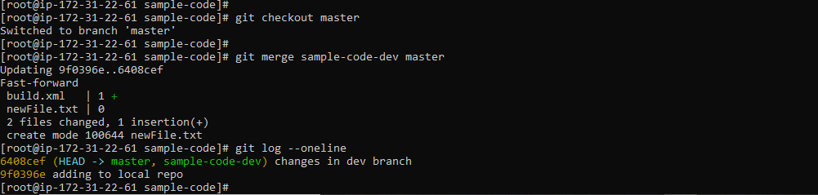

•Create a remote repository in github.com,

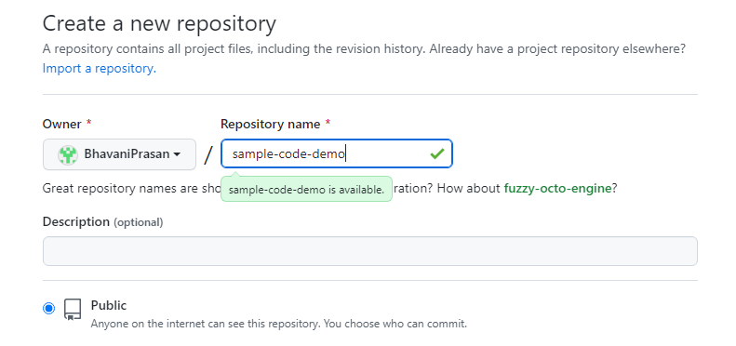

•Push the local repository to company’s remote repository

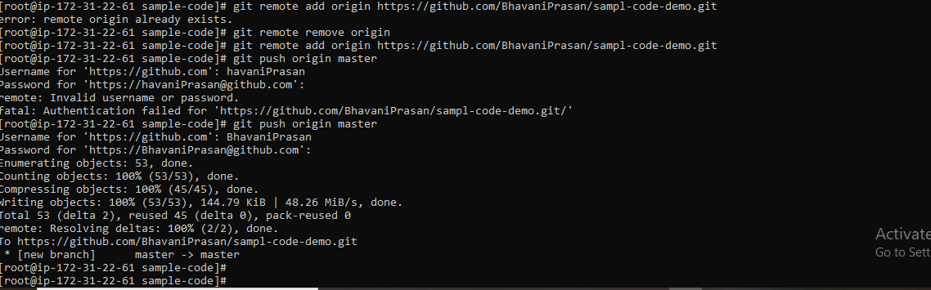

Personal Access Token to connect to github from git,

Hithub->Setting->developer setting-> generate new token -> select scope as repo ->create.

Copy the token and save it in notepad. Use it when connect to github (push/pull)