Module 3: Git And Jenkins

Assignment II

Done By **BhavaniRaju**

**Problem Statement**

You are working as a DevOps Engineer in a company named Sanders & Fresco Pvt ltd. You have been asked by your manager to create a Maven Project using Jenkins and build a war file of that project. As a proof of concept, you have been given a web application to build. And once done with building the war file, deploy it over the tomcat server.

**Steps to solve:**

1. Create 2 jenkins job,

* Continuous Integration
* Continuous Deployment

1. ContinousIntegration Jenkins Job

* Create pipeline project,

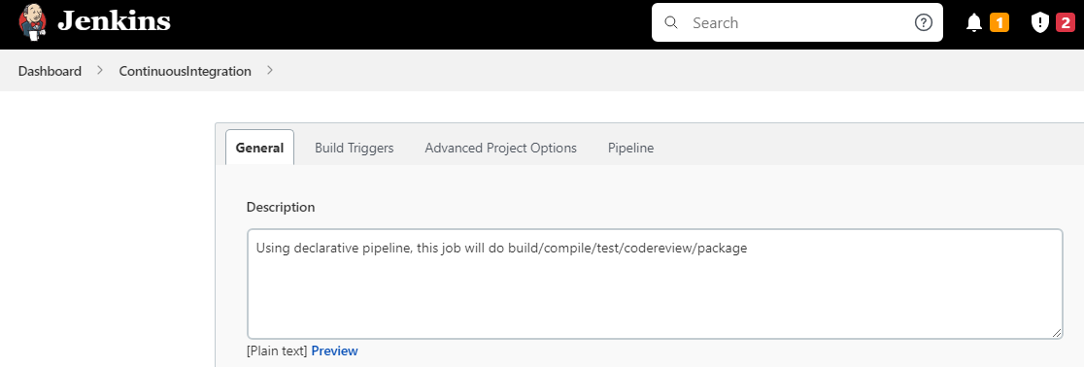

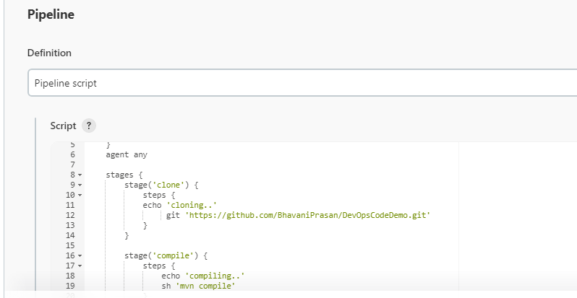

* Create declarative pipeline for building/testing/package under pipeline section,

|  |
| --- |
| pipeline{  tools{  jdk 'myjava'  maven 'mymaven'  }  agent any  stages{  stage('Checkout'){  steps{  echo 'cloning..'  git 'https://github.com/Sonal0409/DevOpsClassCodes.git'  }  }  stage('Compile'){  steps{  echo 'complie the code..'  sh 'mvn compile'  }  }  stage('CodeReview'){  steps{  echo 'codeReview'  sh 'mvn pmd:pmd'  }  }  stage('UnitTest'){  steps{  sh 'mvn test'  }  }  stage('MetricCheck'){  steps{  sh 'mvn cobertura:cobertura -Dcobertura.report.format=xml'  }  }  stage('Package'){  steps{  sh 'mvn package'  }  }  }  } |
|  |  |
| * Run the job, |  |
|  |  |
| * The war file will be placed in the workspace dir of Jenkins, |  |
|  |  |
|  |  |
| 1. Create a free style project, ContinousDeployment.      * Under Build Trigger Tab, select Build after other projects are built. And give ContinousIntegration Job as projects to watch.      * Under Build Tab, select Execute shell. * write to create a docker file, * create tomcat image and deploy the war inside it. * Port to access container,8080 * Run the tomcat server. * Build the image. * Run it to create a tomcat container.   Shell script  ============  rm -rf myfiles  mkdir myfiles  cd myfiles  cp /var/lib/jenkins/workspace/ContinuousIntegration/target/addressbook.war .  touch dockerfile  cat <<EOT>> dockerfile  FROM tomcat:9  ADD addressbook.war /usr/local/tomcat/webapps  EXPOSE 8080  CMD ["catalina.sh", "run"]  EOT  sudo docker build -t myimage01:$BUILD_NUMBER .  sudo docker run -itd -P myimage01:$BUILD_NUMBER |  |
|  |  |
|  |  |
|  |  |
| * Build the job, console output |  |
|  |  |
| * Check the status of container in server |  |
|  |  |
|  |  |
|  |  |
|  |  |
|  |  |
|  |  |
|  |  |
| * We can access our addressbook application using IPv4 address of server and its port(49153 displayed above) |  |
|  |  |
|  |  |
|  |  |
|  |  |
| Note:   * Jenkins doesn’t have root access to execute docker commands, so give root permission to jekins in /etc/sudoers as shown below, |  |
|  |  |
|  |  |
|  |  |
|  |  |
|  |  |
|  |  |
|  |  |
|  |  |
|  |  |
|  |  |
|  |  |
|  |  |
|  |  |
|  |  |
|  |  |
|  |  |
|  |  |
|  |  |
|  |  |
|  |  |
|  |  |
|  |  |
|  |  |
|  |  |
|  |  |
|  |  |
|  |  |
|  |  |
|  |  |