Module 3 – Git and Jenkins

Assignment 1

Done by **Bhavani Raju**

Hooli Co has put Harry and Kane to implement a new set of features in their feature software. Both started working separately, making their own copies of the same source code. Now, it has become difficult for them to track the changes they’ve made in the original code and they are finding it difficult to merge their code together.

**Action Items**

•Create two separate branches from master

* Dev1 and dev2 branches are created from master.



•Make changes in the same function of the source code in both the branches

* Dev1 branch -> JenkinsFile1 modified

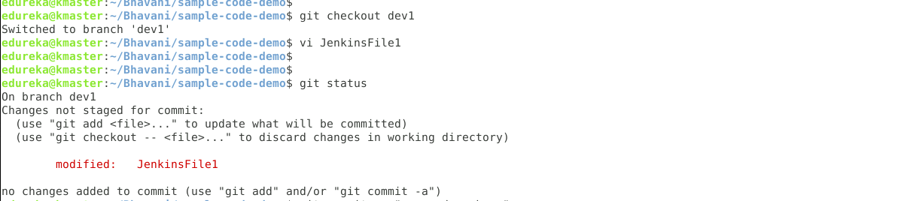

* Commit the changes.
* Switch to master.
* Merge dev1 branch to master branch.

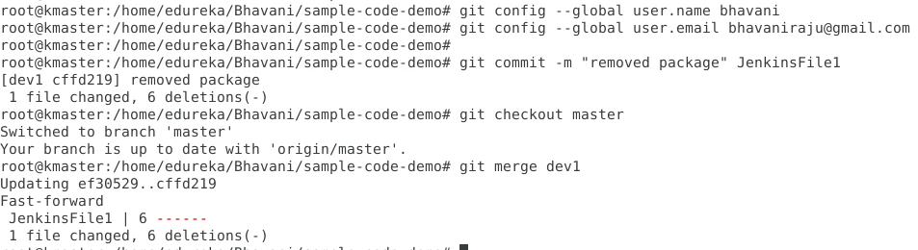



•Try and merge branch2 into the master (merge conflict should arise)

* In dev2 branch, modify the same file.
* Commit the changes in dev2 branch.

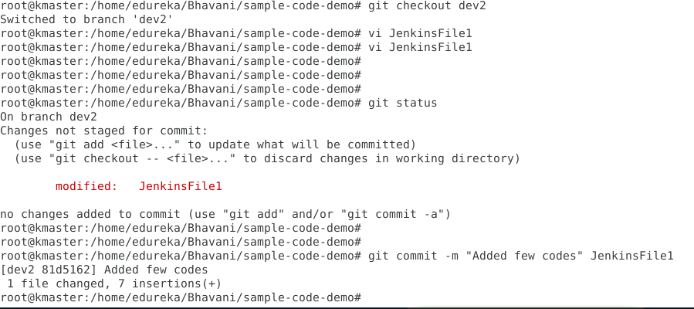

* Merge conflict arises when try to merge dev2 branch to master.
* Switch to master.
* Merge dev2 to master
* Conflict arises.

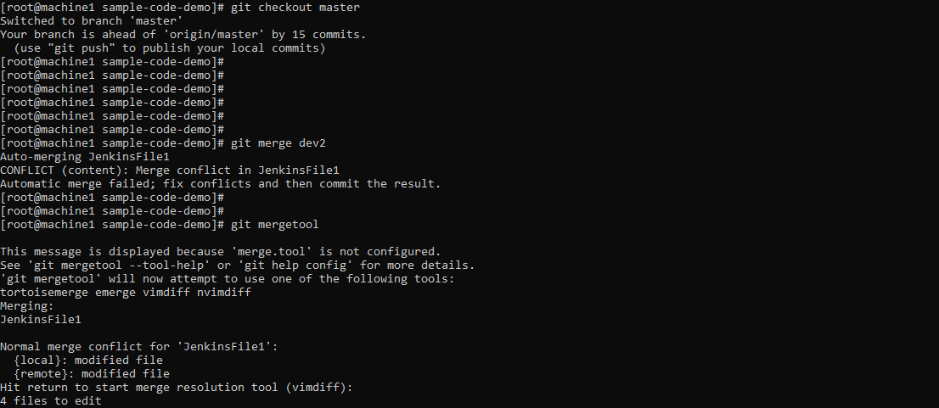

•Install a merge tool of your choice and resolve the merge conflicts using

git mergetool command

* Used vimdiff to resolve merge conflicts
* Here in this tool, LOCAL = destination branch(which is Master in our case). Where you want to merge.
* REMOTE = Source branch (Dev2 in our case)
* The bottom panel shows the difference of code within <<<< ------ >>>> this block, remove those marks. And save the LOCAL copy by giving :wq!
* Once done , commit the file.

