**Module 4: Continuous Integration With Jenkins**

**Done By BhavaniRaju**

**Problem Statement**

* Create a freestyle project with the name QA_UNIT_TEST in Jenkins that is driven from job DEVELOPER_CODE_REVIEW and performs unit testing.Take a screenshot of the console output showing a successful build of unit testing.

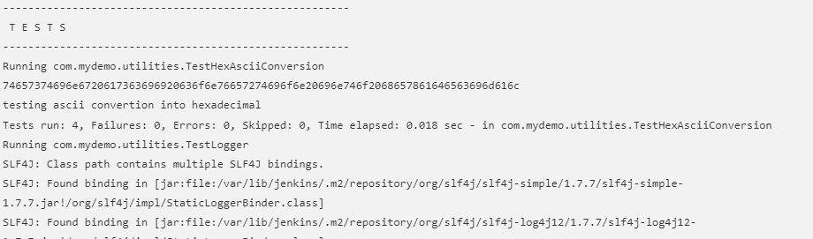

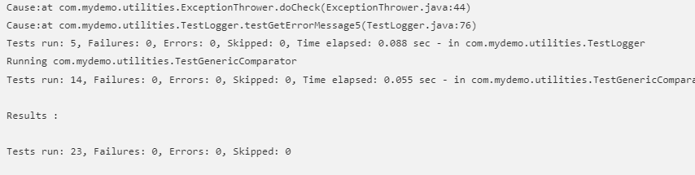

* Create a freestyle project with the name QA_ METRICS _CHECK in Jenkins to check the test cases. Make sure the Cobertura plugin is installed in Jenkins.Take a screenshot of the metrics from the dashboard of the project.

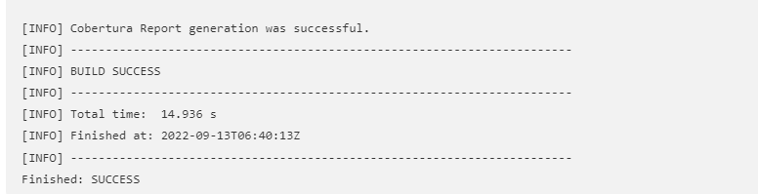

* Create a freestyle project with the name QA_ PACKAGE in Jenkins to create an executable jar/war file. Take a screenshot of the target folder created in the workspace.

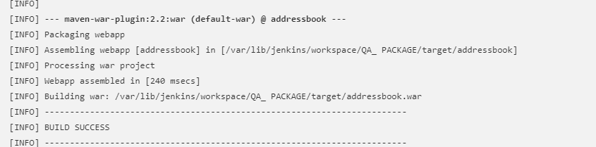

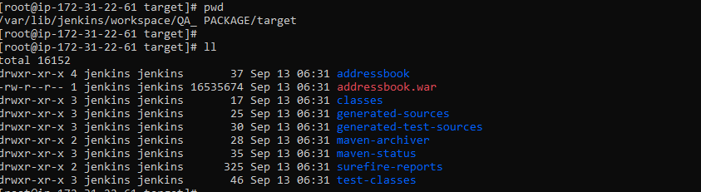

* Create a pipeline named SAMPLE_COMPILE_VIEW with Build Pipeline View option, select DEVELOPER_COMPILE project under layout section, and run the pipeline to check the console output.Take a screenshot of the pipeline dashboard showing the status of the projects

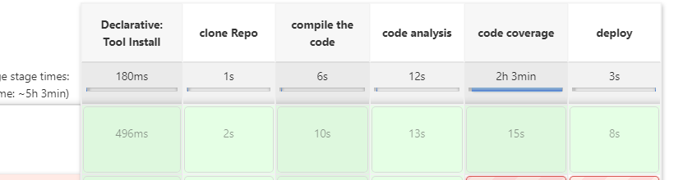

* The pipelines can also be extended to running web tests and load tests. Explain how you would do the same using Jenkins?