**Module 5: Configuration Management with Ansible**

**Done By: Bhavani Raju**

**Problem Statement**

Rashford assoc. are having trouble provisioning their server environment because of the inconsistencies caused by the new update. They have Hired Marcus to solve their problems related to managing servers. Marcus, after researching, introduced Ansible to the system. Now, he needs to provision the production environment for the upcoming update of their software.

**Action Items**

•Create separate roles for setting up Apache Tomcat and Apache Maven

•Add the necessary logic to the roles to set up the tools

•Create a new playbook and call Tomcat as well as Maven roles inside it

•Execute the playbook on all the hosts

* Create 2 roles in /etc/ansible/roles/ directory using following command,

Ansible-galaxy init setup-tomcat-role

Ansible-galaxy init setup-maven-role

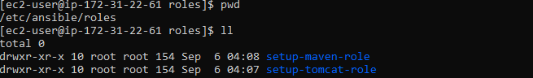

* Write the logic to setup and start the tomcat in the following path,

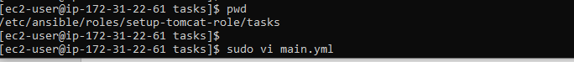

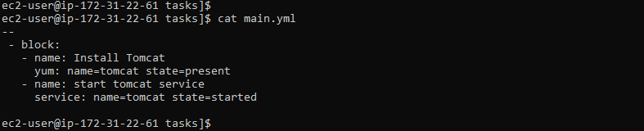

* Write the logic to install maven in the following path,

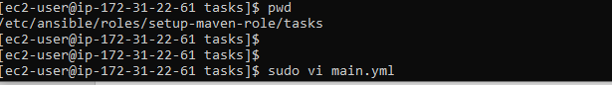

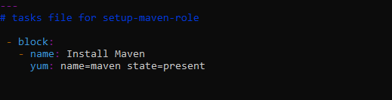

* Create the playbook and call the roles,

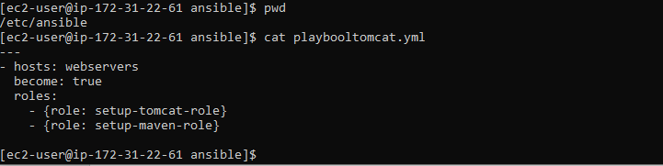

* Do syntax check and run the ansible playbbok,

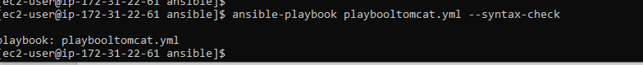

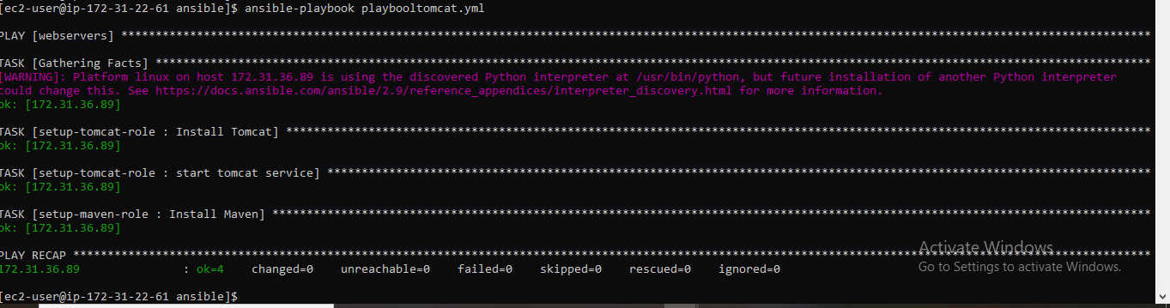

* Log on to host machine and check whether tomcat and maven installed,

