**Module-7: Containerization using Docker Part – II**

**Done By Bhavani Raju**

You are working with a web development agency that highly relies on Drupal as their base framework for develoing web applications for their clients. So far, you have been deploying Drupal manually across all the servers but now the firm wants to have the process streamlined and automated.

**Objectives:**

•Download your company’s website files from the given link

•Write a docker file that will make your company’s website work

out of the box with a web server (Tip -You can use httpd / apache image and build on top of it)

•Make sure that you use volumes to store the actual data of the website outside of the container

•Push the docker image to your docker hub account so that it can

be pulled later

•Create a swarm cluster

•Deploy your firm’s website on the swarm cluster and expose port 80 to access the website. Also, ensure that the volumes are configured properly so that the source of the files is the same for all the containers of the service

Application Link:

https://github.com/edurekacontent/dockerContent

1. Create a docker file to create a apache http server and deploy the code inside /usr/local/apache2/htdocs

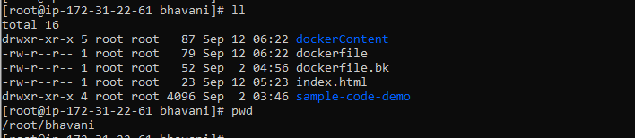

1. Clone the repository where project is available.

**Git clone https://github.com/edurekacontent/dockerContent**

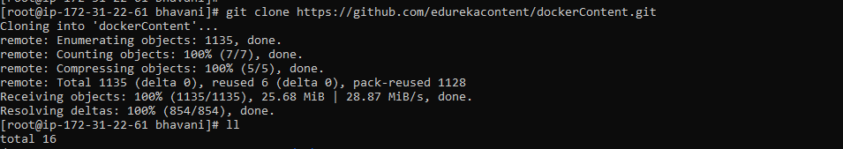

1. Create docker file like below,

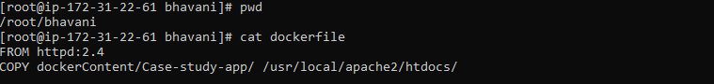

1. Build and run the docker file,

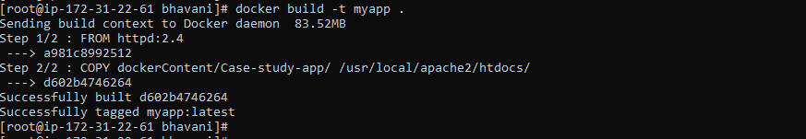





1. In browser, access your application <ip address:8081>

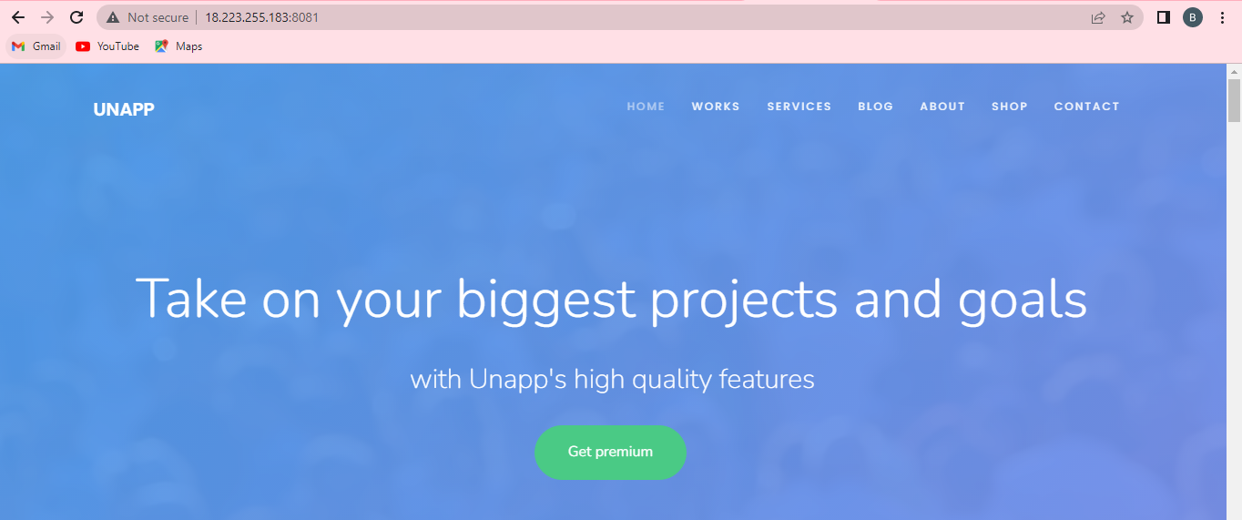

1. Login to docker hub and create a new account.

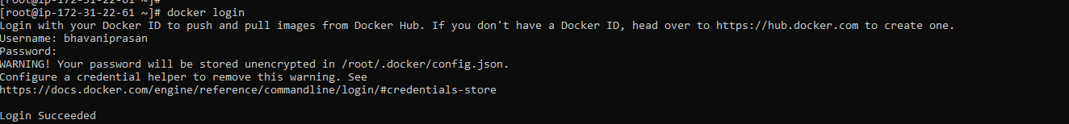

1. Push your newly created image to hub,

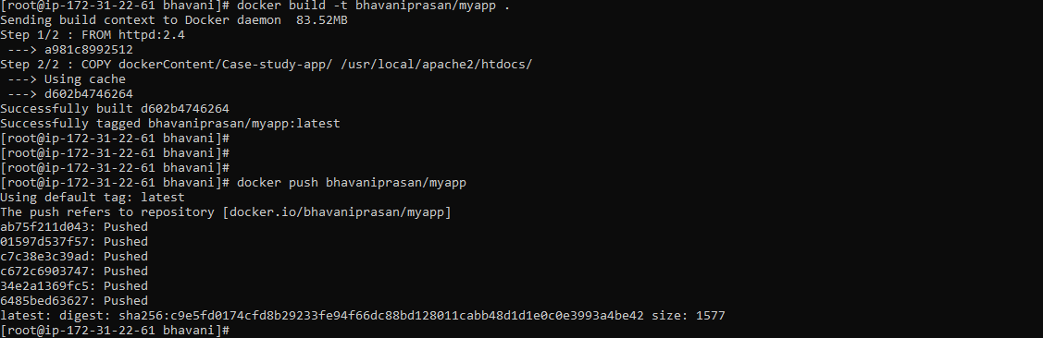

1. Check whether your image is updated in docker hub registry.

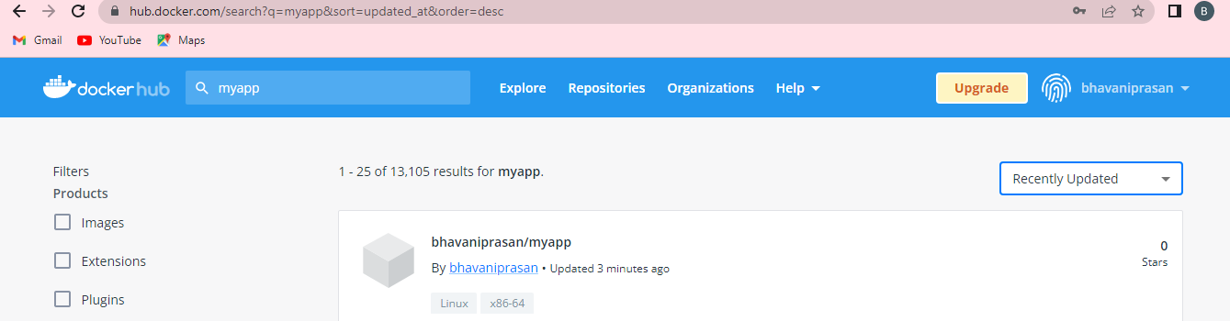

1. Create docker swarm Cluster,

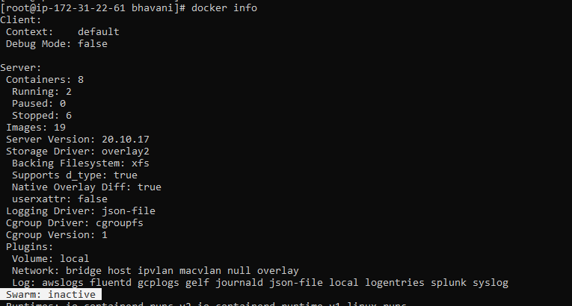

1. Activate the docker swarm,

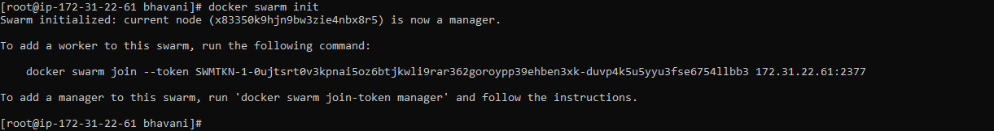



1. Copy the above command in worker machines inorder to join the docker swarm cluster,

In worker 1 machine,

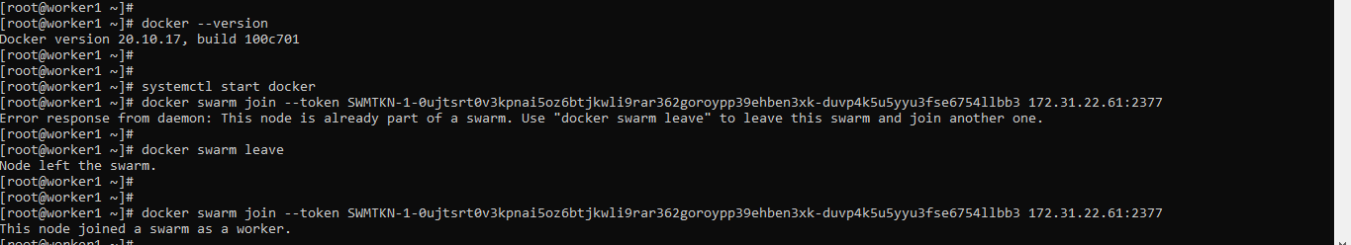

In worker 2 machine,

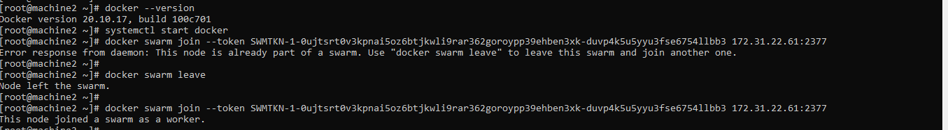

In the Leader machine,



1. Create a docker swarm service,

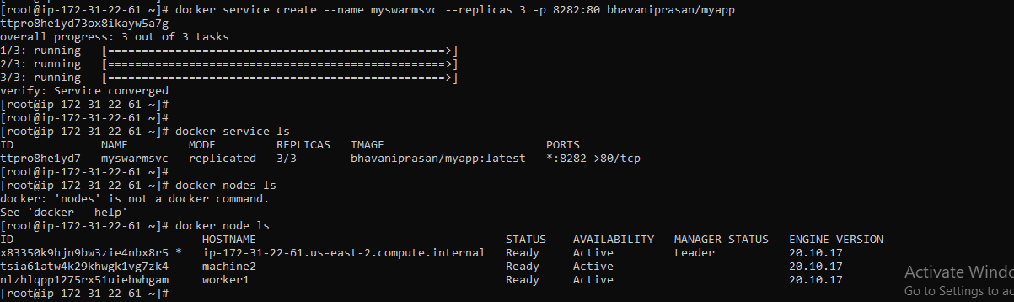

1. Access your application in the browser by using any 3 IP’s where container’s are available with the port 8282.

