**Project – 1**

**Done By Bhavani Raju**

**Steps for executing the solution:**

•Use the Master VM for Jenkins, Ansible, GIT etc.

[Bhavani] : Installed Jenkins,Ansible, Git in master machine.

•Use the fresh instance for Jenkins Slave Node (Test Server)

[Bhavani] : Created new amazon ec2 instance to act as a slave machine.

•Change the IP address of the VMs accordingly

[Bhavani] : changed the host name of slave machine as slave.

•Add Build Pipeline Plugin and Post-build task plugin to Jenkins on the masterVM

[Bhavani] : Installed

•Install python, openssh-server and git on the slave node manually

[Bhavani] : Installed

•Use the image devopsedu/webapp and add your PHP website to it using a Dockerfile

[Bhavani] : Since not sure about the usage of this PHP webapp and not having enough details about in which webserver PHP application has to be deployed, I have used the nginx image to deploy.

•Push the PHP website, and the Dockerfile to a git repository

[Bhavani] : I have used my sample files to deploy in the nginx server.

**Below tasks should be automated through Jenkins by creating a pipeline:**

1.Push an Ansible configuration on test server to install docker.

* Created following jenkins job to setup/install docker in slave machine through Ansible.



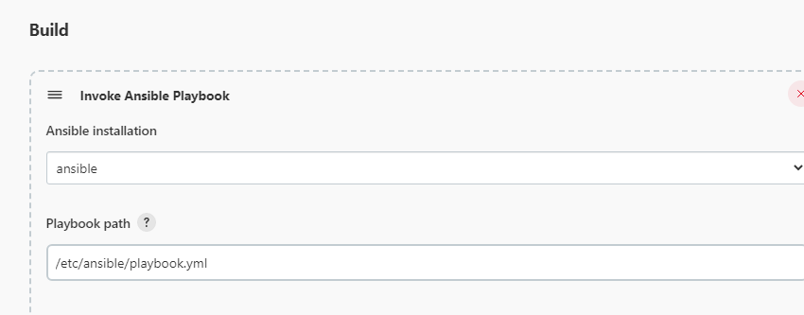

Playbook.yml file in /etc/ansible,

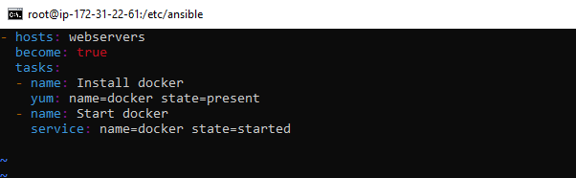

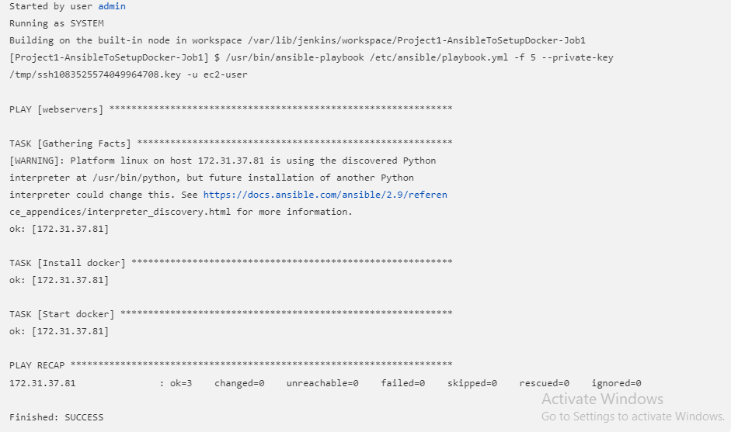

3.This Jenkins job will create the docker file to build and deploy the nginx docker container in the slave machine.

Also if this job fails, will delete the container created in slave machine.



* This project will be executed in slave machine and create the containers.

Restrict where this project can be run,

Label Expression: linux_slave

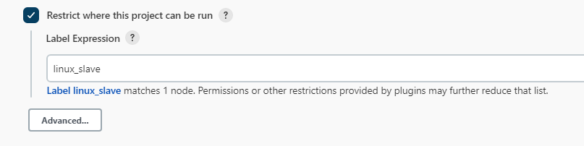

**Steps to add slave node in Jenkins**

============================

In Manage Jenkins 🡪 Manage nodes and clouds 🡪 set up a slave machine 🡪

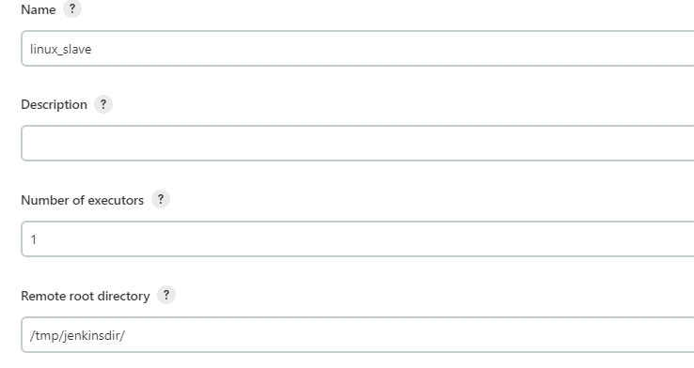

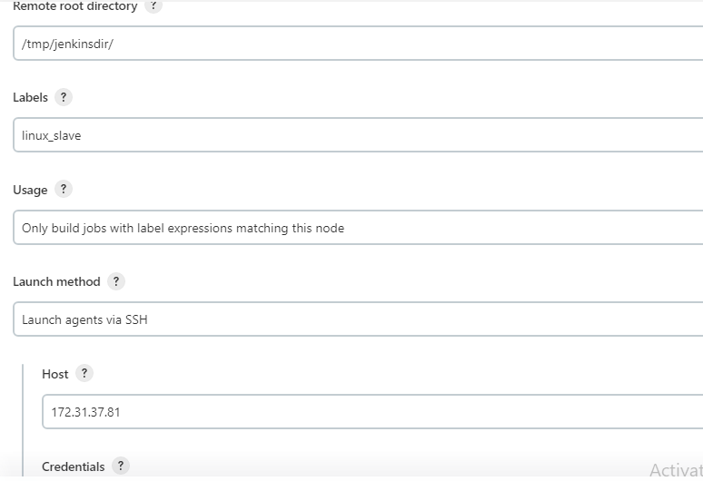

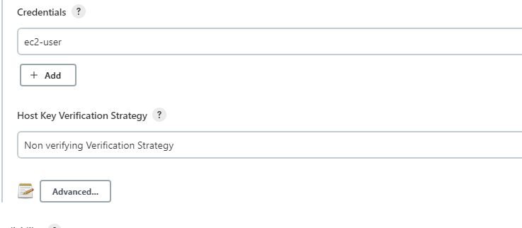

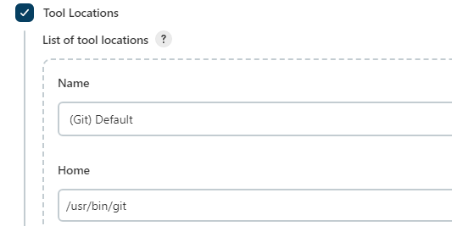

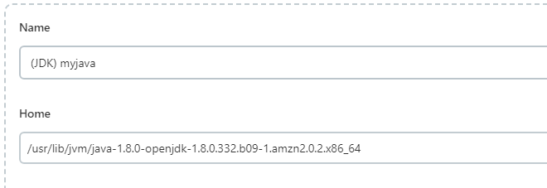

* This job will be triggered only when this job (**Project1-AnsibleToSetupDocker-Job1**) is stable.
* 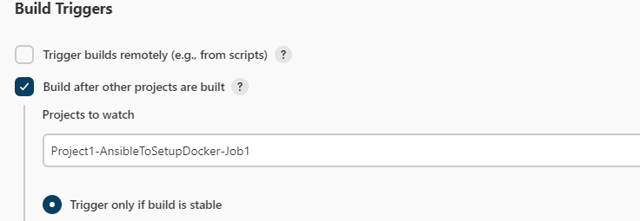

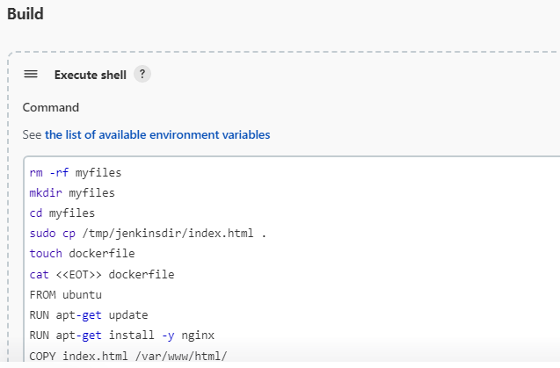

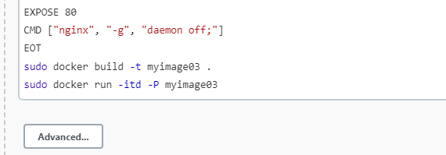



* Under Post build Actions tab, select post build tasks and mention Log text as failure.

If this job fails, then need to remove the running container.

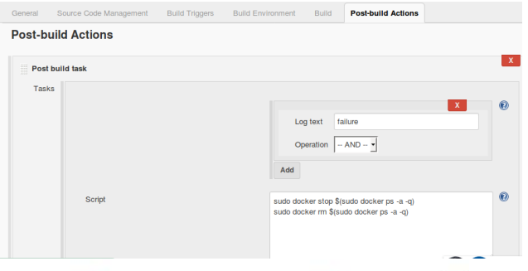

* Localhost:8383

