**CREATING MUSIC MAGIX COMPANY**

**LANDING PAGE**

**Name : Punyamanthula Bhavani**

**Email ID : bhavanipunyamanthula6@gmail.com**

**Phone No : 7842424507**

**Roll No : 2221310**

**College : PR Government College(A)**

**Source Code:**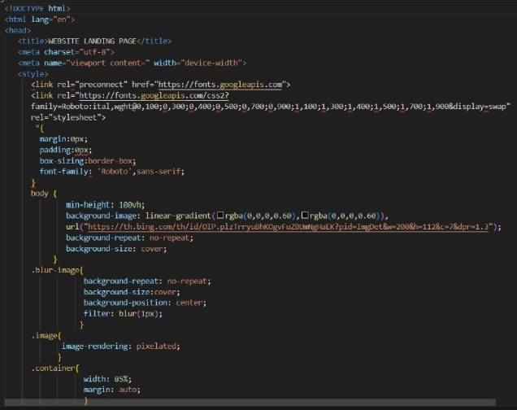

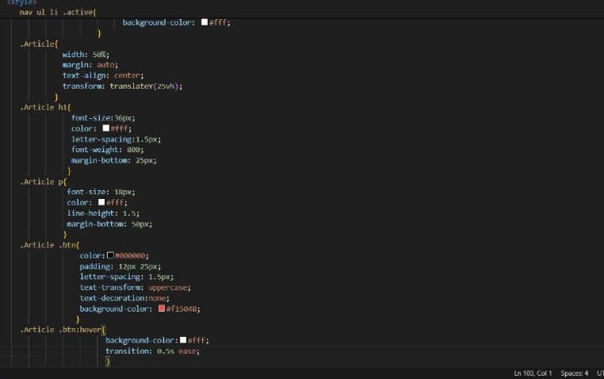

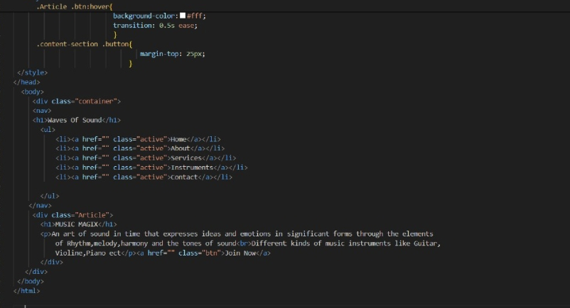

**Final Output:**

