Creating Card Components

and Button Components Using

React.JS

Name :Punyamanthula Bhavani

email :bhavanipunyamanthula@gmail.com Phone no : 7842424507

Roll No : 2221310

College Name : PR Government college (A )

source code :

CARD COMPONENT :

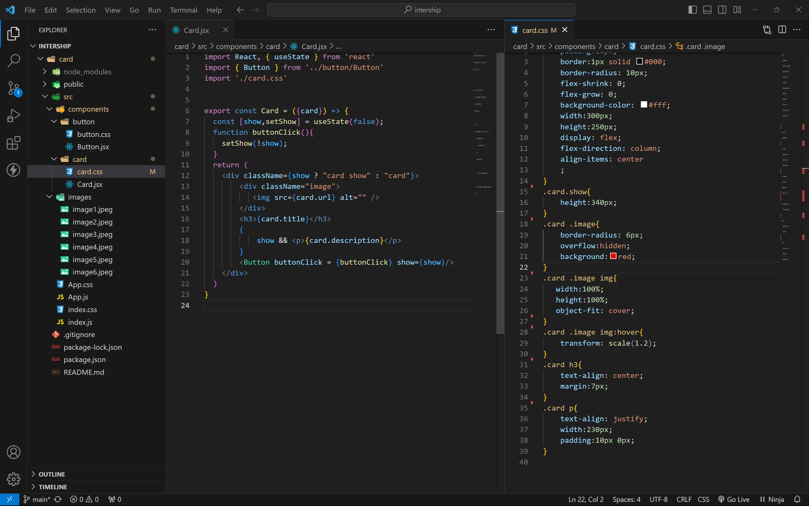

BUTTON COMPONENT :

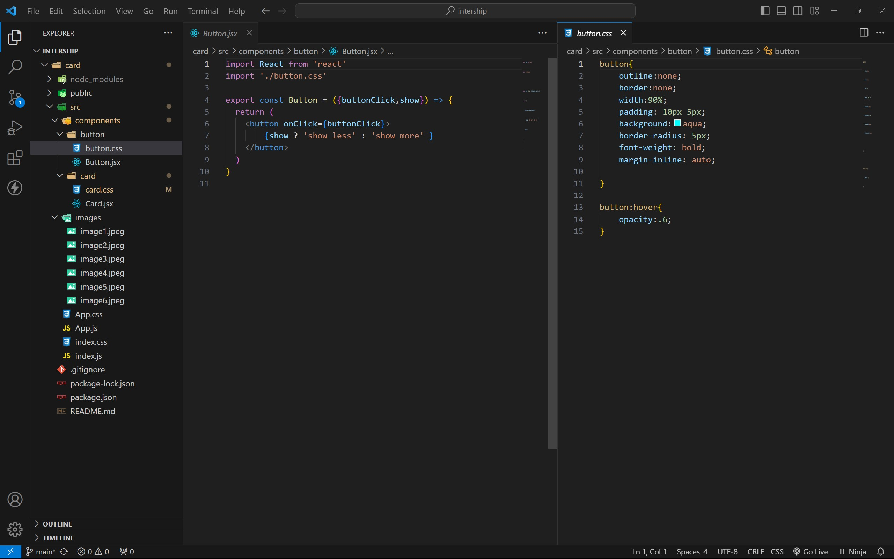

APP COMPONENT :

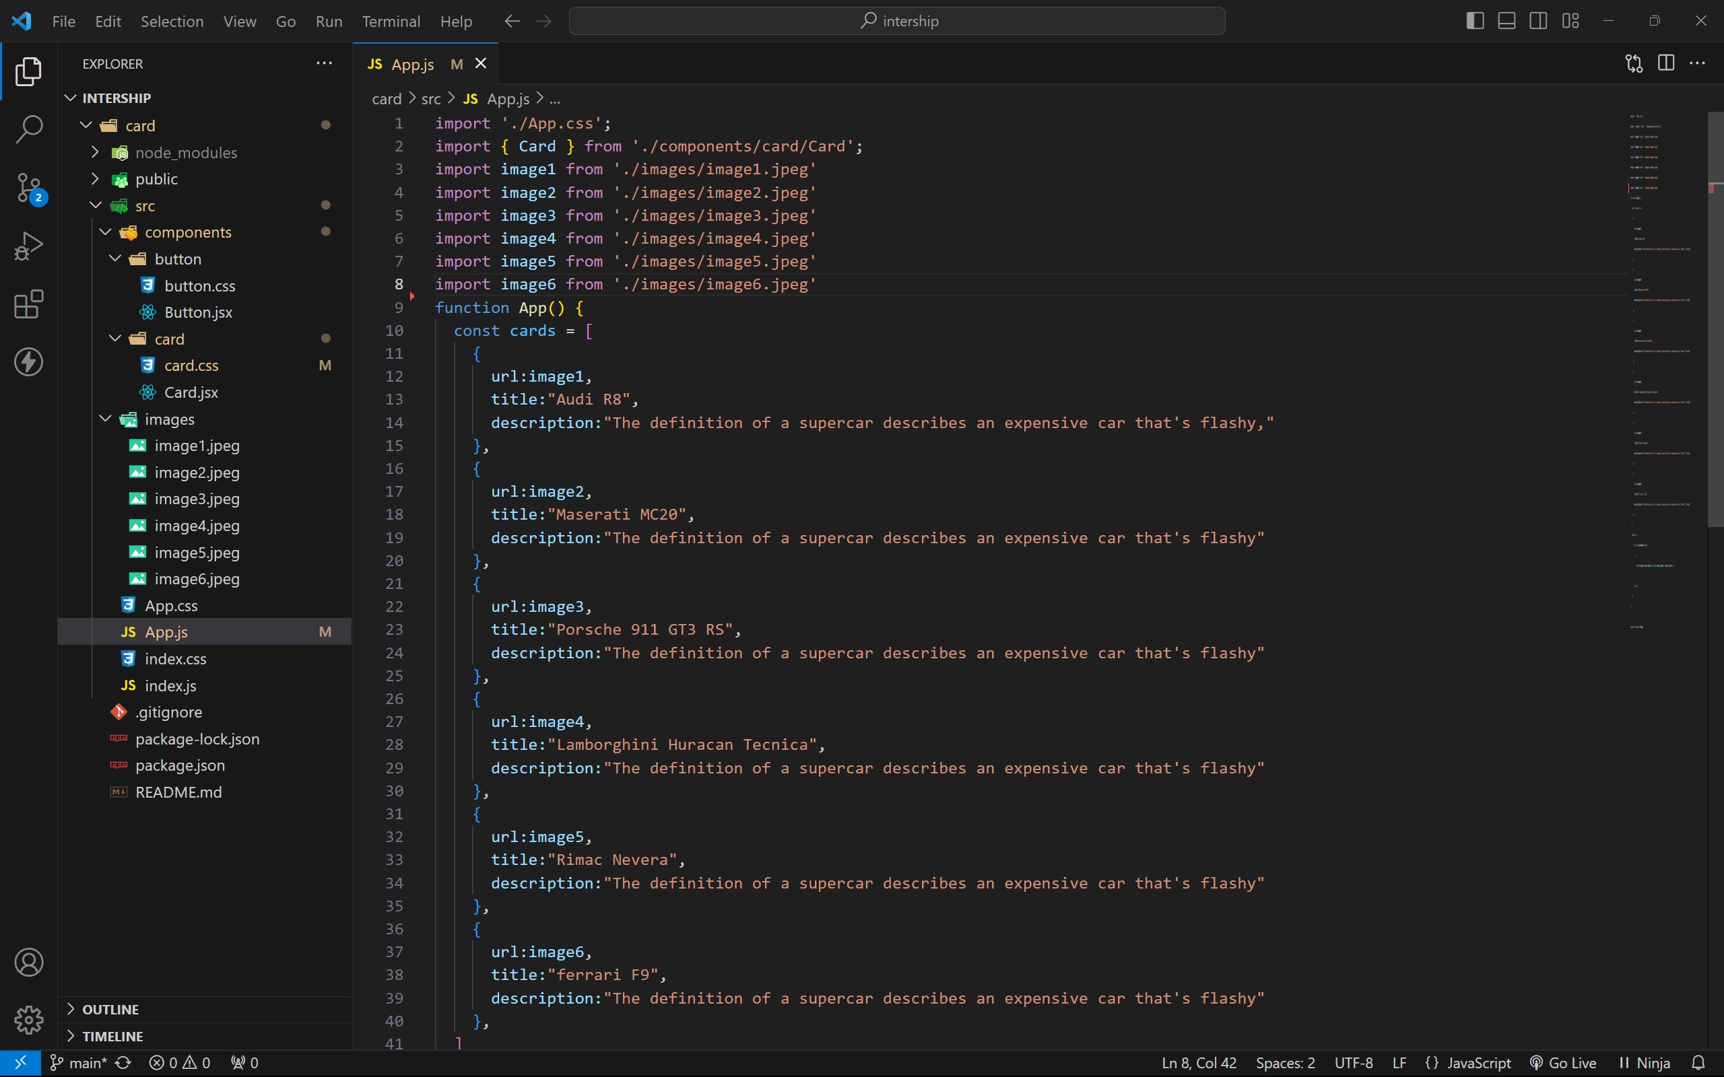

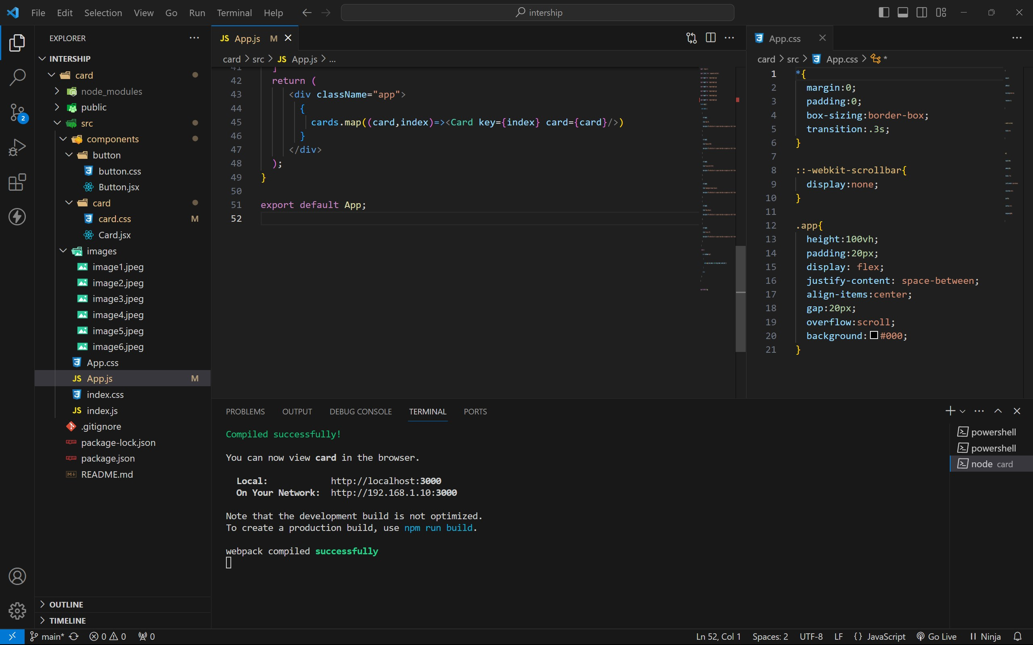

approach :

1. . initially taking an array of objects like below

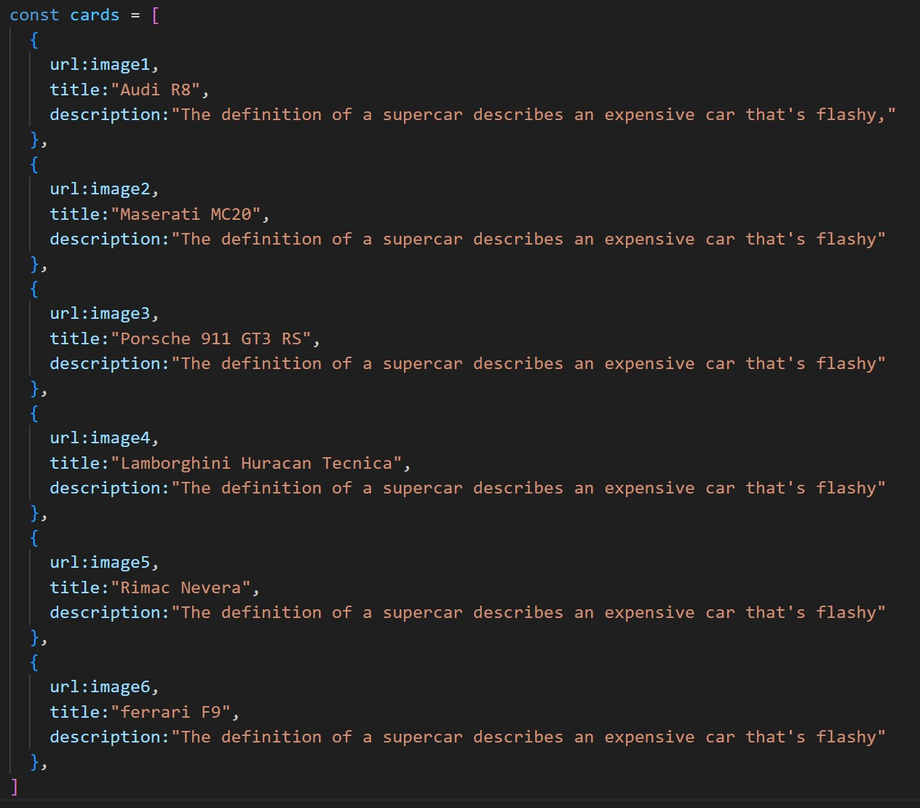

1. . Passing this card array to child (card component) of App component by using props;
2. . getting data as argument like {card} in card component.
3. . in card component i use one state [show, setShow] to get extra info as

description.

1. . When we click the button then show becomes true by assigning setShow (!show) .

OUTPUT :

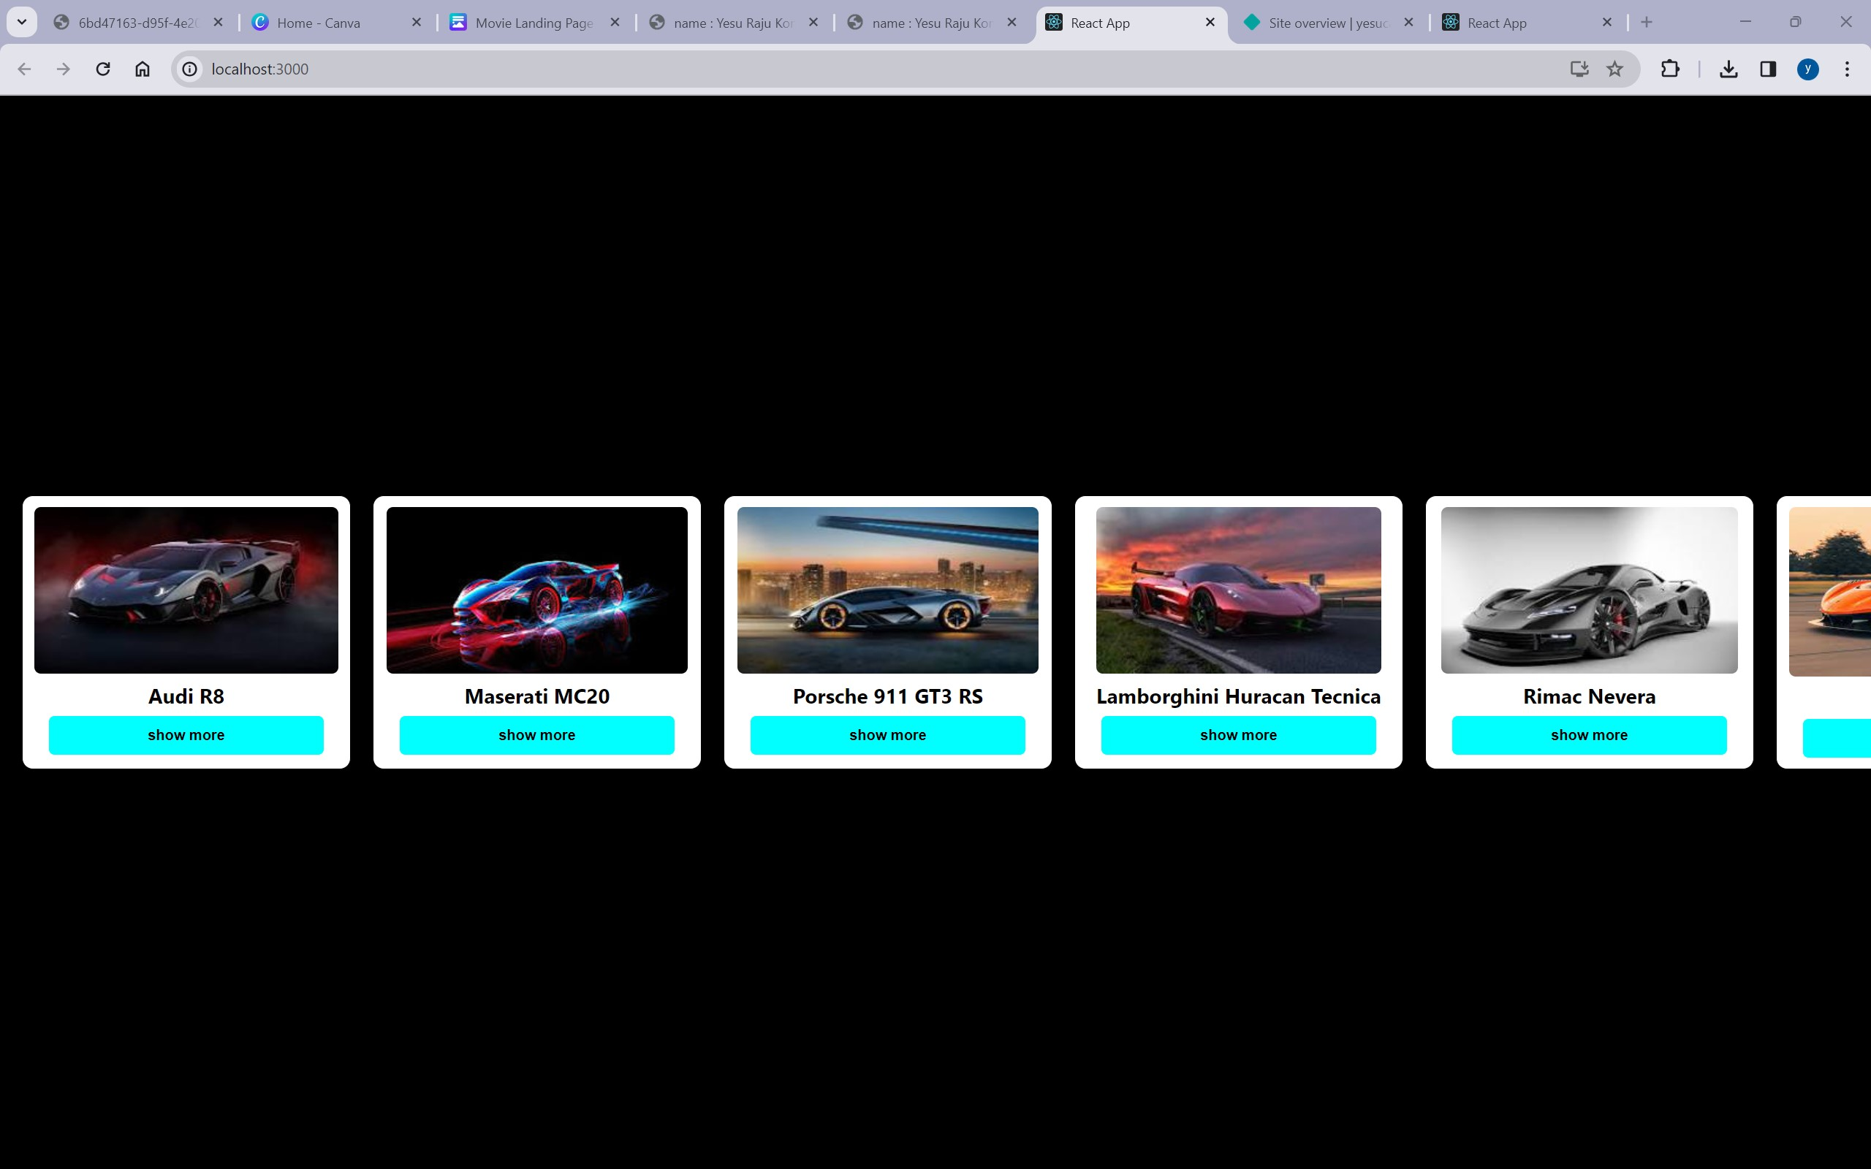

AFTER BUTTON CLICKS :

