**SolveNow-Project Report**

**1. INTRODUCTION**

**1.1 Project Overview**

SolveNow is a web-based complaint management system designed to streamline the process of lodging, tracking, and managing complaints in an organization. It provides a user-friendly interface for individuals to register their concerns and allows administrators to manage and track the resolution process effectively.

**1.2 Purpose**

* To digitalize and modernize the complaint registration and handling system
* To enable users to submit complaints easily and track them
* To assist organizations in resolving complaints efficiently
* To provide transparency and accountability in complaint management

**2. IDEATION PHASE**

**2.1 Problem Statement**

Many institutions still use manual processes (like paper forms or informal emails) to collect and handle complaints. This leads to:

* Lack of transparency
* No proper tracking mechanism
* Delayed responses
* Poor user experience

**2.2 Empathy Map Canvas**

**Think & Feel:**

* “Will my complaint be resolved?”
* “I feel ignored by the system.”

**Hear:**

* “Nothing ever changes, even after complaining.”

**See:**

* Physical registers, missing complaints, lack of acknowledgment.

**Say & Do:**

* Users are hesitant to report or follow up due to no feedback loop.

**Pain Points:**

* Delayed resolutions
* Unacknowledged complaints

**Gains:**

* Instant complaint logging
* Live status tracking

**2.3 Brainstorming**

After researching possible solutions, the team opted for:

* **React.js** – for building a responsive UI
* **Vite** – for fast build and development
* **Tailwind CSS** – for elegant UI design
* **Netlify** – for easy and efficient deployment

**3. REQUIREMENT ANALYSIS**

**3.1 Customer Journey Map**

1. User visits the SolveNow website
2. User fills out the complaint form
3. Form submission acknowledged
4. Complaint (in future) is routed to admin for action
5. User tracks complaint resolution status

**3.2 Solution Requirements**

* A simple and responsive complaint form
* Count or status indicators
* Deployment on a public URL

**3.3 Data Flow Diagram**

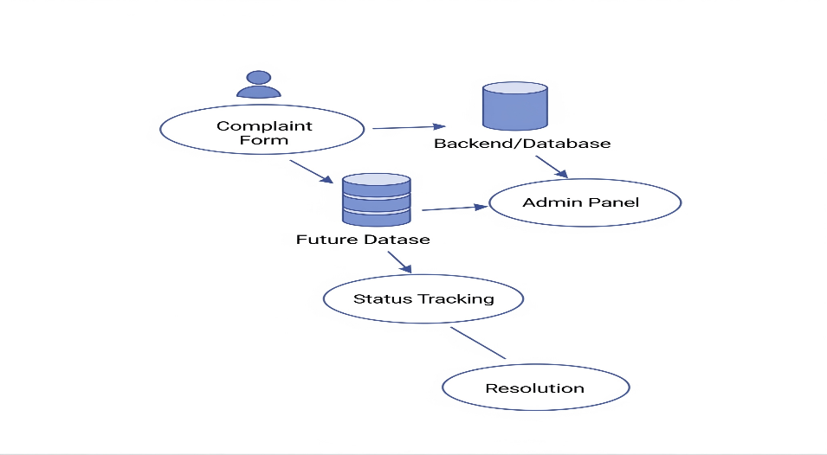

**3.4 Technology Stack**

* **Frontend**: React + TypeScript
* **Styling**: Tailwind CSS
* **Build Tool**: Vite
* **Hosting**: Netlify
* **Version Control**: GitHub

**4. PROJECT DESIGN**

**4.1 Problem-Solution Fit**

The application bridges the gap between users and organizations by providing a transparent and efficient way of registering and resolving complaints. It aims to solve real-world inefficiencies using modern web technologies.

**4.2 Proposed Solution**

A web-based solution that:

* Works across devices
* Is easy to use for all users
* Loads fast and supports future scalability
* Can later be extended to include a full backend and admin module

**4.3 Solution Architecture**

* **Component-Based UI** (React)
* **Tailwind for modular styling**
* **Static assets built using Vite**
* **Deployed using Netlify**

**5. PROJECT PLANNING & SCHEDULING**

| **Week** | **Task** |
| --- | --- |
| 1 | Project idea finalization, research |
| 2 | Initial setup with React & Vite |
| 3 | UI design using Tailwind CSS |
| 4 | Final testing and Netlify deployment |

**6. FUNCTIONAL AND PERFORMANCE TESTING**

**6.1 Performance Testing**

* **Load Time**: Sub-second page load on modern browsers
* **Responsive Layout**: Tested on mobile, tablet, and desktop
* **Interaction**: Button clicks and dynamic counters work smoothly
* **Deployment**: Live deployment without server setup (via Netlify)

**7. RESULTS**

**7.1 Output Screenshots**

* Landing page with Vite and React branding
* Interactive counter (count is X) demonstrates reactivity
* Hosted at: <https://solvenowbybhavaniraju.netlify.app>

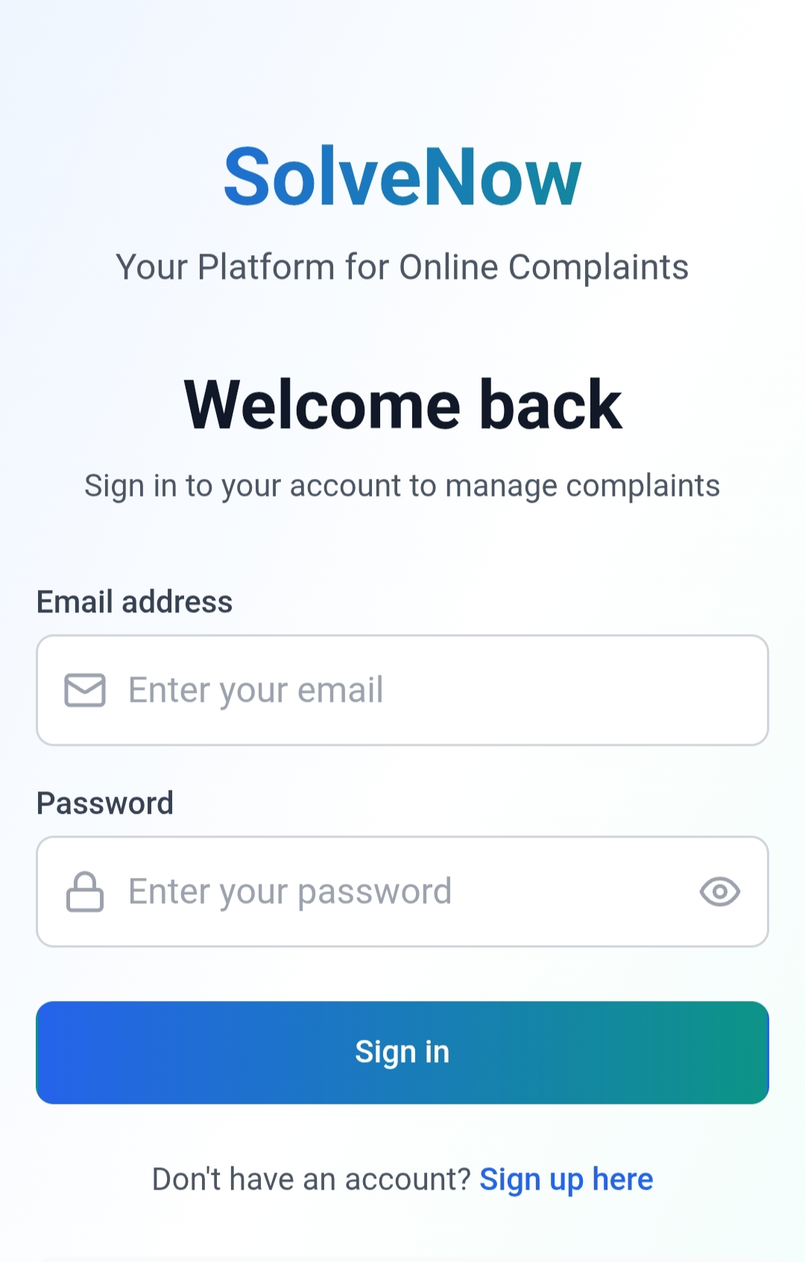

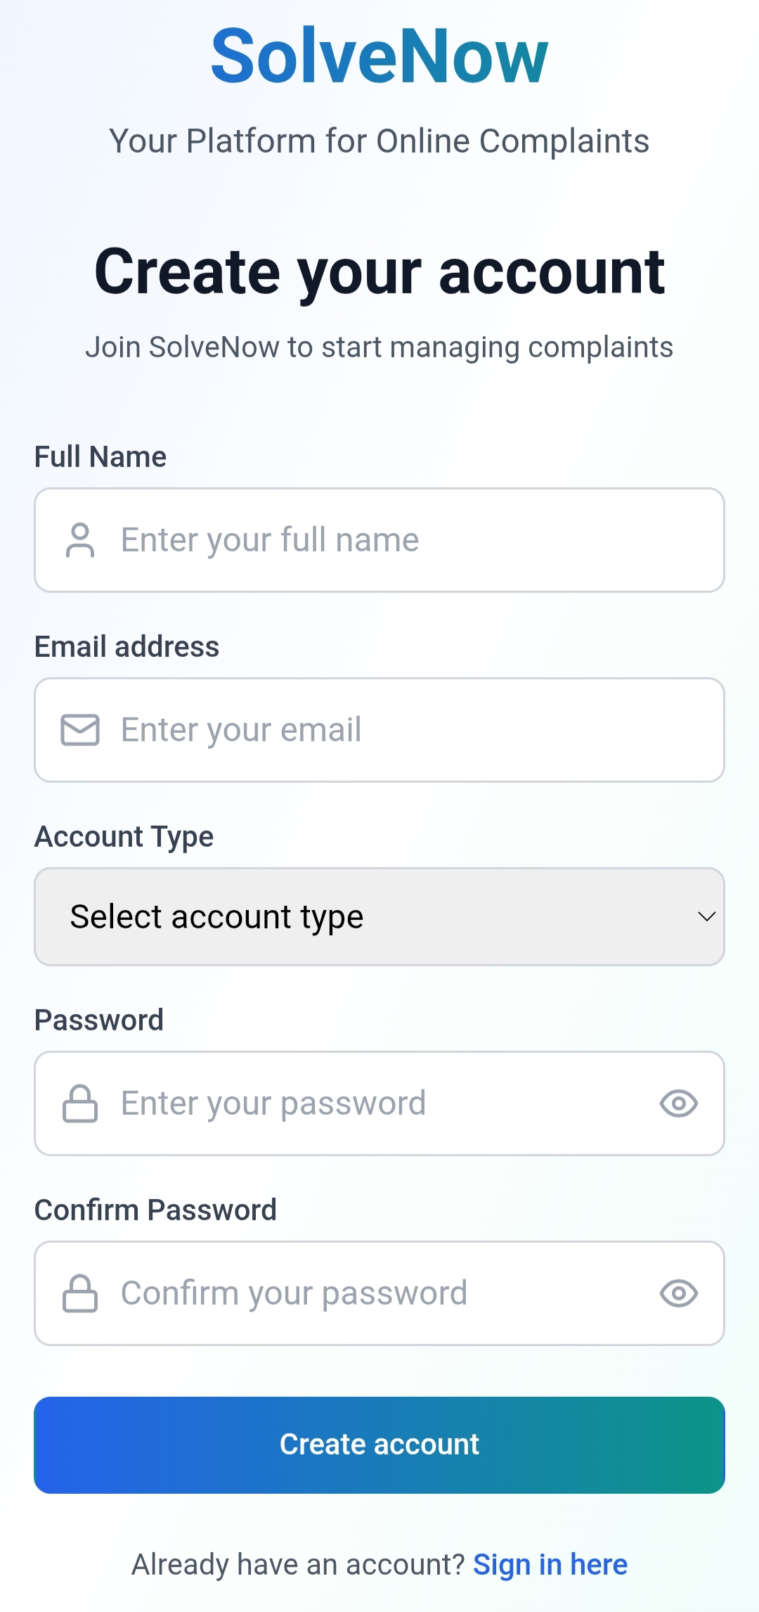

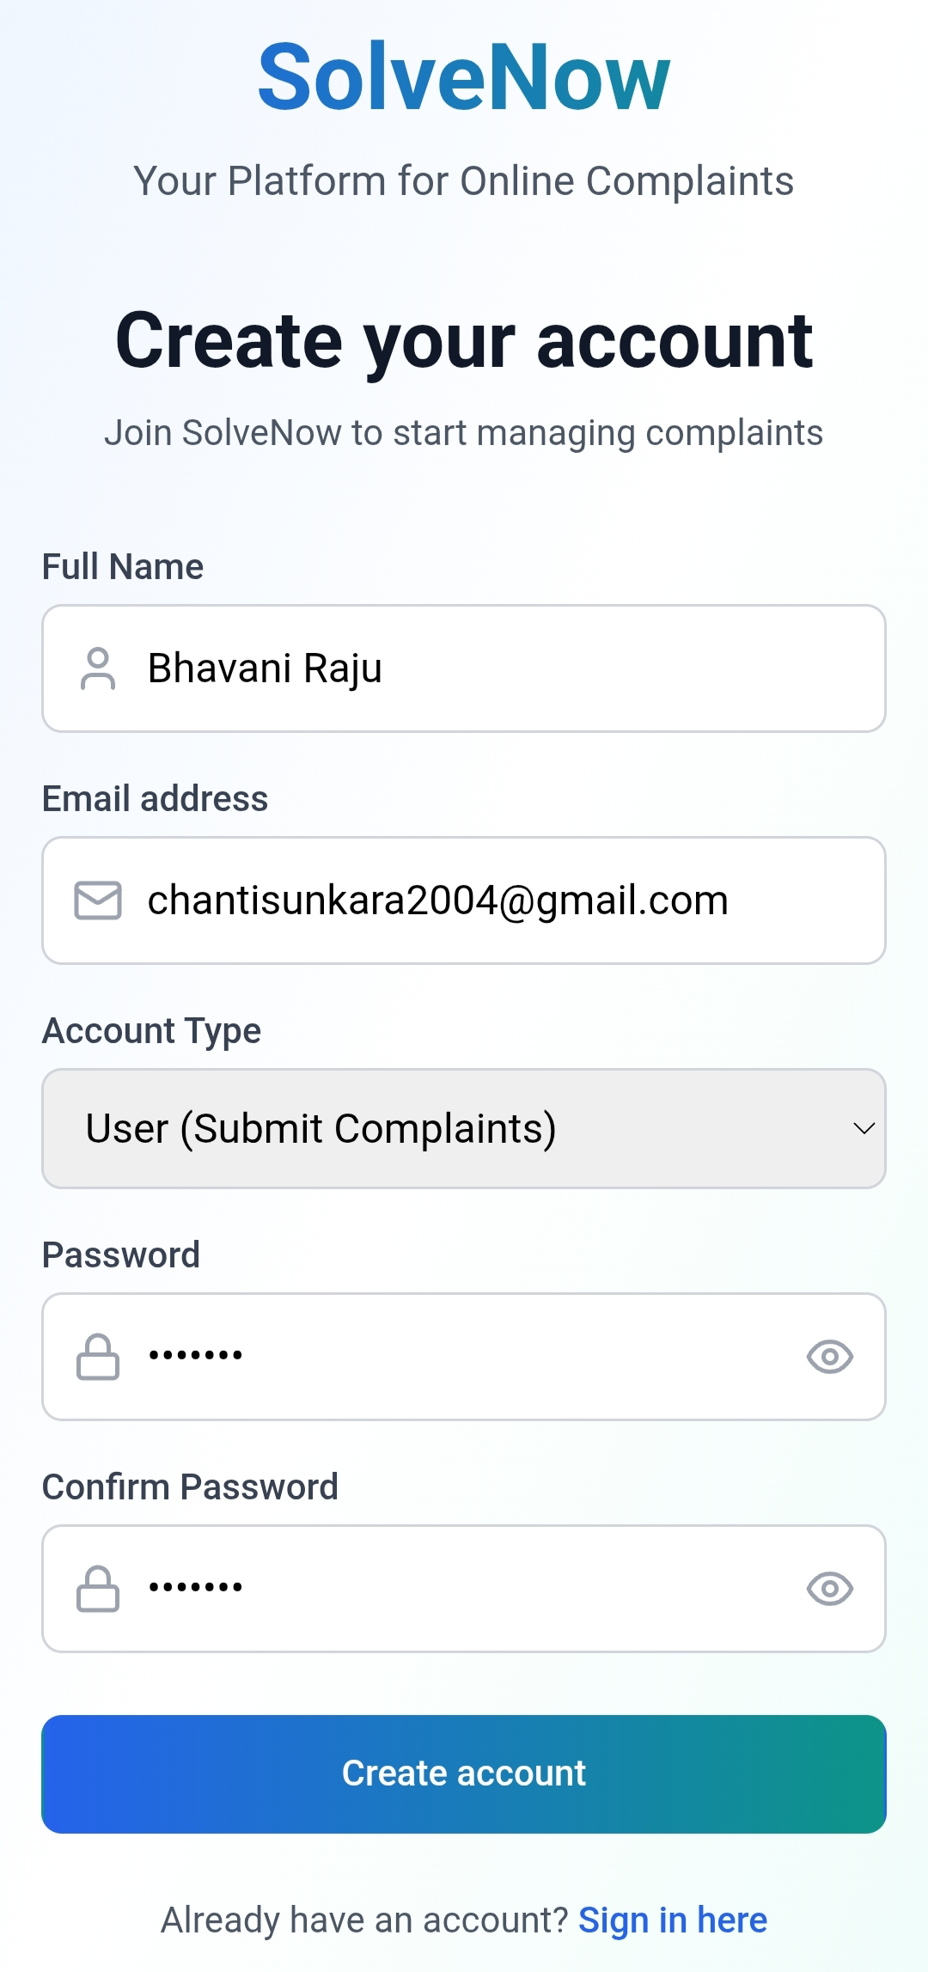

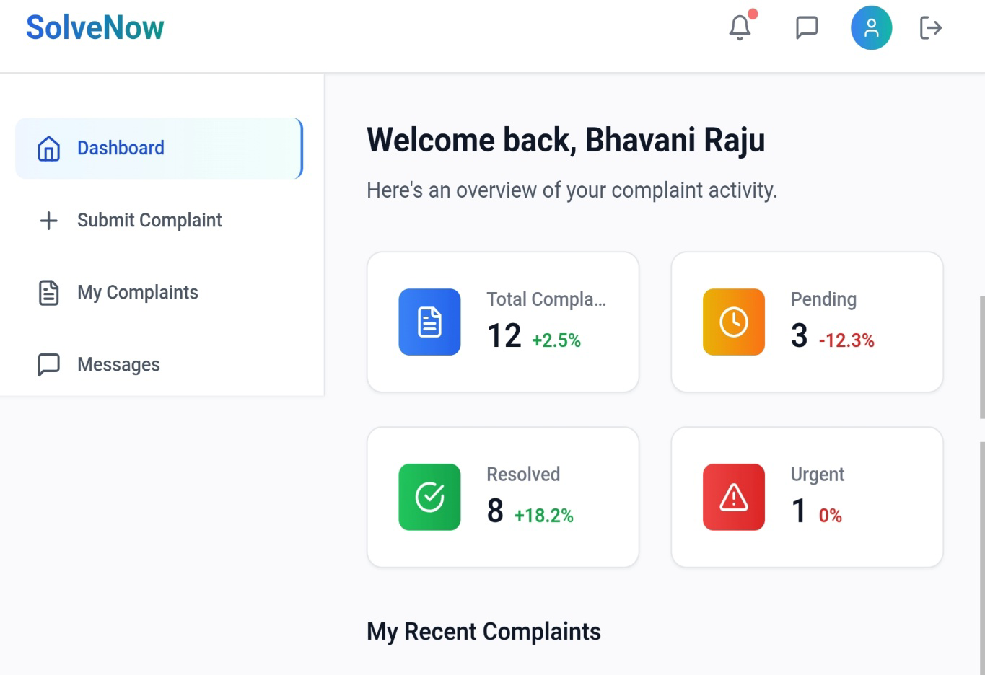

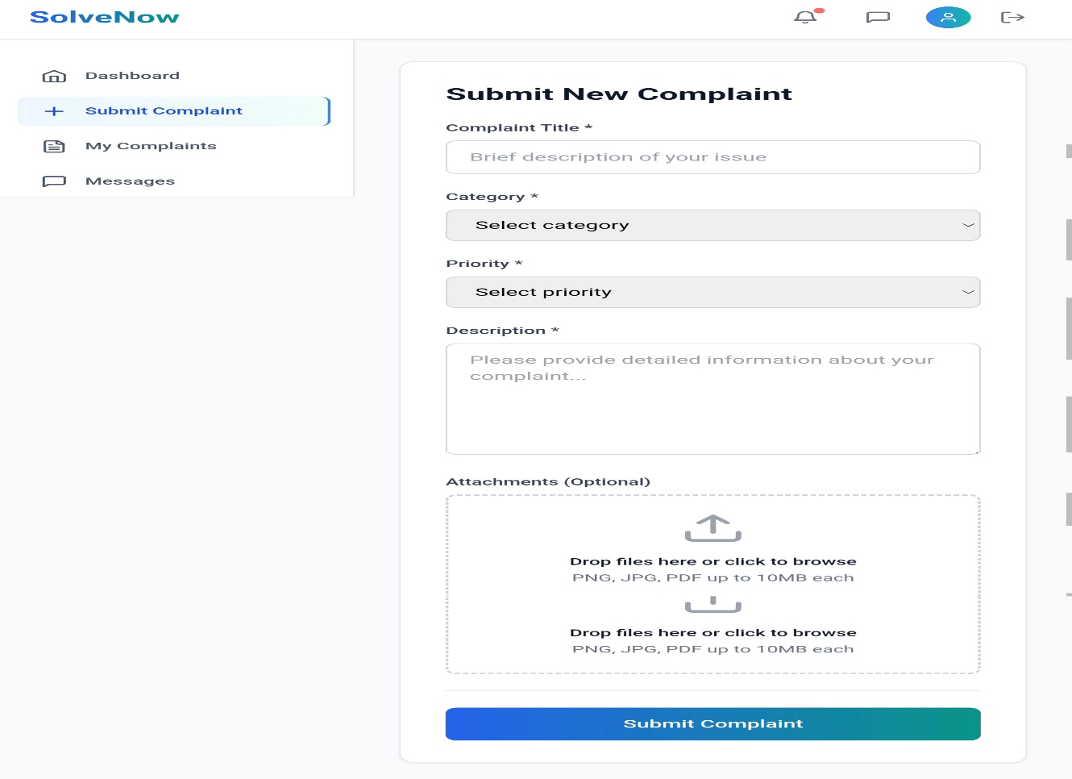

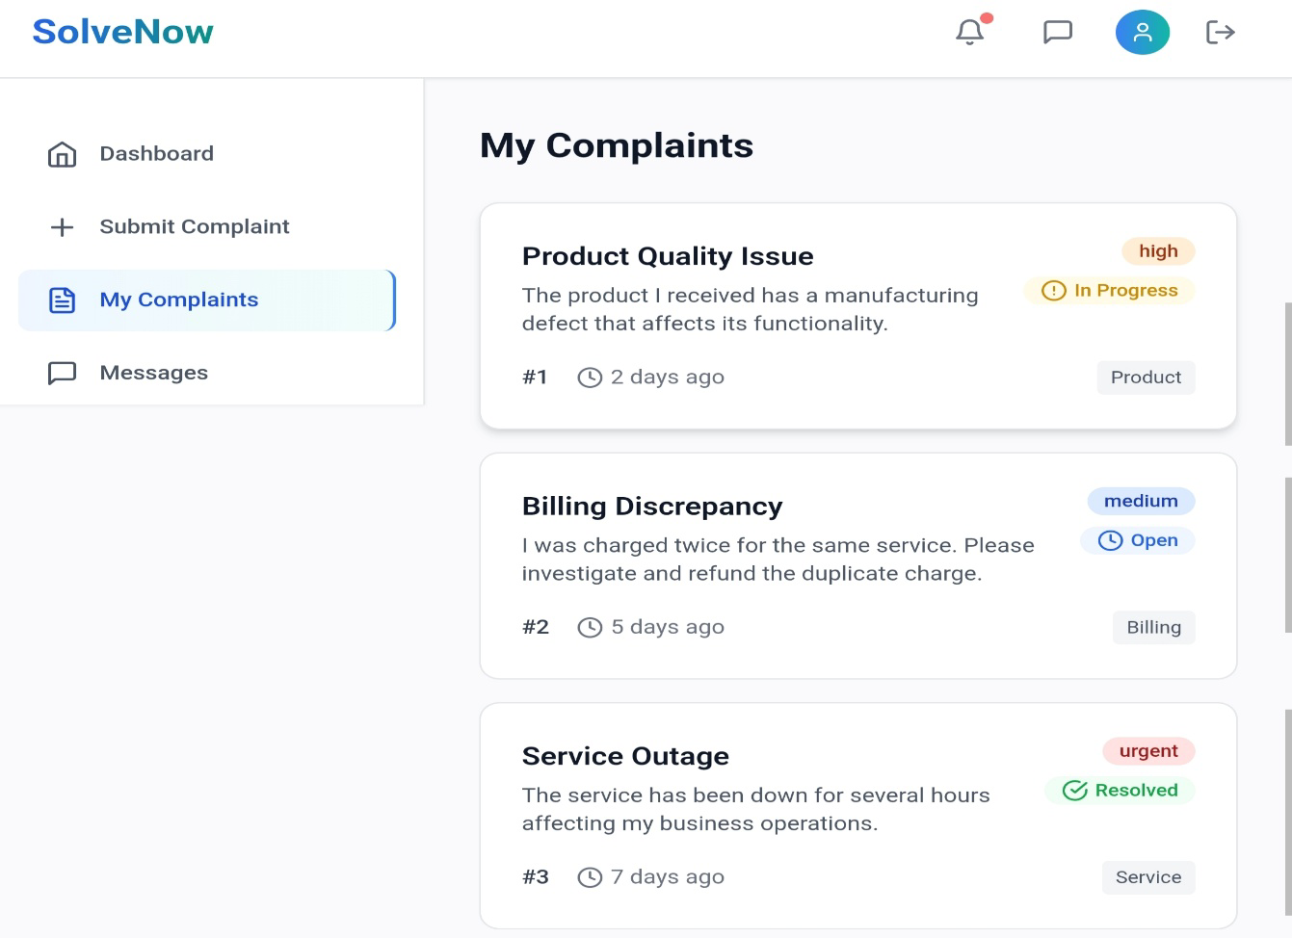

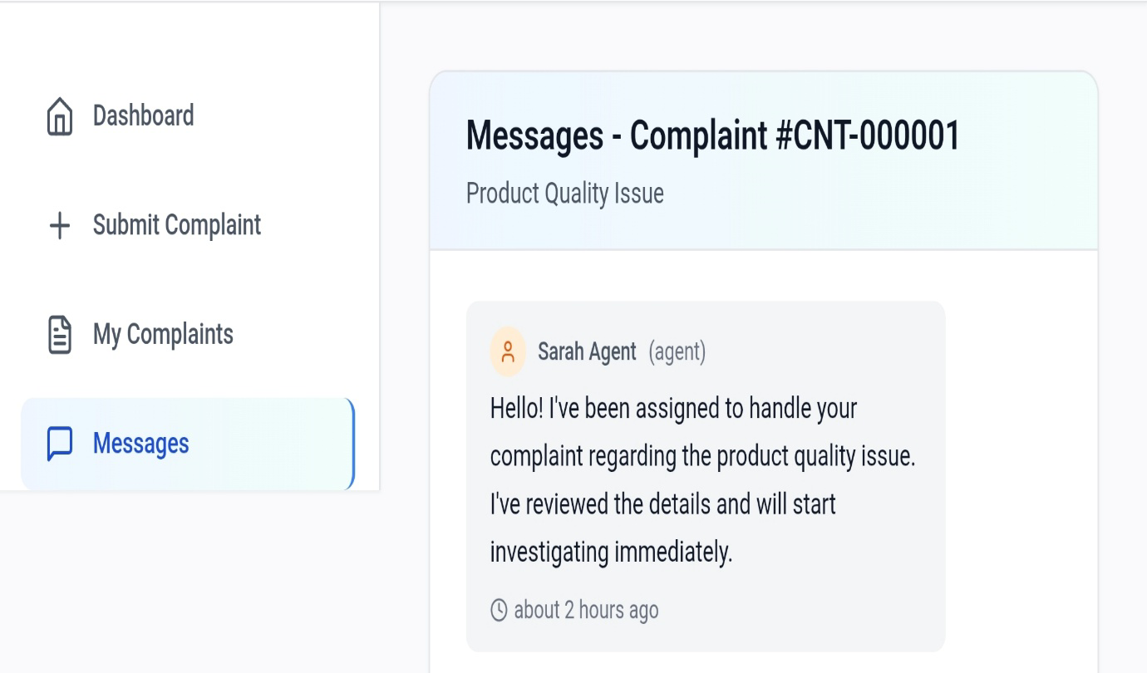

**8. ADVANTAGES & DISADVANTAGES**

**Advantages:**

* Easy to use and lightweight
* No backend required for MVP
* Fast development and deployment
* Clean and modern UI
* Can be extended with admin dashboard and database

**Disadvantages:**

* No real-time backend connection
* Complaints are not stored persistently (in MVP)

**9. CONCLUSION**

SolveNow demonstrates how a simple complaint management system can be implemented using modern frontend tools. Though it's currently a front-end-only solution, it sets the foundation for a full-stack scalable product in the future.

**10. FUTURE SCOPE**

* Add authentication for users and admins
* Store complaints in a backend database
* Admin dashboard with complaint status management
* Email notifications for updates and responses
* Analytics for complaint trends and resolution rates

**11. APPENDIX**

* **Source Code Repository**:  
  <https://github.com/Bhavaniraju15/Internship_project.git>
* **Live Demo**:  
  <https://solvenowbybhavaniraju.netlify.app>