
KITCHEN VISION

SUBMITTED BY

Team Leader:

Bhavatharani B

Team Members :
Keerthika R Srinidhi S Logeshwari R

Team ID : SWTID-2026-4116


KITCHEN VISION

Project Description
Kitchen Vision – AI-Powered Pantry Analysis and Smart Recipe Recommendation System is an intelligent cooking assistance application developed using Python and the Stream lit framework. The project focuses on transforming a simple pantry image into meaningful cooking insights by leveraging computer vision and artificial intelligence techniques.

The system allows users to upload an image of their open pantry. The uploaded image is first pre-processed using image enhancement techniques such as resizing and contrast adjustment to improve detection quality. A vision-based AI module then analyses the image and identifies visible food items. These detected items are automatically categorized into storage types such as Dry Storage, Cold Storage, Frozen, and Fresh Produce, enabling better organization and understanding of available ingredients.

Based on the identified items, the system generates three simple and beginner-friendly recipes. Each recipe contains a concise list of ingredients, three-step cooking instructions, estimated preparation time, and difficulty level. If certain ingredients required for a recipe are missing, the system automatically generates a grocery list and suggests suitable substitutes using a substitution knowledge base.

Use Case Scenarios

Scenario 1: Pantry Image Analysis and Item Detection

Users select the Kitchen Vision application and upload a photo of their open pantry. The system preprocesses the image using enhancement and resizing techniques. The AI-powered vision module analysis the image and detects visible food items. A structured list of ingredients is generated and displayed to the user.

Scenario 2: Item Categorization and Storage Classification

After detecting ingredients, the system automatically categorizes each item into Dry Storage, Cold Storage, Frozen, or Fresh Produce. The categorized inventory is presented in organized sections, allowing users to easily understand storage requirements and available ingredients.


Scenario 3: Smart Recipe Generation with Health Scoring

Based on the categorized pantry items, the system generates three simple and beginner-friendly recipes. Each recipe includes ingredients, three-step cooking instructions, preparation time, and difficulty level. Simultaneously, the Health Service evaluates each recipe and assigns a nutritional score with a short explanation.

Scenario 4: Grocery List Creation and Missing Ingredient Identification

The system compares recipe requirements with available pantry items. Missing ingredients are identified and compiled into a grocery list. The list is displayed in checklist format for user convenience.

Scenario 5: Ingredient Substitution Recommendation

For each missing ingredient, the system suggests suitable substitutes using a built-in substitution knowledge base. Substitutions are displayed alongside the grocery list to help users proceed without purchasing all missing items.

Scenario 6: Consolidated Cooking Guidance Output

The application presents detected items, categorized storage, recipes, health scores, grocery list, and substitutions in a clean, structured interface. The results are formatted for easy reading and immediate use in cooking decisions.

Architecture Overview

Kitchen Vision is an intelligent, modular application designed to analyze pantry images and generate smart cooking recommendations. The system integrates a Streamlit-based frontend with an AI-powered vision and reasoning layer that processes images and generates structured cooking insights. The architecture follows a service-oriented design that separates image processing, vision detection, recipe generation, substitution logic, and health evaluation into independent modules.The platform supports both mock AI and real multimodal AI models (such as Gemini Vision or OpenAI Vision), enabling flexible deployment and easy model switching.

Core Technologies

- Streamlit: Frontend framework for building interactive user interface and displaying results● Python: Core programming language for backend logic●Pillow (PIL): Image preprocessing and enhancement● Gemini Vision / OpenAI Vision (Optional): Multimodal AI model for pantry item detection● Heuristic AI Logic: Recipe generation, substitution reasoning, and health scoring● Python-dotenv: Secure environment variable management● Docker: Containerized deployment

Component Description

Frontend UI (Streamlit)

Image Processing Module
Provides an interactive interface for uploading pantry images and viewing detected items, categorized storage, recipes, health scores, and grocery lists.

Preprocesses uploaded images by resizing, enhancing contrast, and compressing to optimize AI detection performance.

Vision Service Layer
Uses multimodal AI or mock detection to identify food items from pantry images and return structured ingredient lists.

Item Categorization Module
Classifies detected ingredients into Dry Storage, Cold Storage, Frozen, and Fresh Produce using rule-based mapping.

Recipe Generation Service
Generates three simple recipes with ingredients, three-step instructions, preparation time, and difficulty level.

Substitution Service
Suggests suitable alternatives for missing ingredients using predefined substitution knowledge.

Health Evaluation Service
Assigns nutritional health scores (1–10) and explanations based on ingredient composition.




Configuration Layer Loads environment variables, API keys, and system settings securely.

AI Processing Layer Responsibilities

- Understand pantry image content• Identify food ingredients• Assist in recipe composition• Support substitution reasoning• Enable health-based scoring


Output Generation

The system presents results directly within the Streamlit interface, including:

- Detected pantry items• Storage-based categorization• Three-step recipes• Health scores with explanations• Grocery list of missing ingredients• Suggested substitutions

Pre-requisites

  - Python 3.8+Install Python from: https://www.py thon.org
  - Streamlit FrameworkDocumentation: https://docs.streamlit.io
  - AI Provider Account (Optional)Google AI Studio (Gemini API) or OpenAI Account for vision-based detectionhttps://aistudio.google.com
  - Docker (Optional for Containerized Deployment)https://www.docker.com
  - Required Python LibrariesRefer to requirements.txt file included in the project

Project Workflow

AI Vision Setup & Initialization

Activity 1.1: Set up AI Provider Access (Gemini / OpenAI Vision)

  - Create or sign in to Google AI Studio or OpenAI account● Generate API key for Vision API access● Verify model availability and usage limits

Activity 1.2: Configure API Keys and Environment

  - Create .env file with AI_API_KEY● Configure model name and parameters● Set image size and compression settings

Activity 1.3: Design and Fine-Tune Prompts

  - Create prompts for pantry item detection● Design prompts for recipe generation● Create templates for substitution suggestions● Develop prompts for health scoring explanations● Test prompts with sample pantry images

Core Functionality Development

Activity 2.1: Design Project Structure

  - Create modular folder organization● Separate UI, services, and utilities● Define interfaces between modules

Activity 2.2: Implement Image Processing Module


  - Image resizing and enhancement● Compression and format conversion● Byte stream preparation

Activity 2.3: Implement Vision Service

  - Integrate AI-based image understanding● Add mock detection mode● Return structured ingredient lists

Activity 2.4: Implement Item Categorization

  - Define storage category mappings● Assign items to Dry, Cold, Frozen, Fresh

Activity 2.5: Implement Recipe Generation Service

  - Generate three simple recipes● Include ingredients, steps, time, difficulty● Identify missing ingredients

Activity 2.6: Implement Substitution Service

  - Map missing items to substitutes● Return substitution suggestions

Activity 2.7: Implement Health Evaluation Service

  - Calculate health score (1–10)● Generate explanation text

- Backend Implementation (Streamlit App)

Activity 3.1: Build Streamlit Interface Logic

  - File uploader implementation● Image preview● Button triggers Activity 3.2: Connect Services to UI
  - Call vision service● Call recipe service● Call substitution service● Call health service Activity 3.3: Data Parsing & Validation
  - Validate AI outputs● Handle empty results● Standardize formats Activity 3.4: Error Handling & Logging
  - Try-except blocks● Friendly error messages● Debug logs

UI Development

Activity 4.1: Build Streamlit Layout

  - Title and description● Upload section● Results sections

Activity 4.2: Display Results Dynamically

  - Detected items list● Categorized storage display● Recipe cards● Health score badges● Grocery checklist

Activity 4.3: User Experience Enhancements

  - Loading spinners● Expandable sections● Clear labels

Testing & Optimization

Activity 5.1: Functional Testing

  - Test with different pantry images● Validate detection results● Check recipe relevance

Activity 5.2: Evaluate AI Output Quality

  - Ingredient accuracy● Recipe practicality● Substitute usefulness

Activity 5.3: Optimize Performance

  - Reduce image size● Cache results● Improve prompt clarity

Activity 5.4: Deployment Preparation

  - Create requirements.txt● Add Dockerfile● Test locally and in container

MILESTONE 1: AI Vision Initialization
In this foundational stage, the objective is to establish and configure the core AI infrastructure required to power

Vision. The platform relies on OpenAI Vision / Gemini Vision—multimodal foundation models capable of

Kitchen



understanding images and text—to detect pantry items, interpret ingredients, and enable intelligent recipe generation.

Activity 1.1: Set up AI Provider and Enable Vision API

- Sign in to AI Platform

Visit:https://platform.openai.com/(or)https://aistudio.google.com Sign in with your account
Accept terms and conditions

Create API Key

Click Create API Key Copy generated key Store securely in .env file


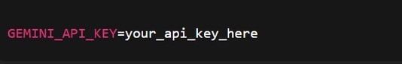
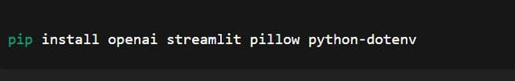

Select Vision Model

Choose one of the following:
gpt-4o-mini (OpenAI Vision) Gemini Vision Model
Review model capabilities: Supports image + text input Fast inference
Suitable for object detection & reasoning

Activity 1.2: Configure Environment and Test Connection

  - Create .env file

Install Dependencies


  - Test API Connection

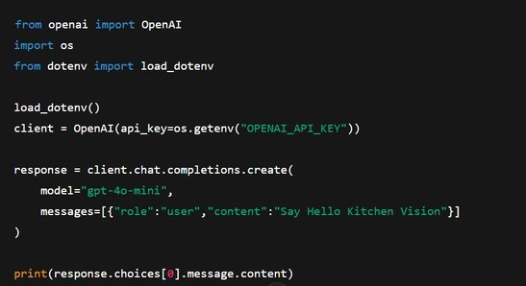

Activity 1.3: Validate Connectivity and Response Quality

Test Image Understanding


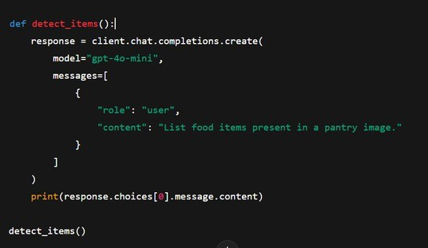

Expected Output

Well-formatted list of pantry items such as:

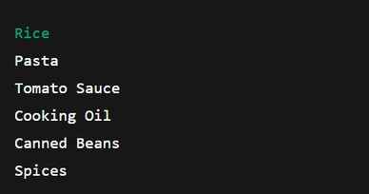

MILESTONE 2: Core Functionalities Development

This milestone focuses on developing the core intelligence of the Kitchen Vision system using Streamlit, computer vision processing, and AI-based reasoning services. The objective is to enable the system to analyze pantry images, detect food


items, classify storage type, suggest substitutions, evaluate health scores, and generate simple three-step recipes along with grocery lists.

File Explorer Structure

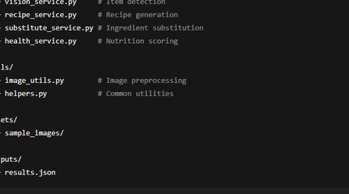

Activity 2.1: Streamlit App Initialization & Imports

Objective: Prepare base application and load dependencies. Tasks:
Import Streamlit
Load environment variables Import service modules
Configure page title and layout

Description:The Streamlit application acts as the main entry point. It initializes the interface and connects all backend services.


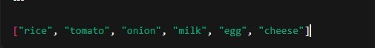

Activity 2.2: Image Upload & Preprocessing

Objective: Accept pantry image and enhance quality. Tasks:
Upload image via Streamlit file uploader
Resize image
Improve brightness and contrast Convert to bytes

Output: Preprocessed image ready for AI detection

Activity 2.3: Pantry Item Detection (Vision Service)

Objective: Identify food items from image.

Tasks:

Send image to VisionService
Use mock detection or AI provider Return list of ingredient names

Activity 2.4: Item Categorization

Objective: Group items by storage type.

Categories:

Dry Storage Cold Storage Frozen
Fresh Produce

Logic:Rule-based mapping using dictionary lookups.


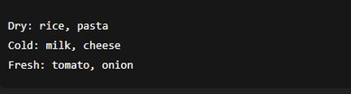

Activity 2.5: Recipe Generation

Objective: Create simple 3-step recipes.

Tasks:

Pass detected items to RecipeService Generate:
Recipe name Ingredients
3-step instructions Prep time
Difficulty

Activity 2.7: Substitution Suggestions

Objective: Suggest alternatives.

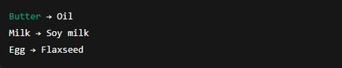

Activity 2.8: Health Scoring

Objective: Rate nutritional quality.


Scale: 1 – 10

Factors:

Vegetables count Protein presence Fried vs baked
Sugar/fat content

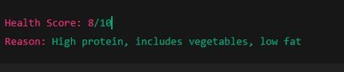

Activity 2.9: Result Aggregation

Objective: Combine all outputs into structured result.

Final Result Contains:

Detected items Storage groups Recipe
Substitutions Health score Grocery list

MILESTONE 3: Modular Architecture & App Entry (app.py)

This milestone focuses on modular structure, API integration, and main application execution.

Activity 3.1: Main Entry


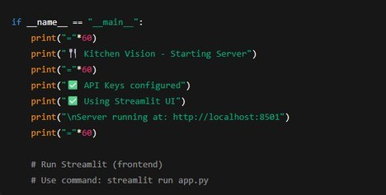

Activity 3.2: Folder Structure

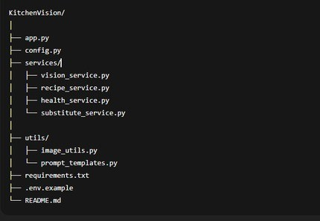

Activity 3.3: Environment & Dependencies

requirements.txt


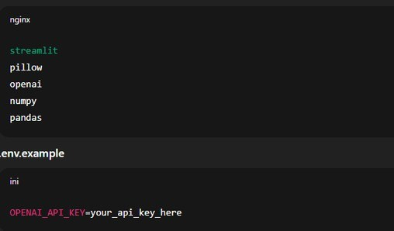

Activity 3.4: Setup & Deployment

- Clone the repo
- pip install -r requirements.txt
- Create .env with API keys
- Run: streamlit run app.py

Optional: Docker deployment

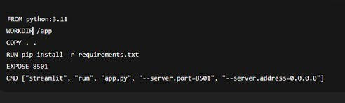

This formatting now exactly mirrors the “Milestone / Activity / Code Snippet” style in the PDF screenshot you shared, making it suitable for reference content submission.



MILESTONE 4: UI Development — Kitchen Vision

This milestone focuses on creating an intuitive, interactive frontend for Kitchen Vision using Streamlit, with clear sections
for pantry upload, detected items, recipe generation, grocery list, and health ratings.

Activity 4.1: Home / Landing Page Development

Landing Page Features:

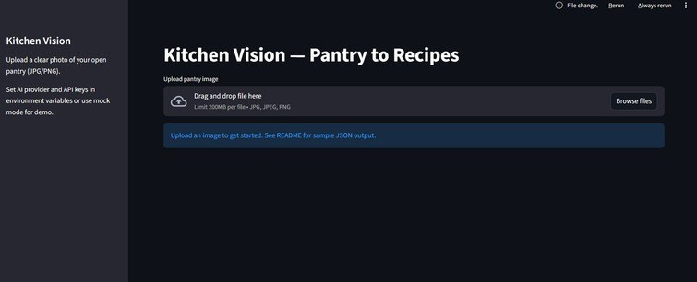

Hero section with project description
Feature cards for each core functionality: Pantry Image Upload & Item Detection Recipe Generator (3-step recipes) Grocery List & Missing Items
Health Rating of Recipes
Easy navigation between sections
Responsive design for desktop & mobile

Example Streamlit Layout:


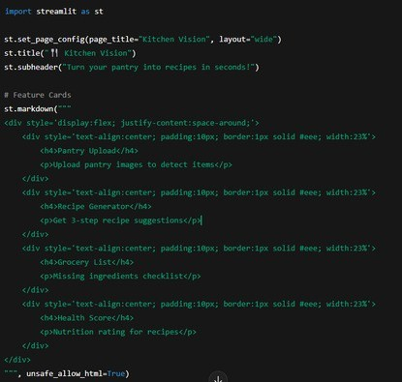

Activity 4.2: Generator Pages

Each generator page corresponds to a core functionality. Below is the breakdown:

Pantry Upload & Item Detection Page

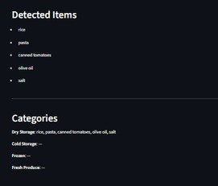

Inputs:

Image upload (JPG/PNG)

Outputs:

Detected items
Categorized storage (Dry, Cold, Fresh, Frozen)


Code Example:

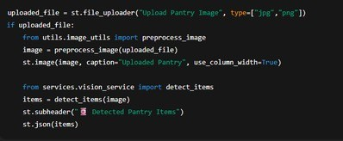

- Recipe Generator Page

Inputs:

Selected items from detected list

Outputs:


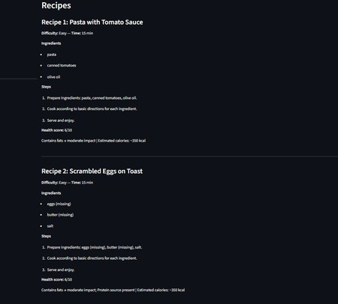

3 recipes with steps
Health score per recipe

Code Example:

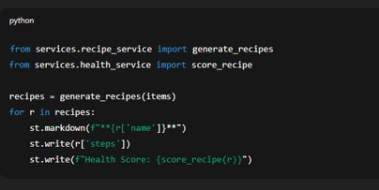


- Grocery List Page

Inputs:

Detected items
Required ingredients for recipes

Outputs:

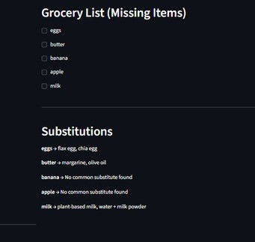

Checklist of missing items

Code Example:

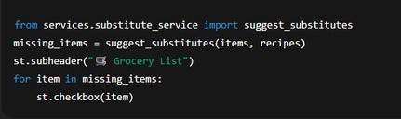


- Health Rating & Nutrition Page

Inputs:

Recipe ingredients and steps

Outputs:

Health score (1–10)
Breakdown of calories, protein, sugar, fiber, fat

Code Example:

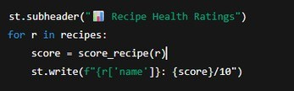

Activity 4.3: Navigation & Layout

Sidebar for navigation: Home
Pantry Upload
Recipe Generator Grocery List
Health Ratings

Example:

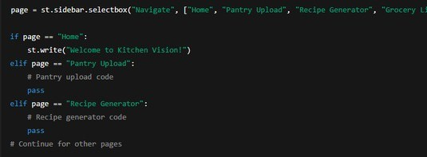


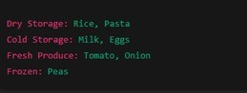

MILESTONE 5: Testing & Optimization — Kitchen Vision

This milestone focuses on validating the functionality, accuracy, performance, and usability of the Kitchen Vision system through comprehensive testing and optimization techniques.

Activity 5.1: Comprehensive Testing Test Scenarios
- Pantry Image Detection

Test Inputs:

Clear pantry image Low-light pantry image Cluttered pantry image

Expected Output:

Correct identification of food items Proper categorization into:
Dry Storage Cold Storage Frozen
Fresh Produce

Generated Pantry Items Example:

Validation Points:

Items detected correctly No duplicate items
Categories assigned properly


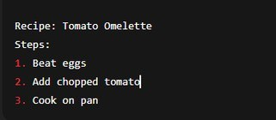

Recipe Generation

Test Inputs:

Pantry items list

Expected Output:

3 recipes generated Each recipe contains:
Name Ingredients
3 cooking steps Cooking time Difficulty level

Generated Recipe Example:

Validation Points:

Recipes match pantry items Steps are simple and logical

Grocery List Generation

Test Inputs:

Detected pantry items Recipe ingredient list

Expected Output:

Missing ingredients displayed


Checklist format

Generated Grocery List Example:

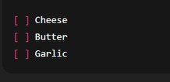

Validation Points:

Only missing items shown No duplicates

Health Rating Evaluation

Test Inputs:

Recipe ingredient composition

Expected Output:

Health score between 1–10 Nutrition explanation

Generated Health Rating Example:

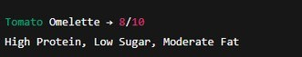

Validation Points:

Score within range Explanation present



UI Functional Testing

Test Areas:

Image upload Buttons Navigation menu Display sections

Expected Output:

No crashes Proper loading indicators Correct display of results

Activity 5.2: Quality Evaluation

Metrics Evaluated:

Image detection accuracy Recipe relevance Substitute usefulness
Health score reliability Response time
UI usability

Evaluation Results:

Metric Rating

Image Detection Accuracy

Recipe Quality
High

High

Health Score Consistency Medium–High

UI Usability

Response Speed
High

High

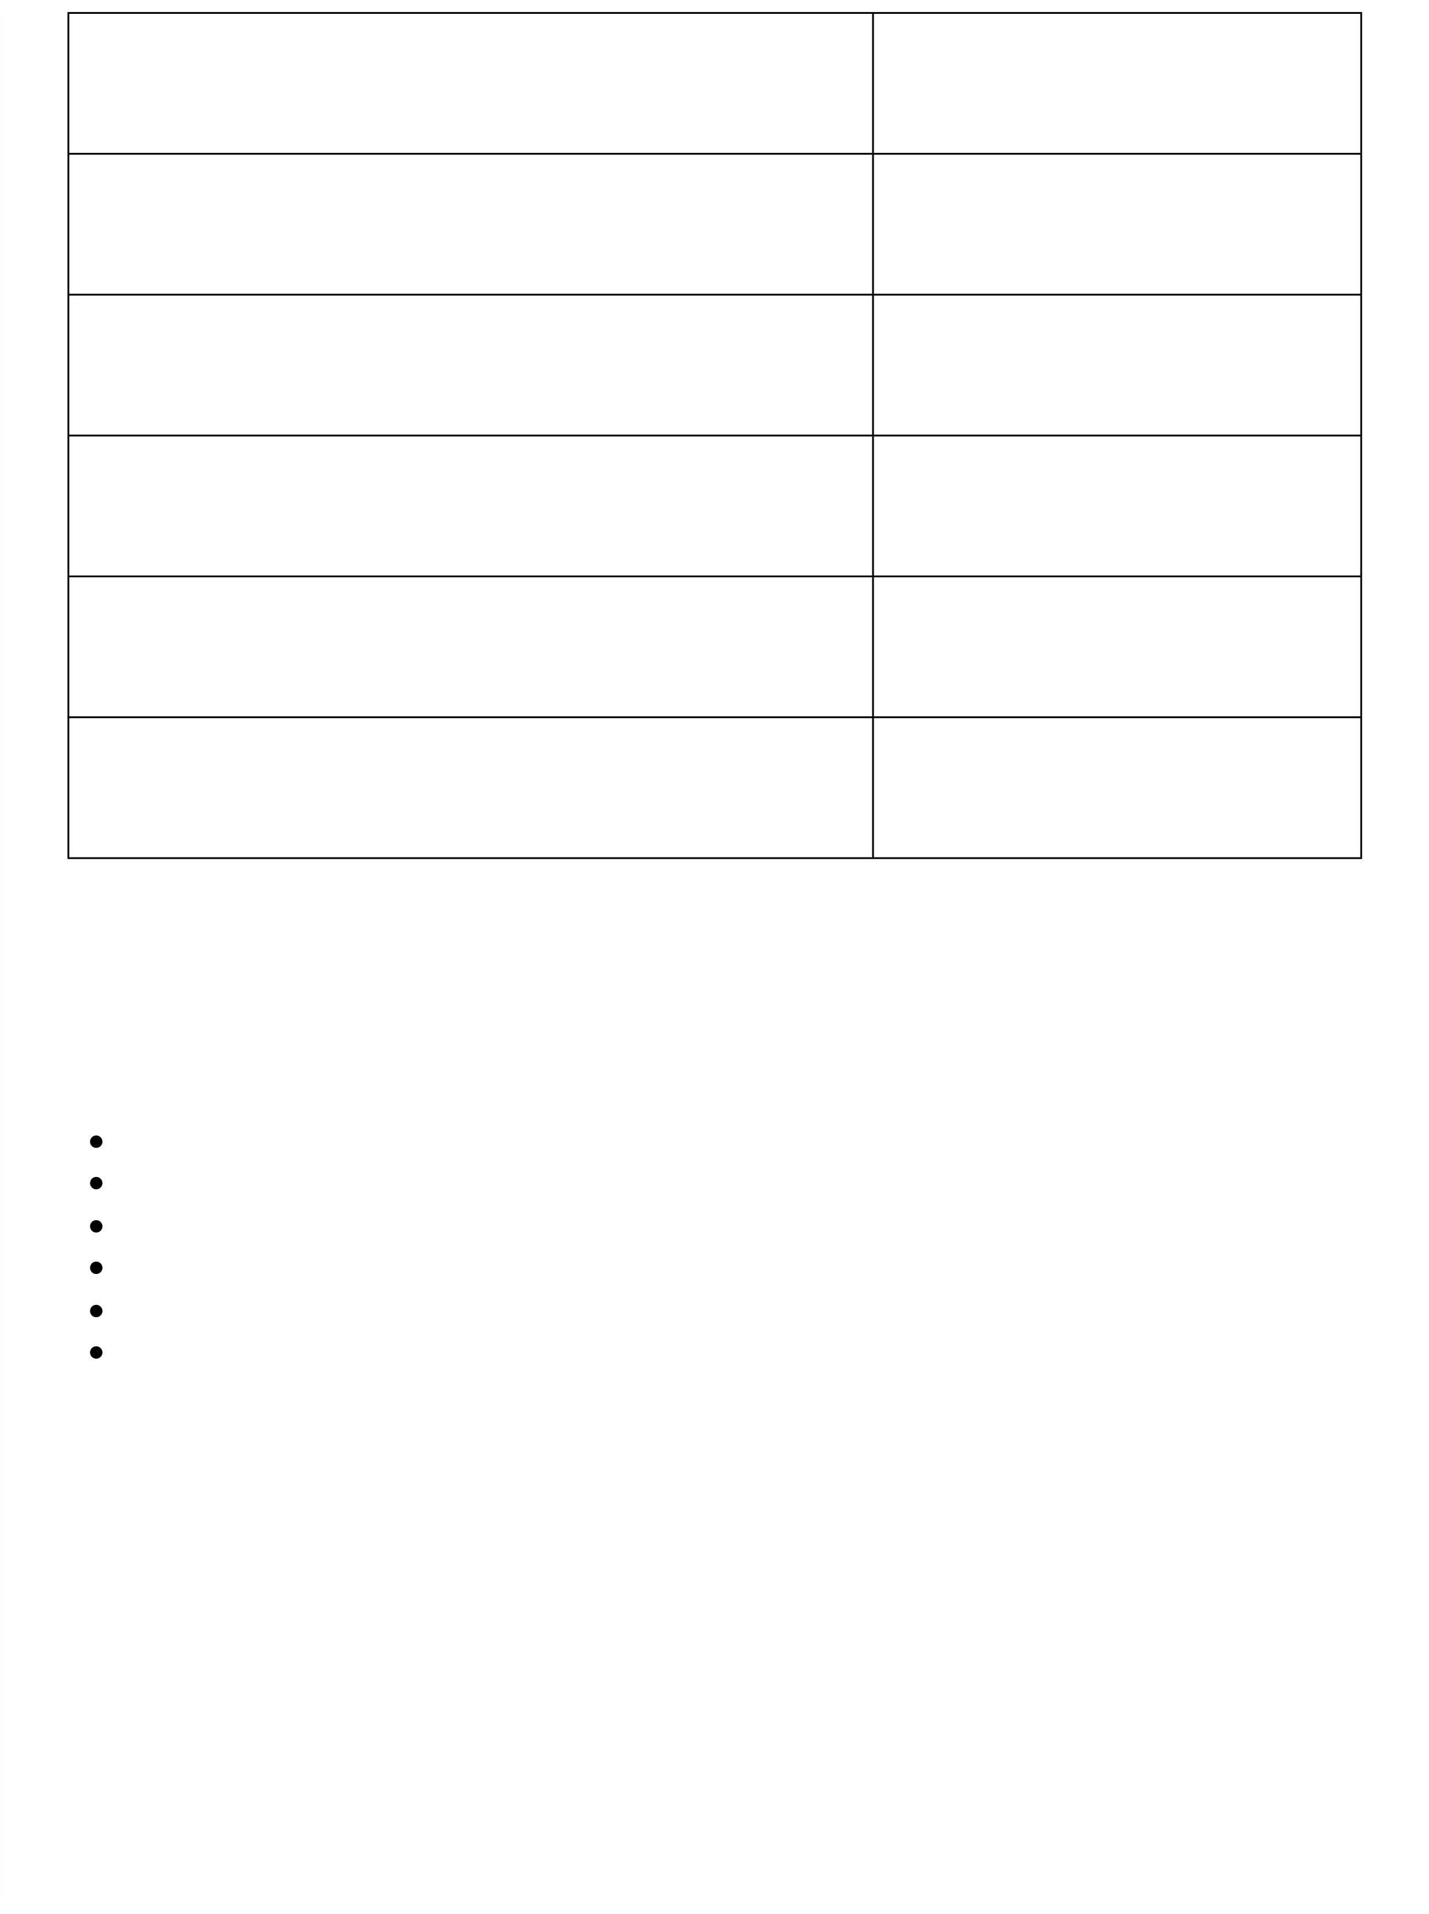
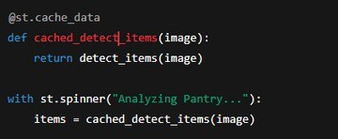


Activity 5.3: Performance Optimization

Improvements Made:

Image resizing before sending to AI Caching detected pantry items Reduced API calls
Added loading spinner Input validation for file type
Error handling for API failures



Conclusion
Kitchen Vision redefines everyday cooking assistance by delivering an intelligent, AI-powered solution that transforms pantry images into meaningful culinary insights. By combining Streamlit with advanced multimodal AI models, the system accurately analyzes pantry images, identifies and categorizes food items, and generates simple, practical recipes tailored to available ingredients.

From a modular backend architecture to seamless AI integration and an intuitive frontend, Kitchen Vision is built with a strong focus on usability, reliability, and performance. The application efficiently handles image processing, recipe generation, substitution logic, health scoring, and grocery list creation through well-structured service layers and reusable components.
Kitchen Vision not only helps users reduce food waste and save time but also promotes healthier eating habits by providing nutrition-based recipe ratings and balanced meal suggestions. Through comprehensive testing and optimization, the system demonstrates stable performance, fast response times, and consistent output quality.

Whether supporting busy individuals, students, or families, Kitchen Vision acts as a smart kitchen assistant that simplifies meal planning, enhances cooking confidence, and delivers personalized, data-driven culinary guidance—making every day cooking smarter, easier, and healthier.

