Computational Geometry

Introduction
The project implements two essential computational geometry algorithms:
1. Convex Hull
2. Polygon Triangulation
3. Point Set Quadrangulation

CONVEX HULL
The convex hull (convex envelope or convex closure) of a set X of points in the Euclidean plane is the smallest convex set that contains X.

We have implemented three convex hull algorithms:
1. Grahams Scan
2. Jarvis Scan
3. Kirkpatrick Seidal

POLYGON TRIANGULATION
Polygon triangulation is the decomposition of a polygonal area (simple polygon) P into a set of triangles i.e., finding a set of triangles with pairwise non-intersecting interiors whose union is P.

Three algorithms have been implement for triangulation of a simple polygon:
1. DCEL data structure to store polygon
2. Partitioning a polygon into y-monotone polygons
3. Triangulating a Y-monotone polygon

POINT SET QUADRANGULATION
A set of points S always admits a simple spanning polygonal chain that in turn admits a hamiltonian triangulation. Then, by removing every other diagonal starting at one end of the chain, we will obtain the desired quadrangulation except perhaps a single triangle at the end. In this case, we will add a single Steiner point there to complete the quadrangulation.

This is implemented using the following algorithms:
1. Grahams Scan
2. Spiralling Rotating Rotating Callipers

DEPENDENCIES
Updating Ubuntu
$ sudo apt-get update
$ sudo apt-get upgrade

Installing Dependencies
$ sudo apt-get install build-essential cmake git libgtk2.0-dev pkg-config libavcodec-dev libavformat-dev libswscale-dev
$ sudo apt-get install python3.5-dev python3-numpy libtbb2 libtbb-dev
$ sudo apt-get install libjpeg-dev libpng-dev libtiff5-dev libjasper-dev libdc1394-22-dev libeigen3-dev libtheora-dev libvorbis-dev libxvidcore-dev libx264-dev sphinx-common libtbb-dev yasm libfaac-dev libopencore-amrnb-dev libopencore-amrwb-dev libopenexr-dev libgstreamer-plugins-base1.0-dev libavutil-dev libavfilter-dev libavresample-dev

Get OpenCV
$ sudo -s
$ cd /opt
/opt$ git clone https://github.com/Itseez/opencv.git
/opt$ git clone https://github.com/Itseez/opencv_contrib.git

Build and install OpenCV
/opt$ cd opencv
/opt/opencv$ mkdir release
/opt/opencv$ cd release
/opt/opencv/release$ cmake -D BUILD_TIFF=ON -D WITH_CUDA=OFF -D ENABLE_AVX=OFF -D WITH_OPENGL=OFF -D WITH_OPENCL=OFF -D WITH_IPP=OFF -D WITH_TBB=ON -D BUILD_TBB=ON -D WITH_EIGEN=OFF -D WITH_V4L=OFF -D WITH_VTK=OFF -D BUILD_TESTS=OFF -D BUILD_PERF_TESTS=OFF -D CMAKE_BUILD_TYPE=RELEASE -D CMAKE_INSTALL_PREFIX=/usr/local -D OPENCV_EXTRA_MODULES_PATH=/opt/opencv_contrib/modules /opt/opencv/
/opt/opencv/release$ make -j4
/opt/opencv/release$ make install
/opt/opencv/release$ ldconfig
/opt/opencv/release$ exit
/opt/opencv/release$ cd ~

Check if OpenCV is installed
$ pkg-config --modversion opencv
3.2.x

INSTALLATION
Copy the files to your favorite directory and then run:
$ mkdir build
$ cd build
$ cmake ..
$ make -j4
$ ./ComputationalGeometry

RESULTS

Polygon Triangulation : O (n logn)
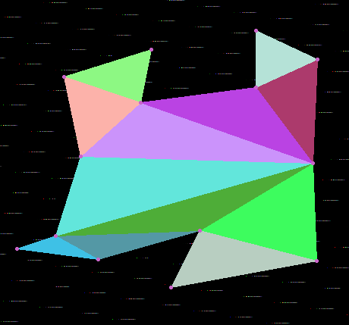
x = 118 y = 240
x = 96 y = 135
x = 211 y = 99
x = 197 y = 169
x = 349 y = 149
x = 349 y = 74
x = 430 y = 112
x = 424 y = 249
x = 429 y = 378
x = 237 y = 413
x = 275 y = 338
x = 141 y = 376
x = 34 y = 362
x = 85 y = 345

Running Polygon Triangulation:

Number of points: 14

Adding edge: (424 , 249) to (275 , 338)
Adding edge: (197 , 169) to (118 , 240)
Adding edge: (275 , 338) to (429 , 378)
Adding edge: (85 , 345) to (141 , 376)
Adding edge: (275 , 338) to (85 , 345)
Adding edge: (424 , 249) to (85 , 345)
Adding edge: (118 , 240) to (424 , 249)
Adding edge: (197 , 169) to (424 , 249)
Adding edge: (349 , 149) to (424 , 249)
Adding edge: (430 , 112) to (349 , 149)
Adding edge: (96 , 135) to (197 , 169)

Triangles:
1> (429,378) (275,338) (424249)
2> (85,345) (275,338) (141376)
3> (197,169) (96,135) (21199)
4> (275,338) (429,378) (237413)
5> (85,345) (141,376) (34362)
6> (85,345) (424,249) (275338)
7> (349,149) (430,112) (424249)
8> (118,240) (424,249) (85345)
9> (197,169) (424,249) (118240)
10> (349,149) (424,249) (197169)
11> (430,112) (349,149) (34974)
12> (96,135) (197,169) (118240)

Time taken by Algorithm:0.435 ms

CONVEX HULL:

1> Grahams Scan : O(n logn)

Running Graham's Algorithm:
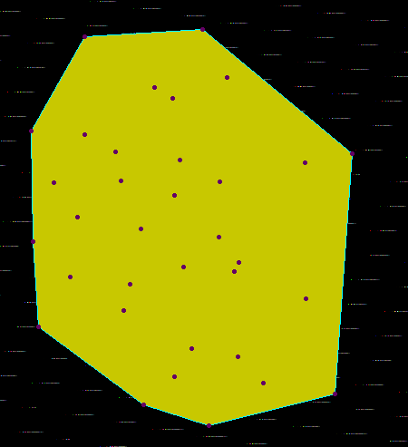
x = 114 y = 256
x = 63 y = 161
x = 156 y = 184
x = 88 y = 218
x = 162 y = 216
x = 172 y = 330
x = 292 y = 306
x = 271 y = 217
x = 184 y = 269
x = 231 y = 311
x = 227 y = 193
x = 279 y = 102
x = 365 y = 196
x = 270 y = 278
x = 221 y = 232
x = 219 y = 125
x = 122 y = 57
x = 122 y = 165
x = 199 y = 113
x = 252 y = 49
x = 417 y = 186
x = 366 y = 346
x = 398 y = 451
x = 319 y = 439
x = 259 y = 486
x = 187 y = 463
x = 240 y = 401
x = 71 y = 377
x = 106 y = 322
x = 165 y = 359
x = 287 y = 316
x = 291 y = 410
x = 221 y = 432
x = 65 y = 283

Number of points: 34

Points on hull : 9

Convex Hull
252 49
417 186
398 451
259 486
187 463
71 377
65 283
63 161
122 57

Time taken by Algorithm:0.171 ms

2> Jarvis Scan : O(np)
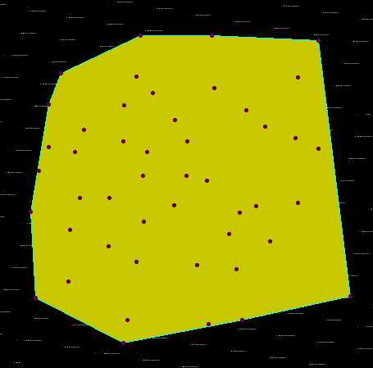
Running Jarvis Algorithm:
x = 194 y = 196
x = 118 y = 113
x = 210 y = 117
x = 146 y = 182
x = 176 y = 324
x = 323 y = 309
x = 296 y = 244
x = 127 y = 367
x = 141 y = 265
x = 177 y = 265
x = 177 y = 265
x = 223 y = 209
x = 135 y = 209
x = 103 y = 203
x = 103 y = 151
x = 195 y = 152
x = 305 y = 131
x = 272 y = 196
x = 257 y = 170
x = 257 y = 170
x = 256 y = 274
x = 219 y = 294
x = 219 y = 294
x = 218 y = 238
x = 271 y = 238
x = 344 y = 158
x = 336 y = 283
x = 210 y = 343
x = 129 y = 304
x = 81 y = 282
x = 91 y = 232
x = 199 y = 414
x = 339 y = 414
x = 373 y = 318
x = 284 y = 347
x = 298 y = 419
x = 332 y = 352
x = 404 y = 192
x = 215 y = 67
x = 302 y = 67
x = 230 y = 137
x = 87 y = 387
x = 194 y = 442
x = 471 y = 385
x = 407 y = 271
x = 356 y = 275
x = 367 y = 178
x = 407 y = 118
x = 432 y = 73
x = 432 y = 205

Number of points: 50

Points on hull : 10

Convex Hull
215 67
302 67
432 73
471 385
339 414
194 442
87 387
81 282
103 151
118 113

Time taken by Algorithm:0.374 ms

3> Kirkpatrick-Seidal : O(n logp)

Running kirkpatrick-seidal Algorithm:
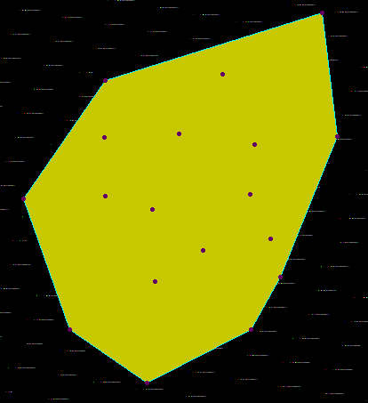
x = 173 y = 246
x = 229 y = 342
x = 370 y = 337
x = 336 y = 244
x = 226 y = 261
x = 283 y = 307
x = 359 y = 294
x = 417 y = 40
x = 305 y = 109
x = 256 y = 176
x = 341 y = 188
x = 173 y = 116
x = 81 y = 249
x = 133 y = 396
x = 220 y = 456
x = 337 y = 396
x = 434 y = 179
x = 172 y = 180

Number of points: 18

Points on hull : 8

Convex Hull
81 249
133 396
220 456
337 396
370 337
434 179
417 40
173 116

Time taken by Algorithm:0.513 ms

REFERENCES

1> Computational Geometry Algorithms and Applications – Mark de Berg

