TEACHER ASSESSMENT

Submitted By :- Bhavdeep Kaur (15078570011)
Disha Surana(15078570014)
Ridhi (15078570035)

ADVANTAGES

- When assessment of teacher practices is transparent and openly collaborative, teachers can build professional communities and learn from one another.
- Measures of teacher performance are most helpful and meaningful when they are based on multiple ratings and clear teaching standards in the formative growth process.
- Feedback is most useful as part of a comprehensive teacher development system.
- Results in good quality of guidance provided to all the students.
- Teacher can get a clear view of their teaching.

DATA FLOW DIAGRAM

Data Flow Diagram for our web-based system is as follow:
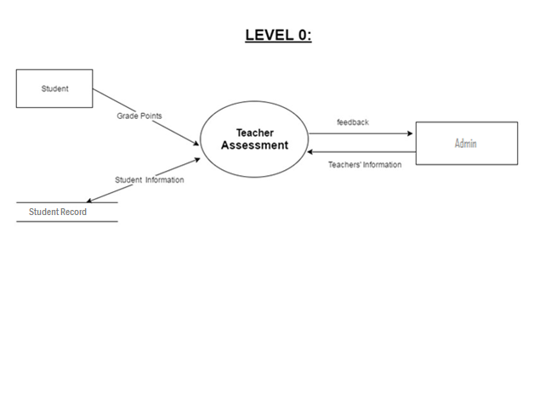
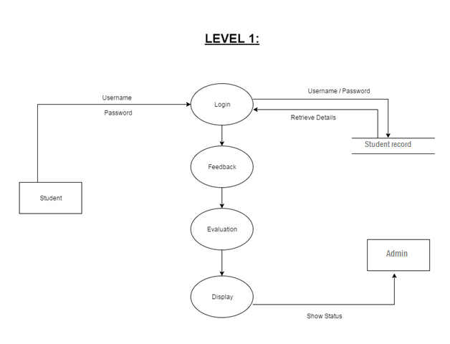
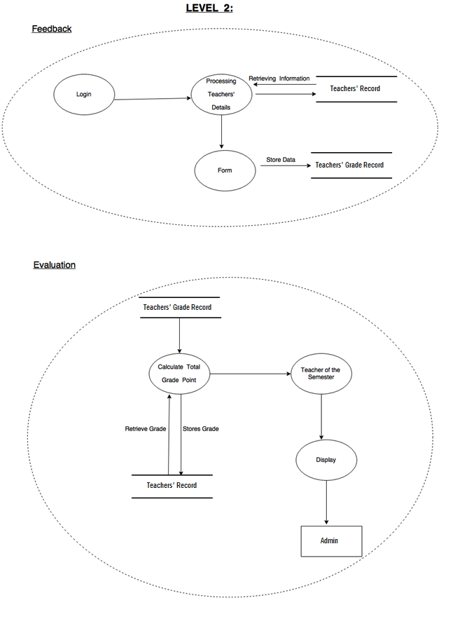

INTERFACE DESIGN

- Home Page


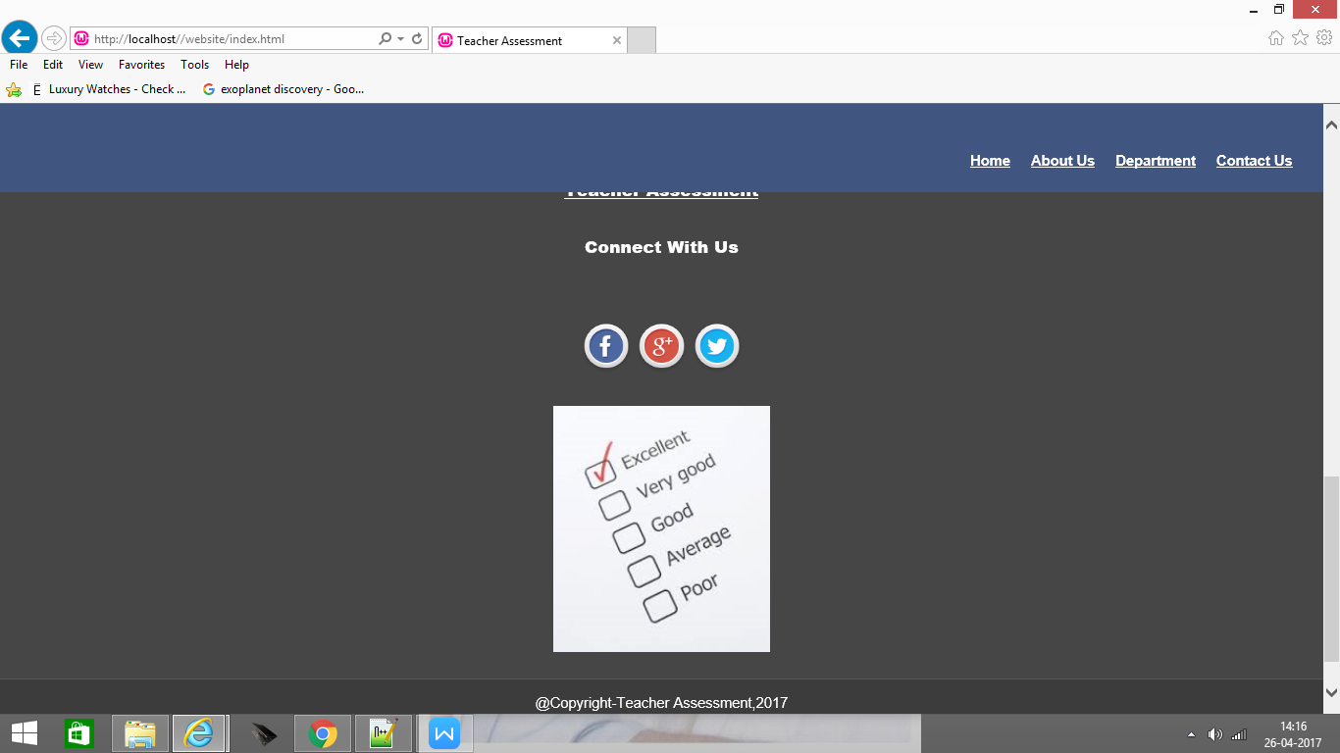

- Admin Page
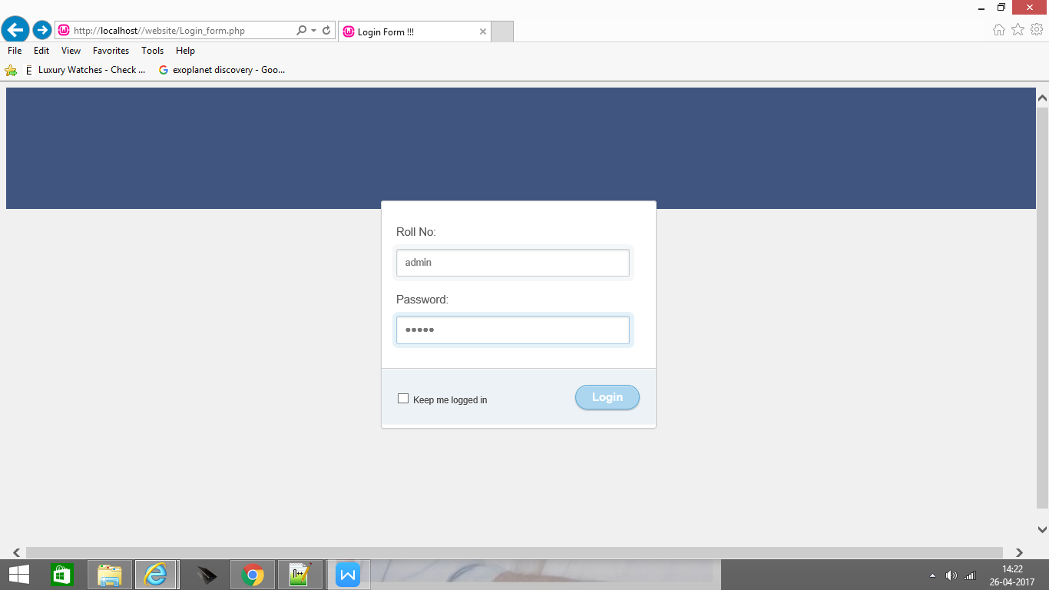
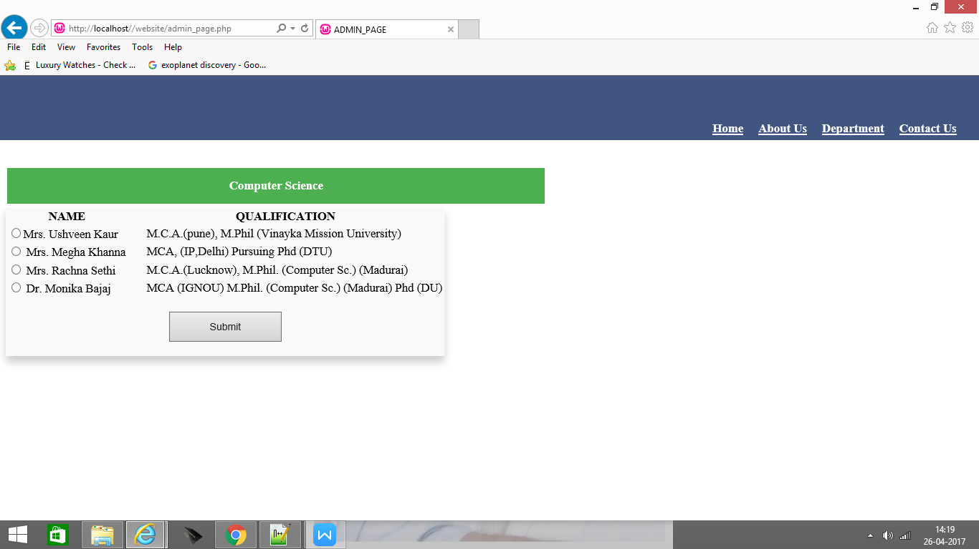
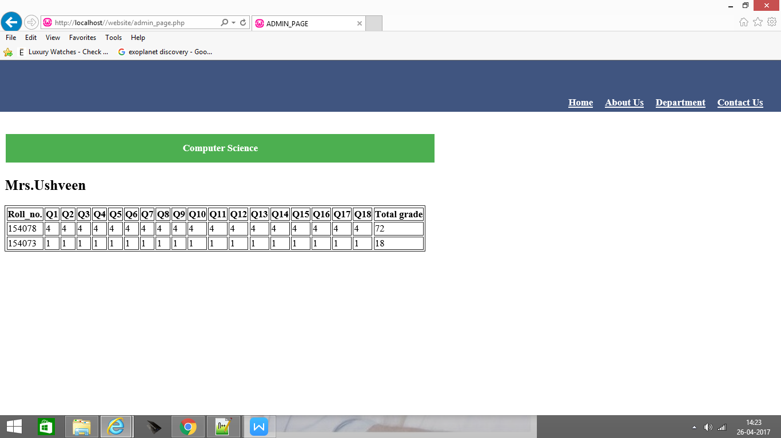

- User Page
