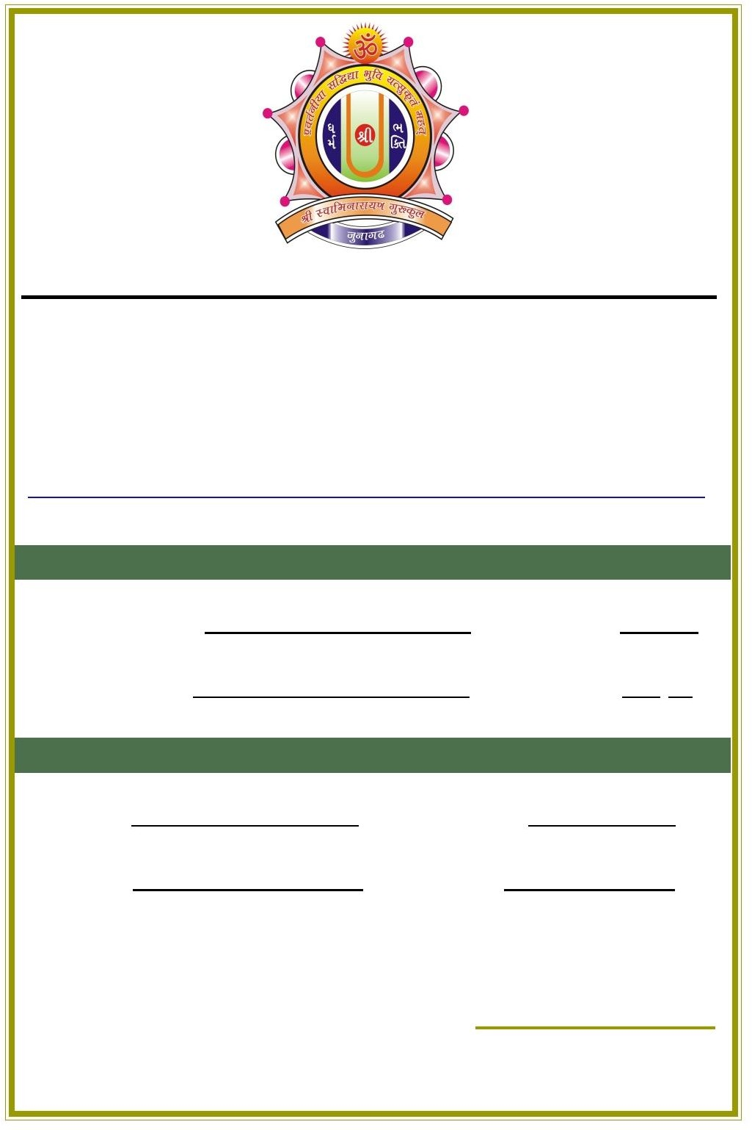

**Shastri Swami Shree Dharmajivandasji Institute of I.T.**

**(Affiliated to Bhakta Kavi Narsinh Mehta University, Junagadh)**

C/o Shree Swaminarayan Gurukul, Colege Road, Junagadh Web: [www.junagadhgurukul.org](http://www.junagadhgurukul.org/)

Email : sssdi[t_jnd@yahoo.com](mailto:t_jnd@yahoo.com)

PROJECT COMPLETION CERTIFICATE

THIS CERTIFICATE IS AWARDED TO

Member Name : VAGHASIYA BHAVDIP Stream : B.C.A

Member Name : PAGHDAL KISHAN Semester : 6

IN COMPLETION OF PROJECT WORK

|  |  |  |
| --- | --- | --- |
| Platform : | ANDROID | Begin Date : 06/01/2022 |
| Database : | FIREBASE | End Date : 20/02/2022 |

**DIRECTOR**