1. Launch an instance

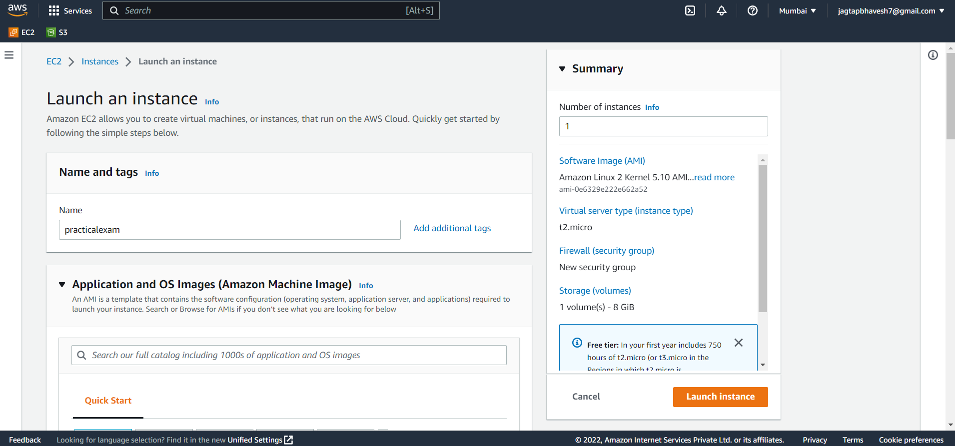

1. Create .pem key pair

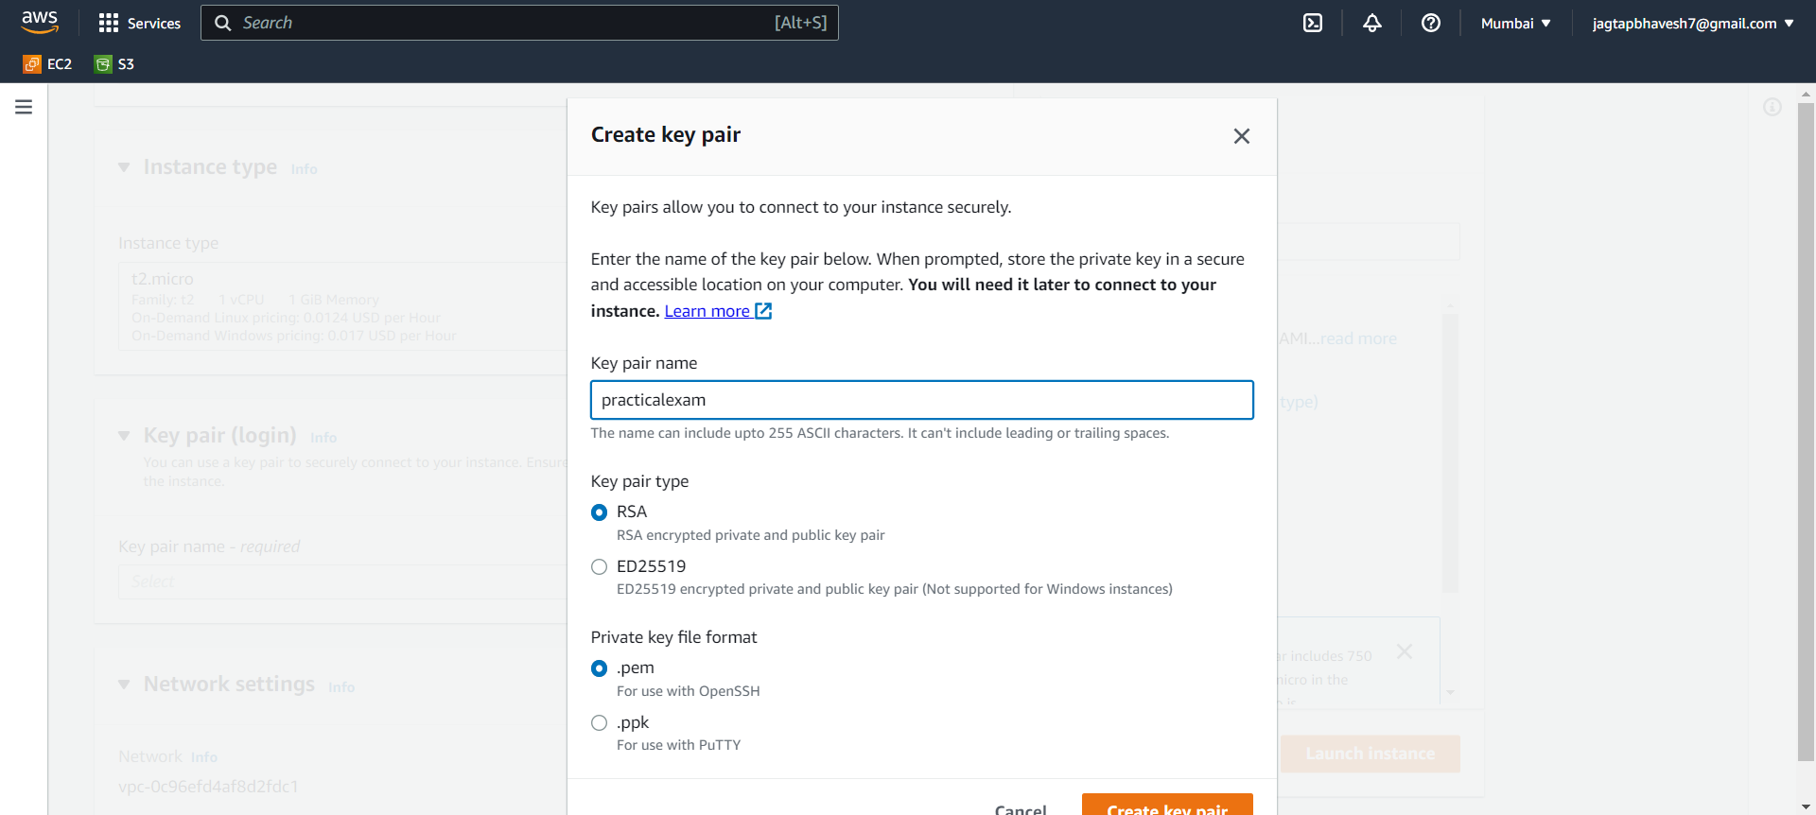

1. Instance launched

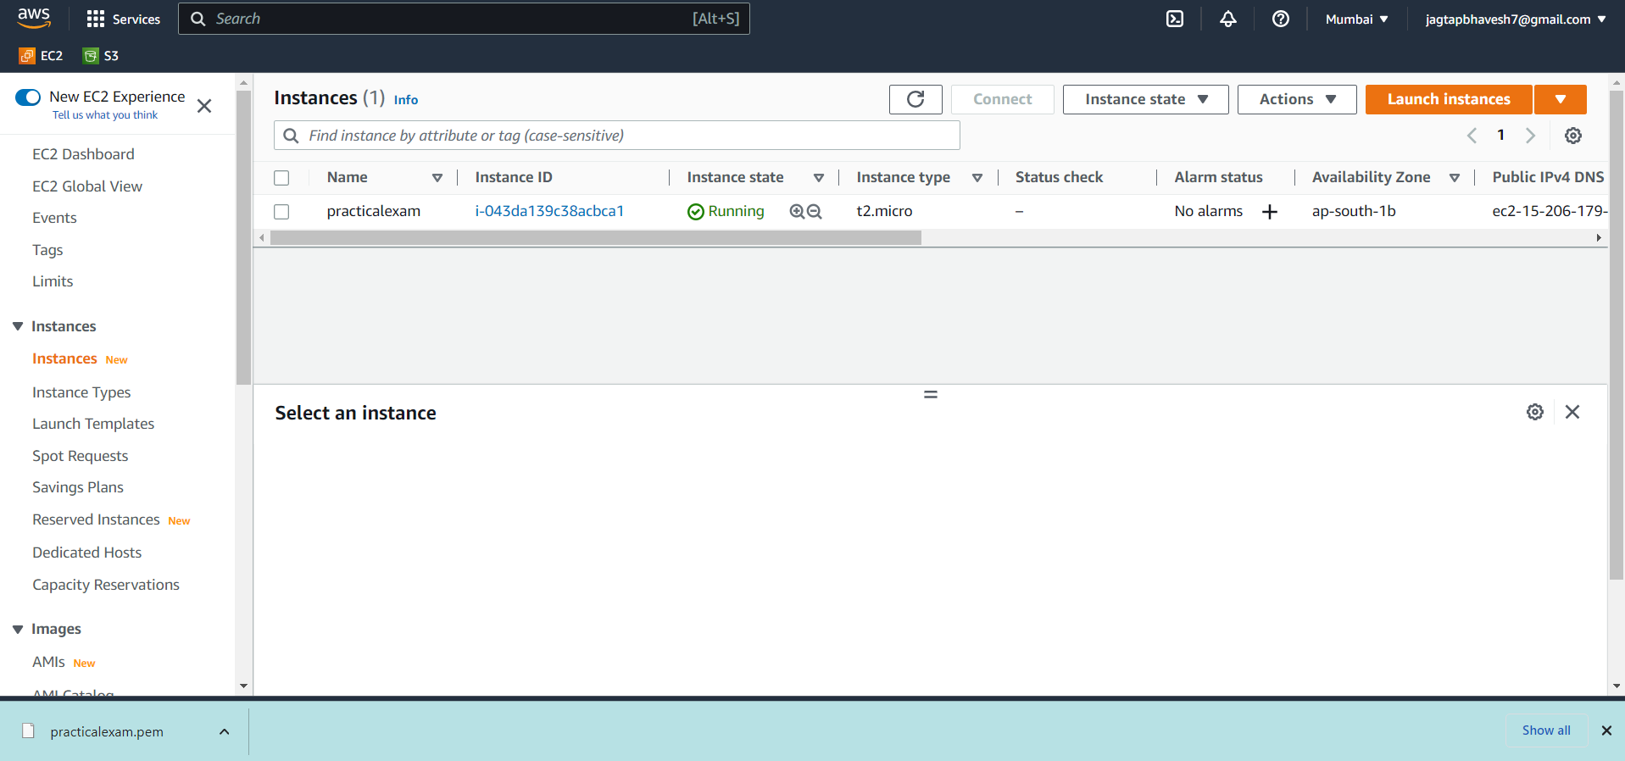

1. Convert .pem file to .ppk file using PuTTy key Generator

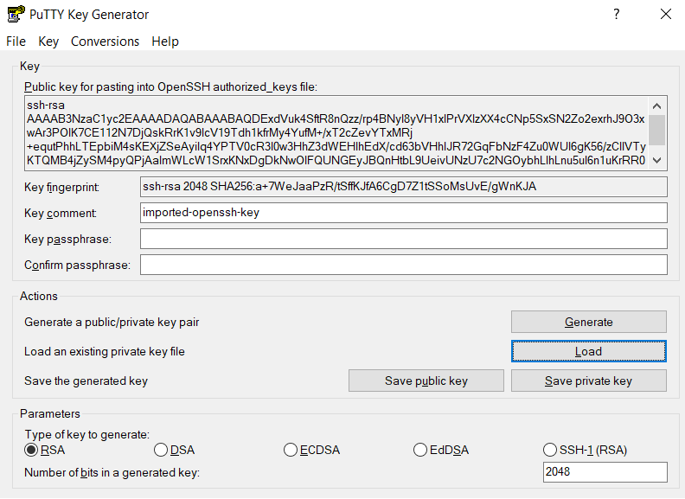

1. Save as private key as add .ppk filename

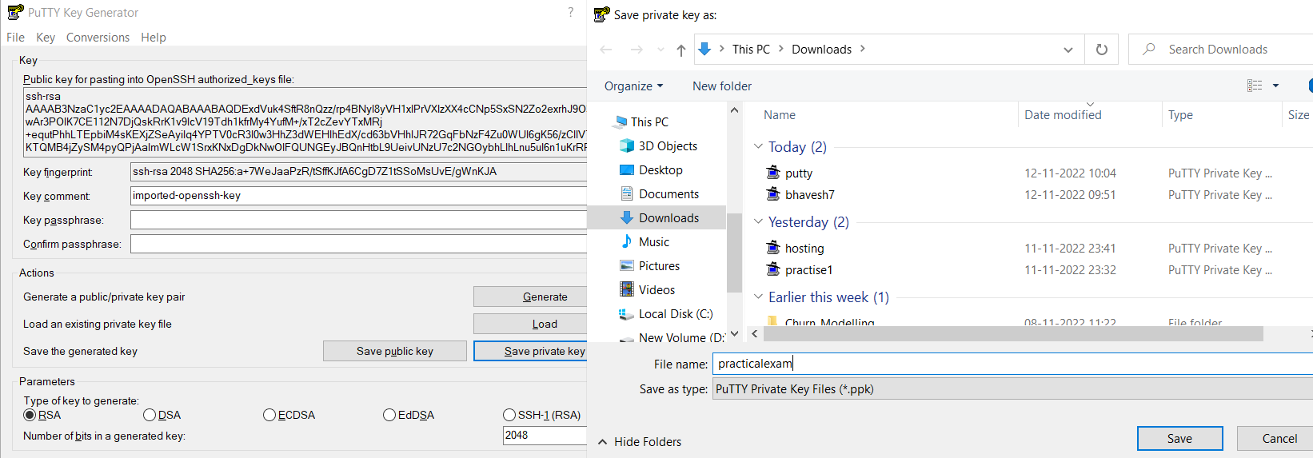

1. For linux SSH connection we use putty for it . Put your instance Public ip4 DNS address in Host Name

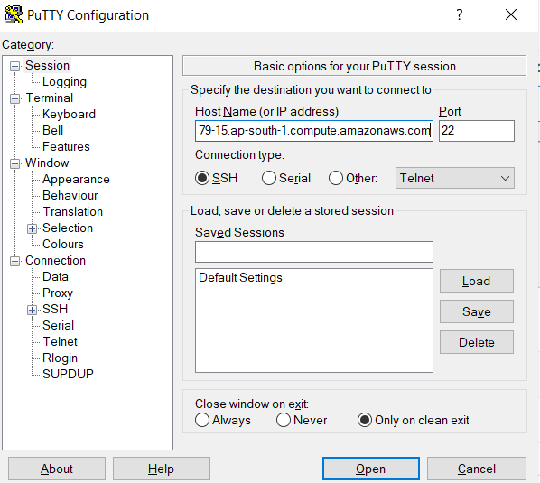

1. Add ec2-user in login-username

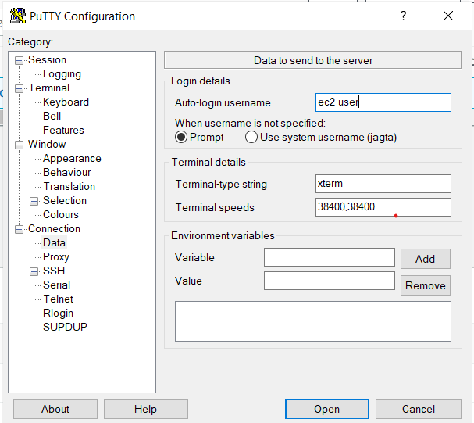

1. Add .ppk file path in it

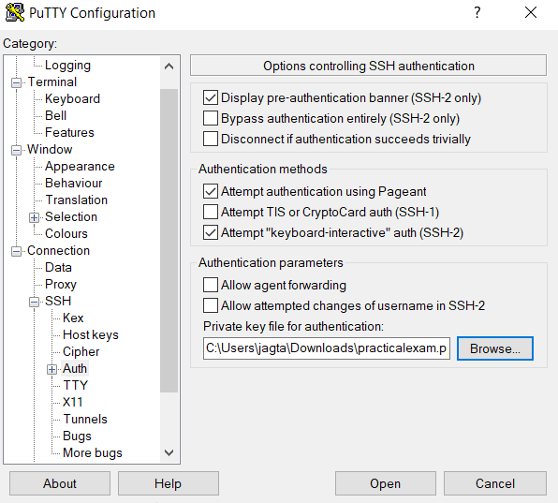

1. Perform Basic linux commands

