**____________________________________________**

**Collapsible Foot Bridge**

**Mechanism**

**__________________**

Presented By,

**Varenya Tiwari**

**Thengadi Bhavesh Sanjay**

**Abstract**

In this study we are going to propose a subtle mechanism for a collapsible (foldable) bridge design provided with its linkage and also it’s required analysis with some other possible mechanism which are feasible for the same operation. For this project we are proposing a piston design a little similar to the slider rocker mechanism such that it can be used for the operation of a foldable bridge and also provided other design possible with Scissor mechanism.

**Proposed Mechanisms**

1. **Piston Foldable Mechanism**

This model will use a piston configuration attached to the end of the bridge which will help retract the portions of bridge forming a collapsible bridge. This design working is somewhat similar to slider rocker mechanism.

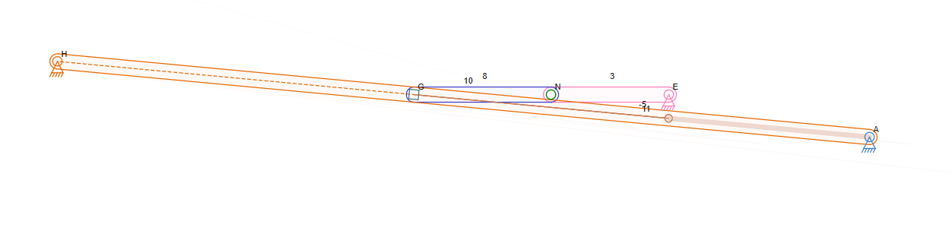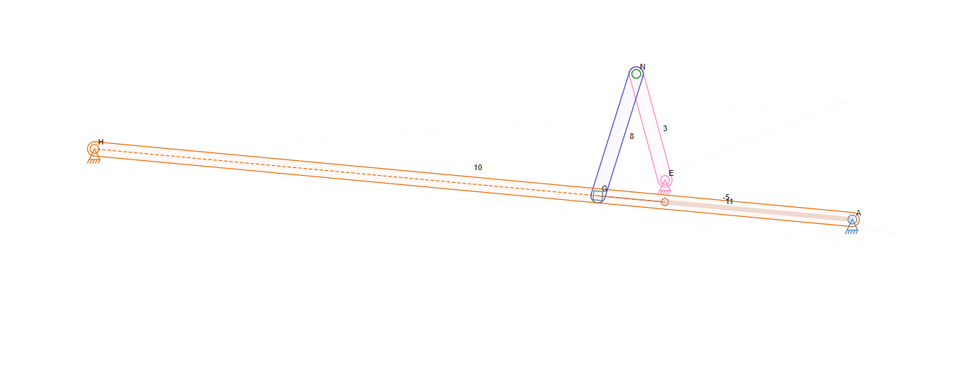

Linkage model differs from the CAD, since due to some constraints in linkage app such big slider was needed to depict the full piston motion.

**Mechanism Analysis:**

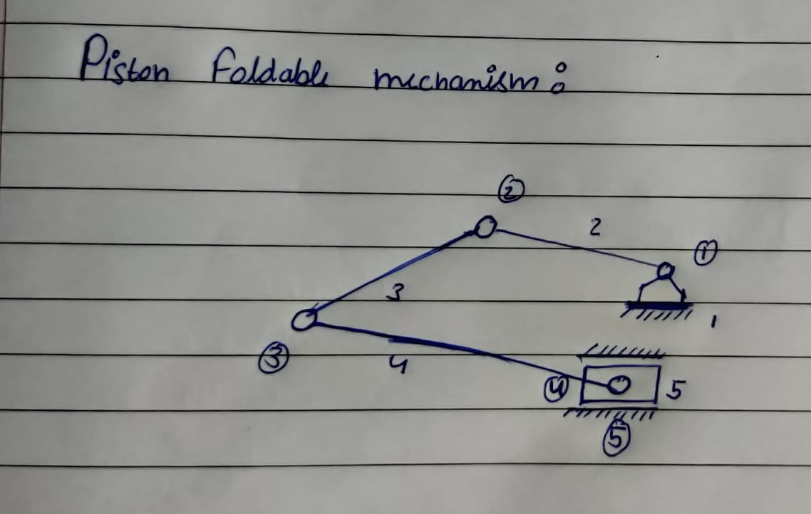

n=5

P1=5

P2=0

F= 3*(n-1) – 2*P1 – P2

F=2

For the ideal case like the one shown in linkage mobility should be 1, but in actual situation for proper operation the piston can’t be kept fixed hence it causes angular motion during its operation.

This results in mobility to be equal to 2 as shown in the image above. Even then with the help of some constraints in the piston motion this extra degree of mobility can be left unnoticed like we have provided the piston the angular freedom to just operate within making an angle of 5º - 15º with the vertical axis. In such a way this extra mobility can be left unnoticed.

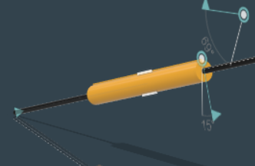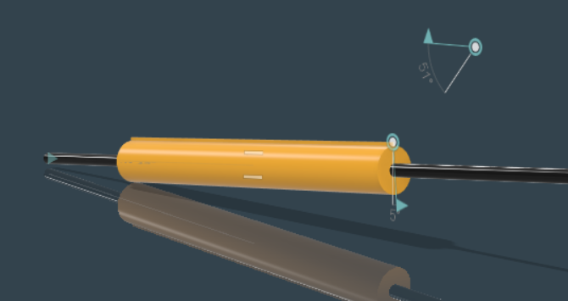

1. **Scissor Mechanism**

This model is based on scissor mechanism where with the help of a piston configuration, scissor links will be unfolded into an operational bridge and can be retracted back as per need.

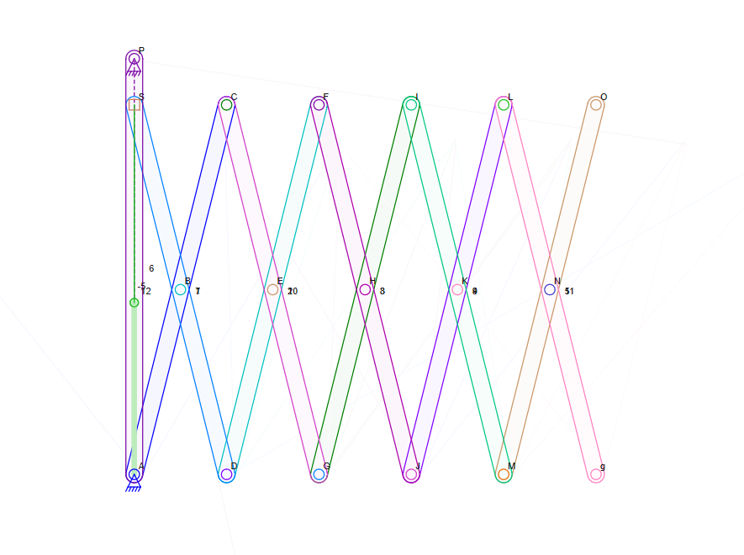

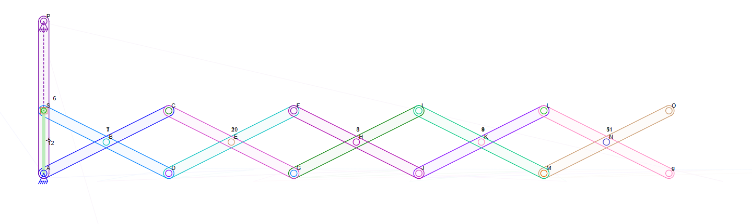

**Mechanism Analysis:**

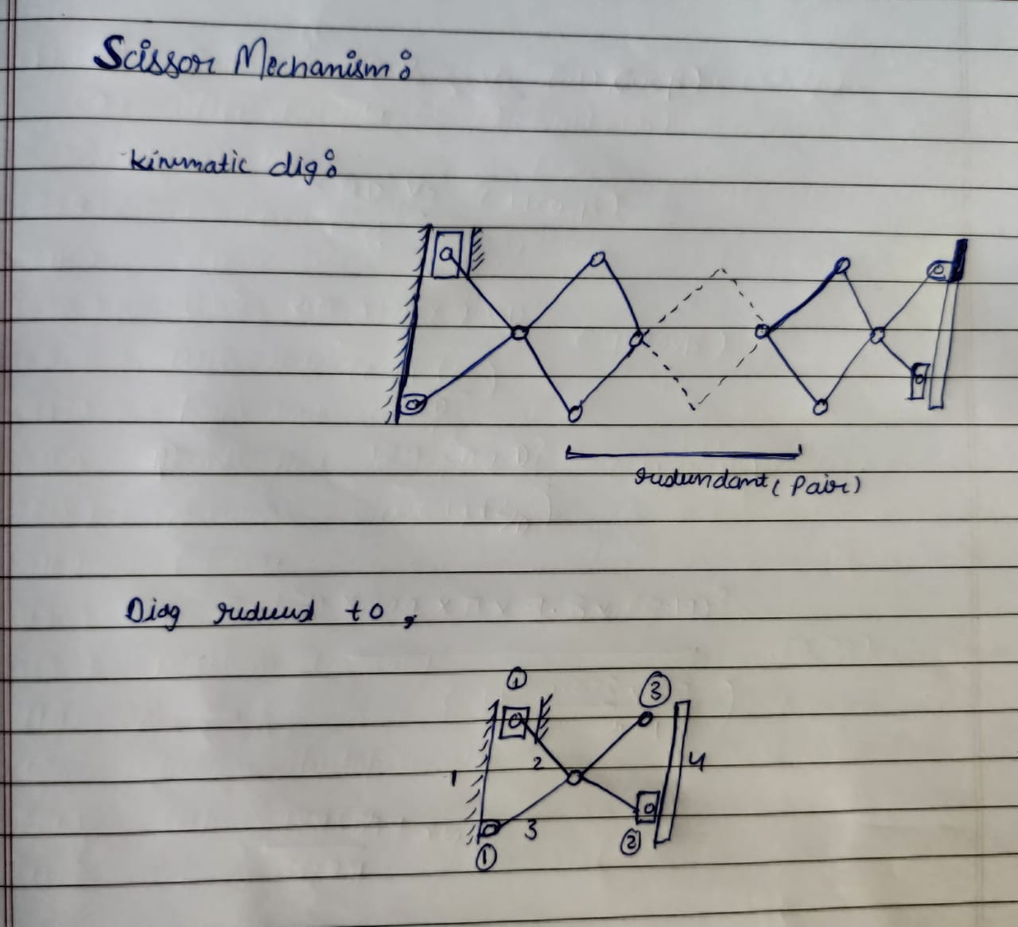

n = 4

P1 = 3

P2 = 2

F = 3(n-1) - 2*P1 – P2

F = 1

**Alternate Mechanism:**

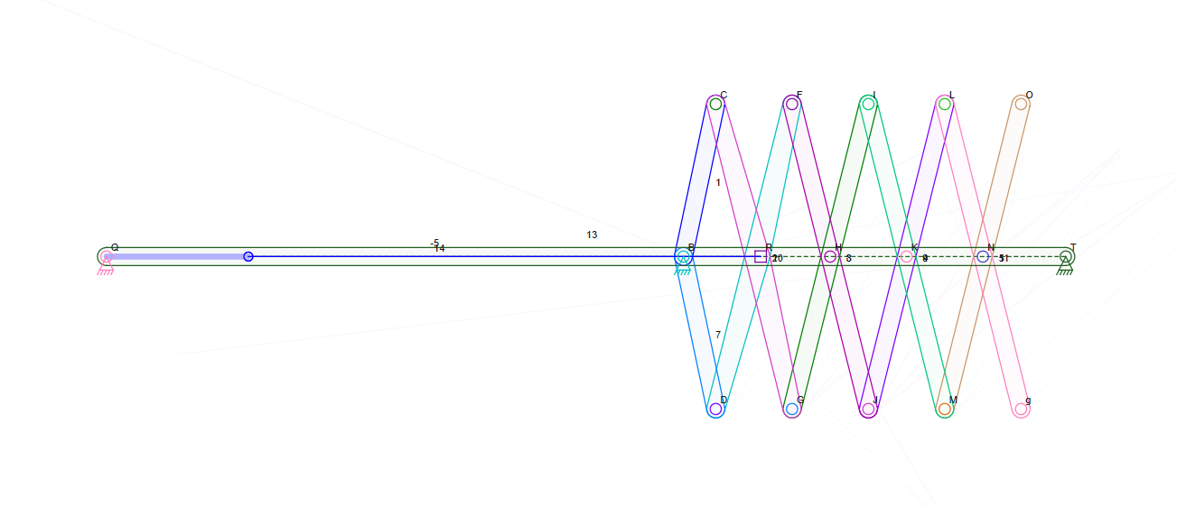

Instead of using slider for performing the operation a horizontal piston configuration can be installed to carry out the same operation. Kinematic analysis remains the same as previous configuration for the mechanism.

**CAD Model**

CAD model design is based on proposed mechanism 1, the piston foldable mechanism and the file for the same is also attached for further reference in dimensioning and constraints.

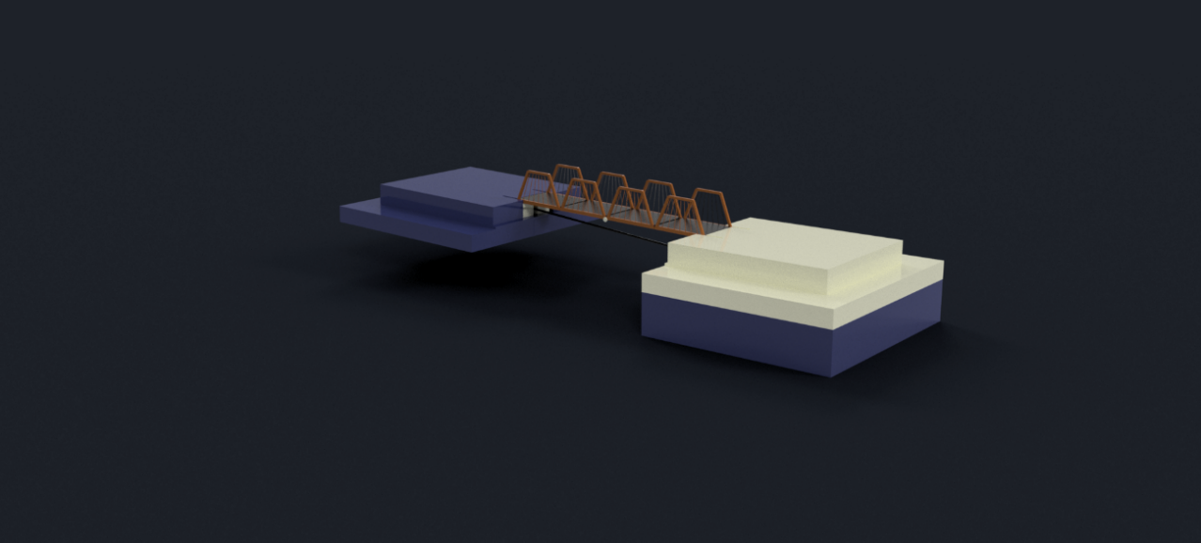

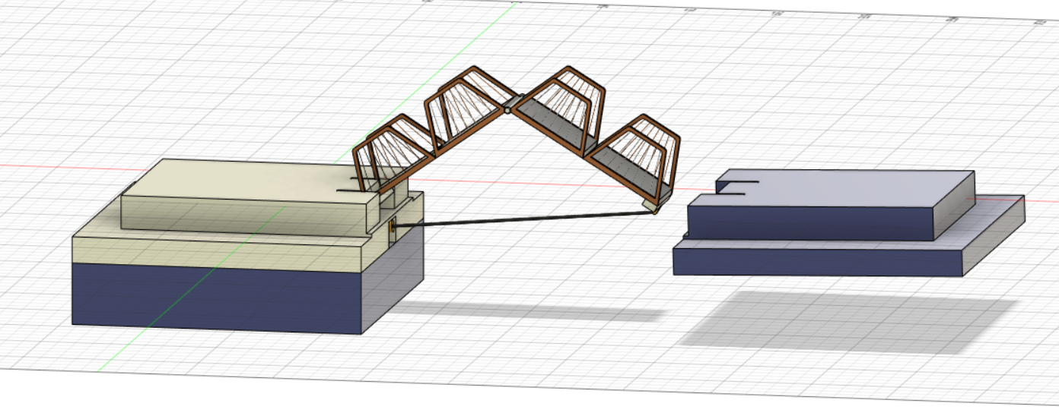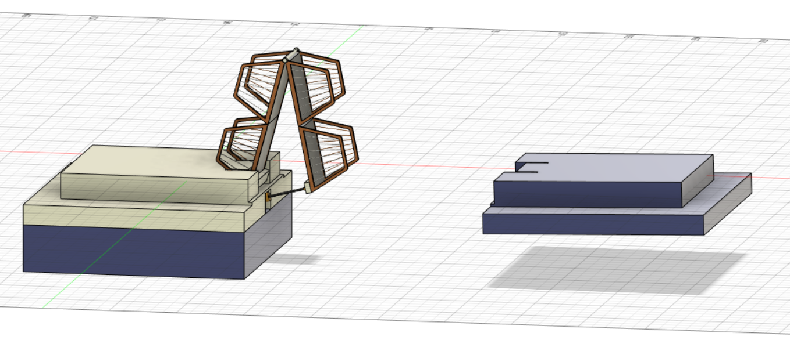

**Components:**

1. **Piston:**

Piston is the most important component of this design which operates the whole mechanism by retracting the bridge from the far end as pushing forward to open up bridge to the full extent.

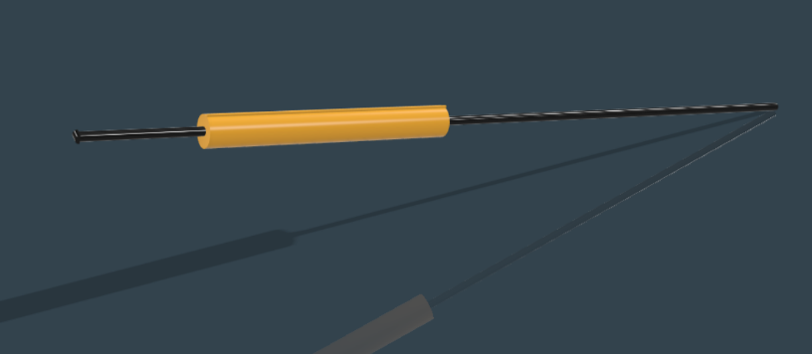

1. **Bridge Body:**

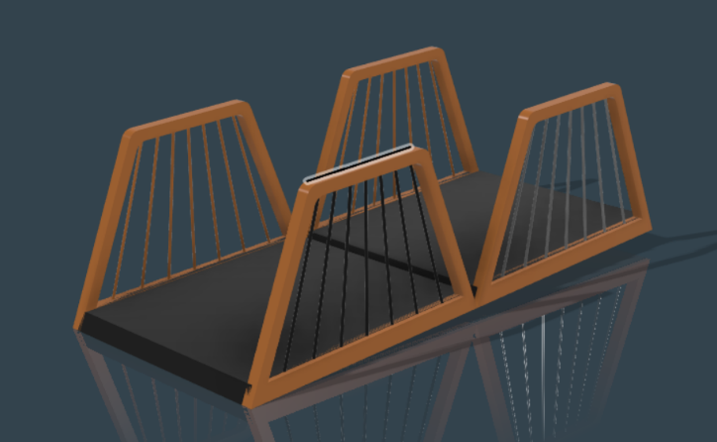Bridge body consists of four elementary block two of which are joined together to form portions of bridge which are able to rotate with the help of rotatory joints in between them.

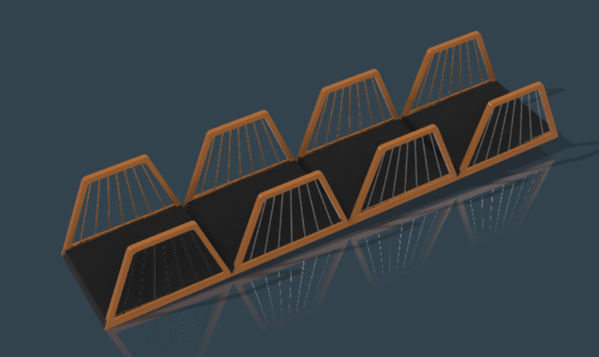

1. **Rotatory Joint:**

A rotatory joint is provided between portions of the bridge to complete the retraction process of the bridge via piston pull.

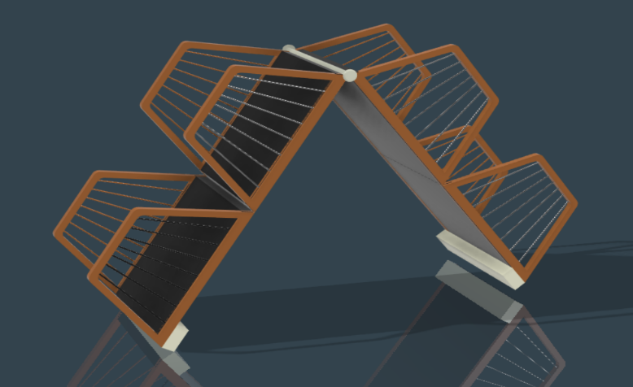

1. **Ground:**

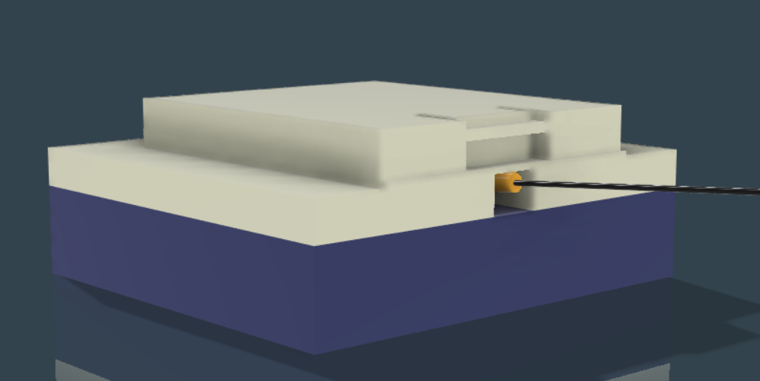

**Design Applications**:

Collapsible or foldable bridges serve a variety of purposes ranging from small design portable bridges used in military and rescue force operations to actual large scale bridge design connecting riversides and with its foldable flexibility ensuring more advantages over conventional fixed bridges. There are worldwide many examples of foldable bridges used for different purposes a few examples to begin with are,

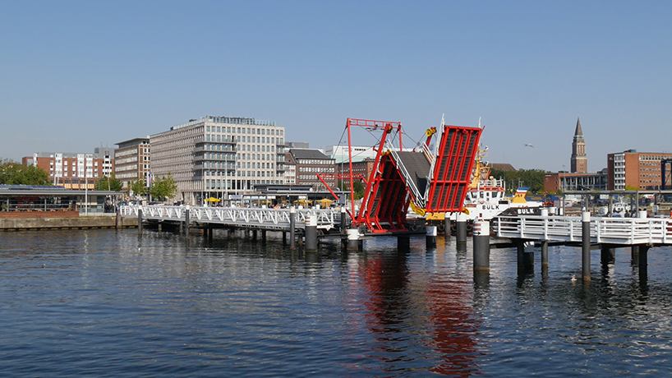

Hörn Bridge (Germany)

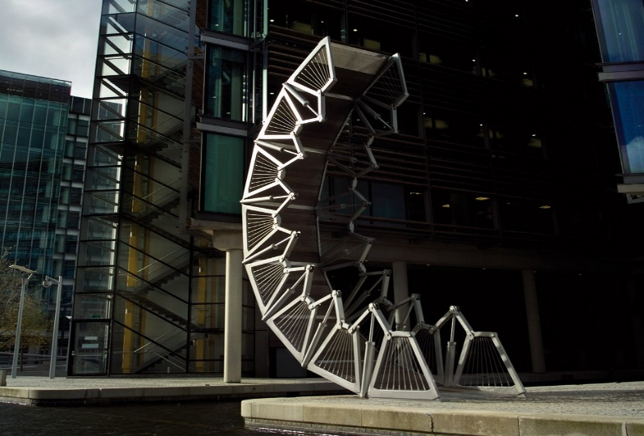Rolling Bridge (England)

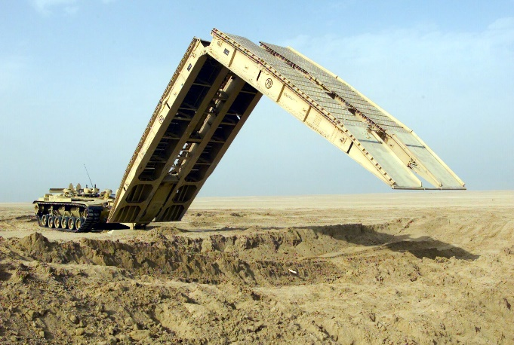Armored Vehicle Folding Bridge

**__________________________________**

**Thank You**

By **Varenya Tiwari**

**190103122**

**Thengadi Bhavesh Sanjay**

**190103099**