Day 1

1. What is coding.

Coding, also known as programming, is the process of designing and building executable computer programs to accomplish a specific task or solve a particular problem

Ket Steps :-

**Problem Definition:**

**Algorithm Design**

**Testing and Debugging:**

**Documentation:**

1. Coding environment

The Coding environment is the Application to used the write the steps of the code.

Like turbo C++ , vs code , Eclips , Project-IDX, and the Online Compiler are available in the market.

This environment is the known as the IDE =>

IDE (integrated Development Environment)

1. Programming language

A programming language is a formalized set of rules and syntax used to instruct a computer to perform specific tasks or operations

1. Compiler / interpreter

Both are the translator

Compiler : -

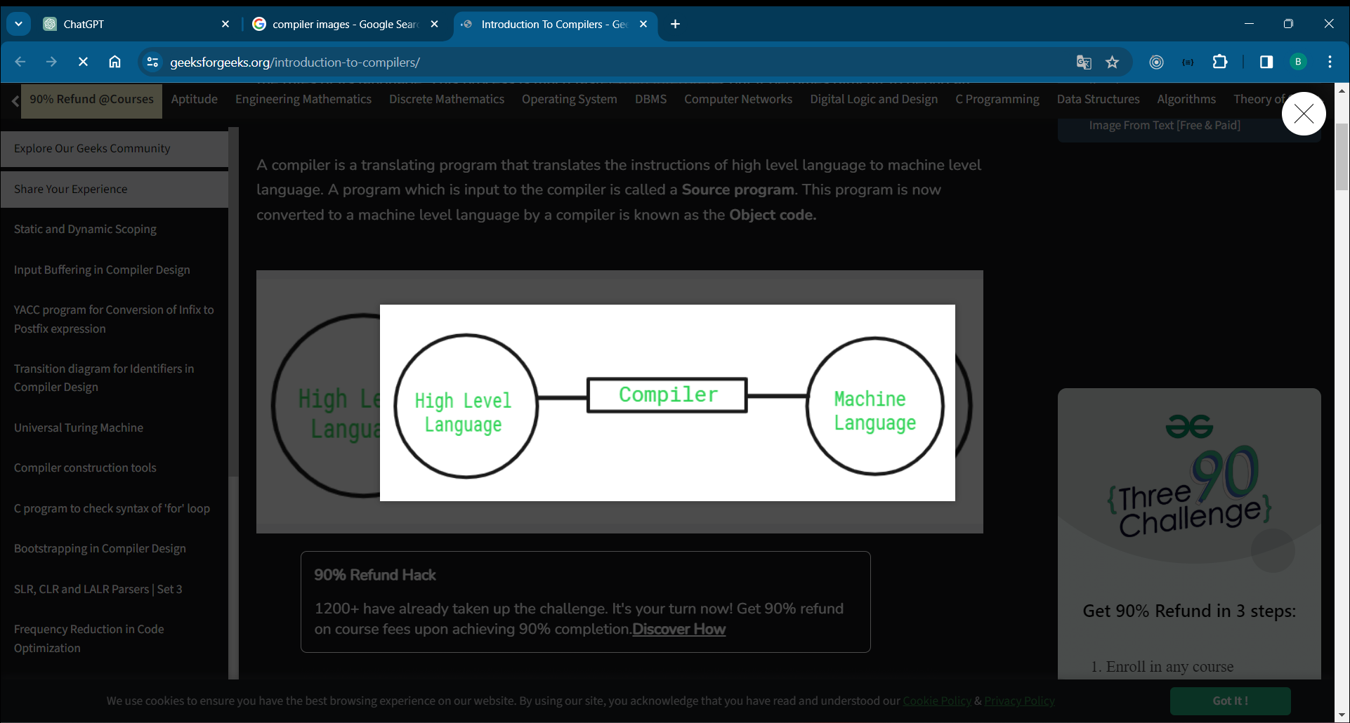

The compiler can convert the high level language into machine level language

Compiler can execute the code line by line

High level === c++ or java code

Machine level language === 0001110011110011

Interpreter

This is the translator to used the convert the high level language in to machine level language

Important thing is the

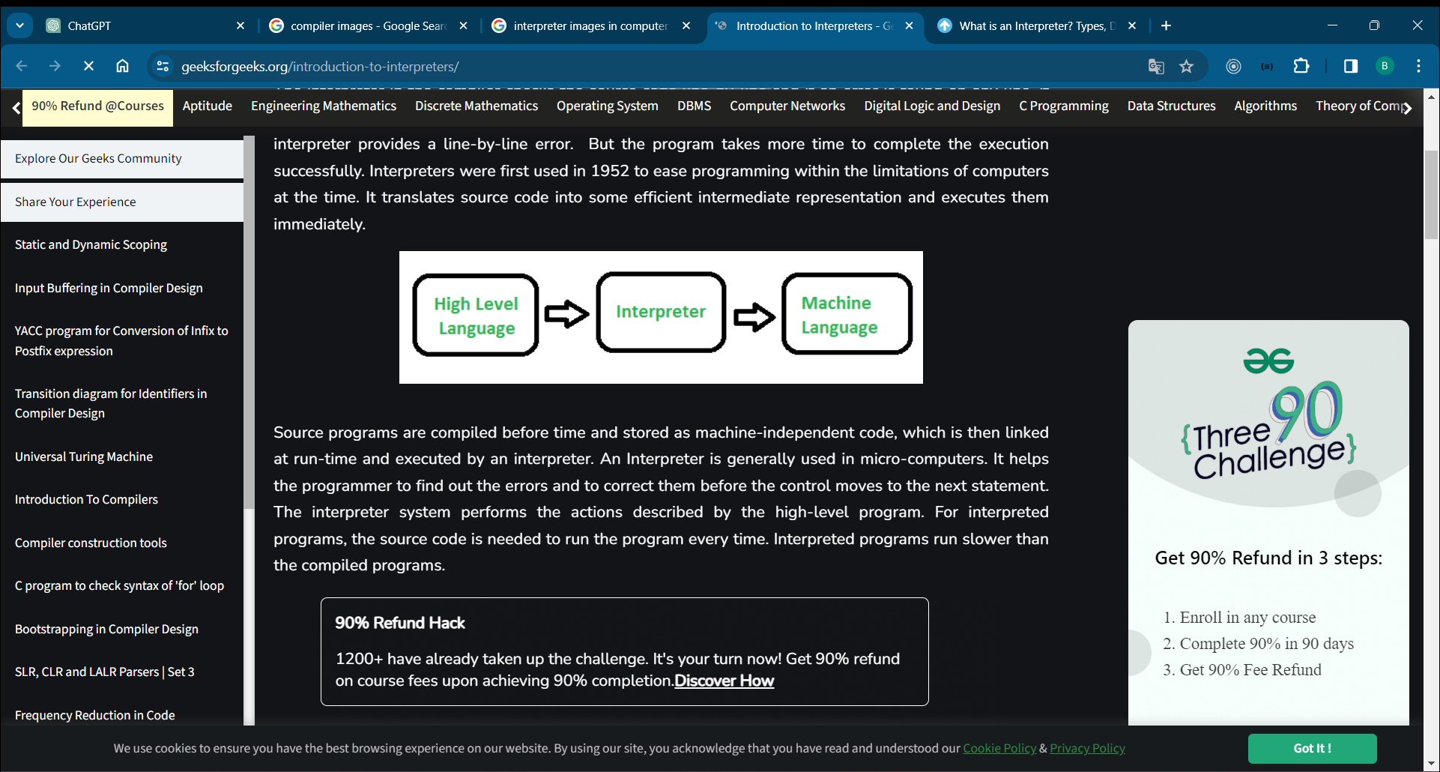

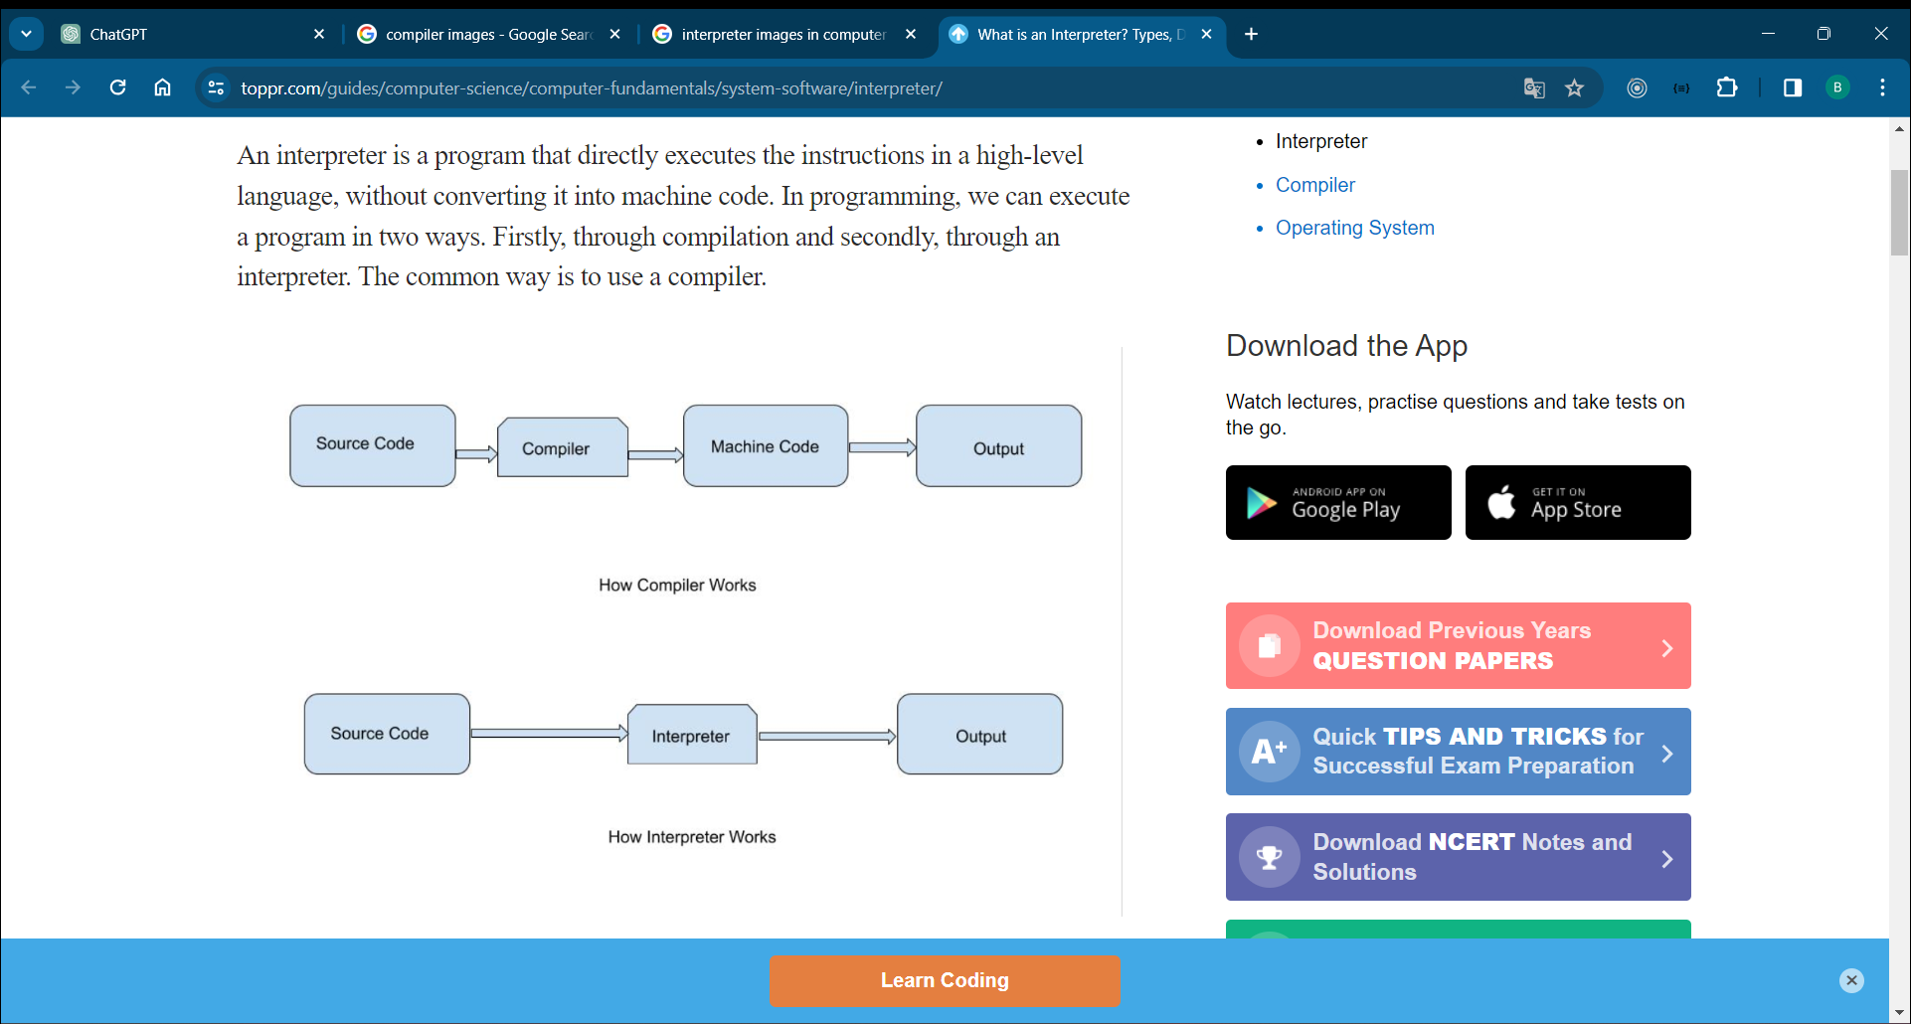

1. Which company used the c++ language ans=>(google search engine [v8])

Information about the v8 engine

1. Github Profile and Linked in Profile

Github it is konow as the vcs =>Version Control System

Information about the github, profile , repo, commit and many more

Thank you

Day 2

1. Variable

The data type defines which operations can safely be performed to create, transform and use the variable in another computation.

1. Data type

In the C programming language, data types constitute the semantics and characteristics of storage of data elements. They are expressed in the language syntax in form of declarations for memory locations or variables. Data types also determine the types of operations or methods of processing of data elements.

1. Example
2. Hw 5 Questions

Thank you

Day 3

1. Operator
2. Conditional statement (if , if-else , nested if, ladder-if)
3. Example
4. Hw 5 Questions

Day 4

1. Loops (for , while,do-while)
2. Goto, switch , continue
3. Hw 5 Questions

Day 5

1. Array
2. String
3. Example
4. Hw 5 Questions

Day 6

1. Object oriented programming
2. Class and object

Day 7

1. Concept of OOP’s