HackerRank: https://www.hackerrank.com/challenges/conditional-statements-in-c/problem
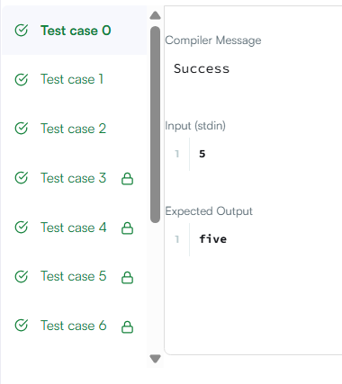
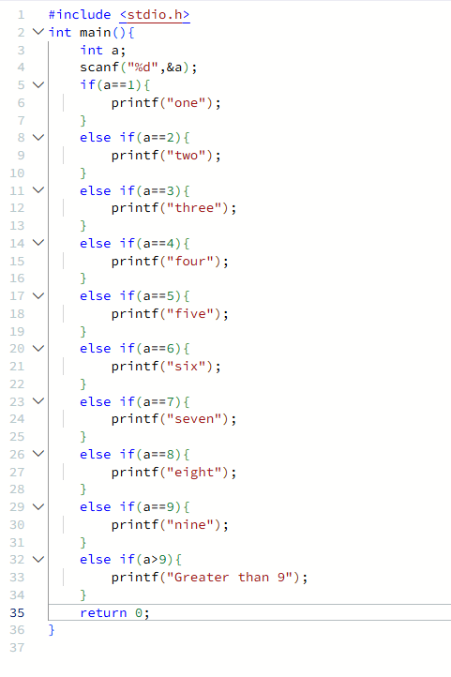

#include <stdio.h>
int main(){
int a;
scanf("%d",&a);
if(a==1){
printf("one");
}
else if(a==2){
printf("two");
}
else if(a==3){
printf("three");
}
else if(a==4){
printf("four");
}
else if(a==5){
printf("five");
}
else if(a==6){
printf("six");
}
else if(a==7){
printf("seven");
}
else if(a==8){
printf("eight");
}
else if(a==9){
printf("nine");
}
else if(a>9){
printf("Greater than 9");
}
return 0;
}

