HackerRank: https://www.hackerrank.com/challenges/find-digits/problem
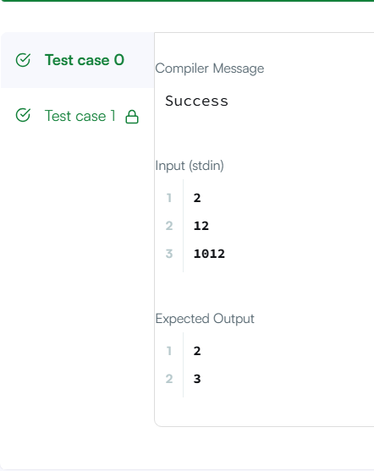
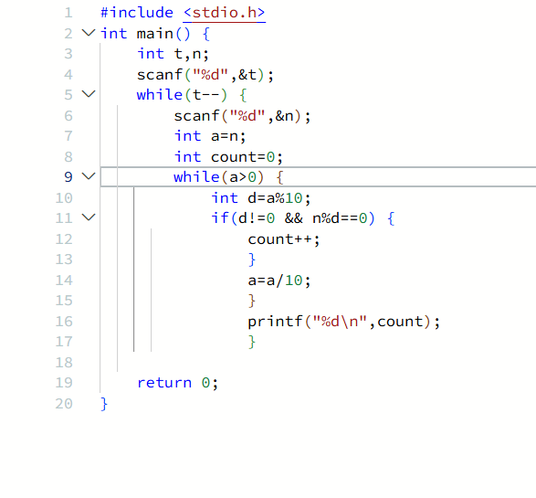
#include <stdio.h>
int main() {
int t,n;
scanf("%d",&t);
while(t--) {
scanf("%d",&n);
int a=n;
int count=0;
while(a>0) {
int d=a%10;
if(d!=0 && n%d==0) {
count++;}
a=a/10;}
printf("%d\n",count);}
return 0;}

