HackerRank: https://www.hackerrank.com/challenges/fizzbuzz/problem
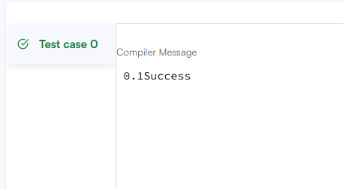
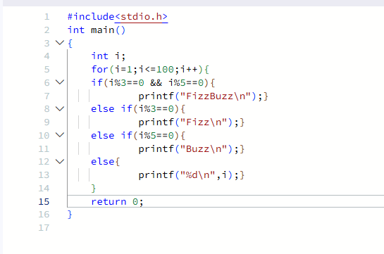

#include<stdio.h>
int main()
{
int i;
for(i=1;i<=100;i++){
if(i%3==0 && i%5==0){
printf("FizzBuzz\n");}
else if(i%3==0){
printf("Fizz\n");}
else if(i%5==0){
printf("Buzz\n");}
else{
printf("%d\n",i);}
}
return 0;
}

