HackerRank: https://www.hackerrank.com/challenges/kangaroo/problem
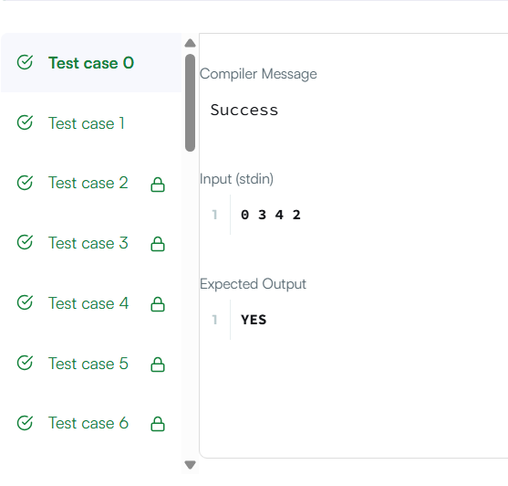
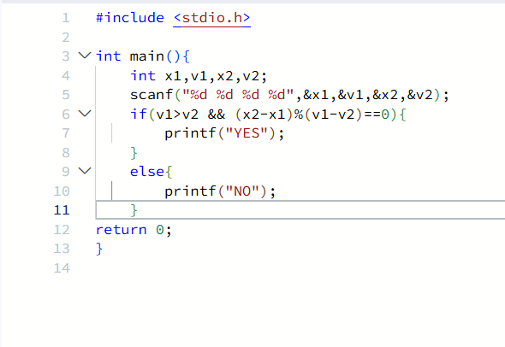
#include <stdio.h>

int main(){
int x1,v1,x2,v2;
scanf("%d %d %d %d",&x1,&v1,&x2,&v2);
if(v1>v2 && (x2-x1)%(v1-v2)==0){
printf("YES");
}
else{
printf("NO");
}
return 0;
}

