HackerRank: https://www.hackerrank.com/challenges/printing-pattern-2/problem
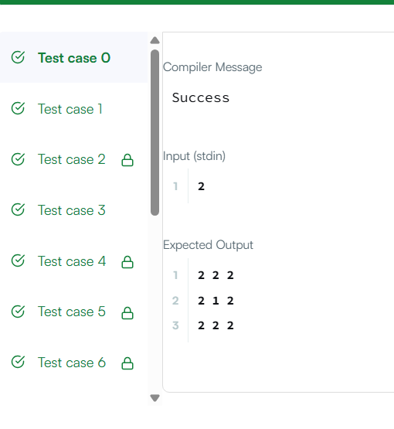
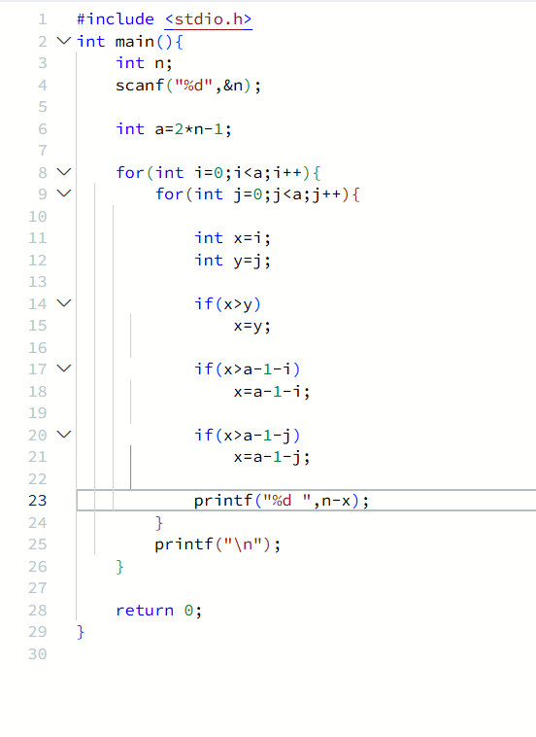

#include <stdio.h>
int main(){
int n;
scanf("%d",&n);

int a=2*n-1;

for(int i=0;i<a;i++){
for(int j=0;j<a;j++){

int x=i;
int y=j;

if(x>y)
x=y;

if(x>a-1-i)
x=a-1-i;

if(x>a-1-j)
x=a-1-j;

printf("%d ",n-x);
}
printf("\n");
}

return 0;
}

