HackerRank: https://www.hackerrank.com/challenges/solve-me-first/problem
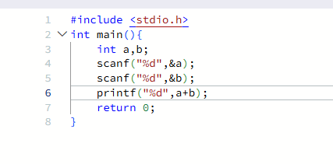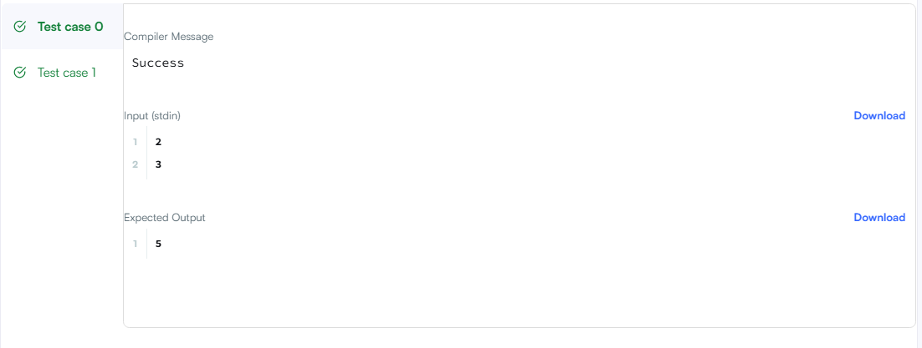
#include <stdio.h>
int main(){
int a,b;
scanf("%d",&a);
scanf("%d",&b);
printf("%d",a+b);
return 0;
}

