HackerRank: https://www.hackerrank.com/challenges/staircase/problem

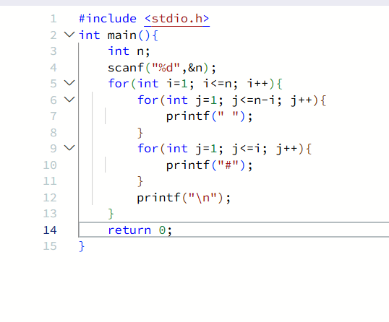
#include <stdio.h>
int main(){
int n;
scanf("%d",&n);
for(int i=1; i<=n; i++){
for(int j=1; j<=n-i; j++){
printf(" ");
}
for(int j=1; j<=i; j++){
printf("#");
}
printf("\n");
}
return 0;
}

