LeetCode: https://leetcode.com/problems/find-numbers-with-even-number-of-digits/
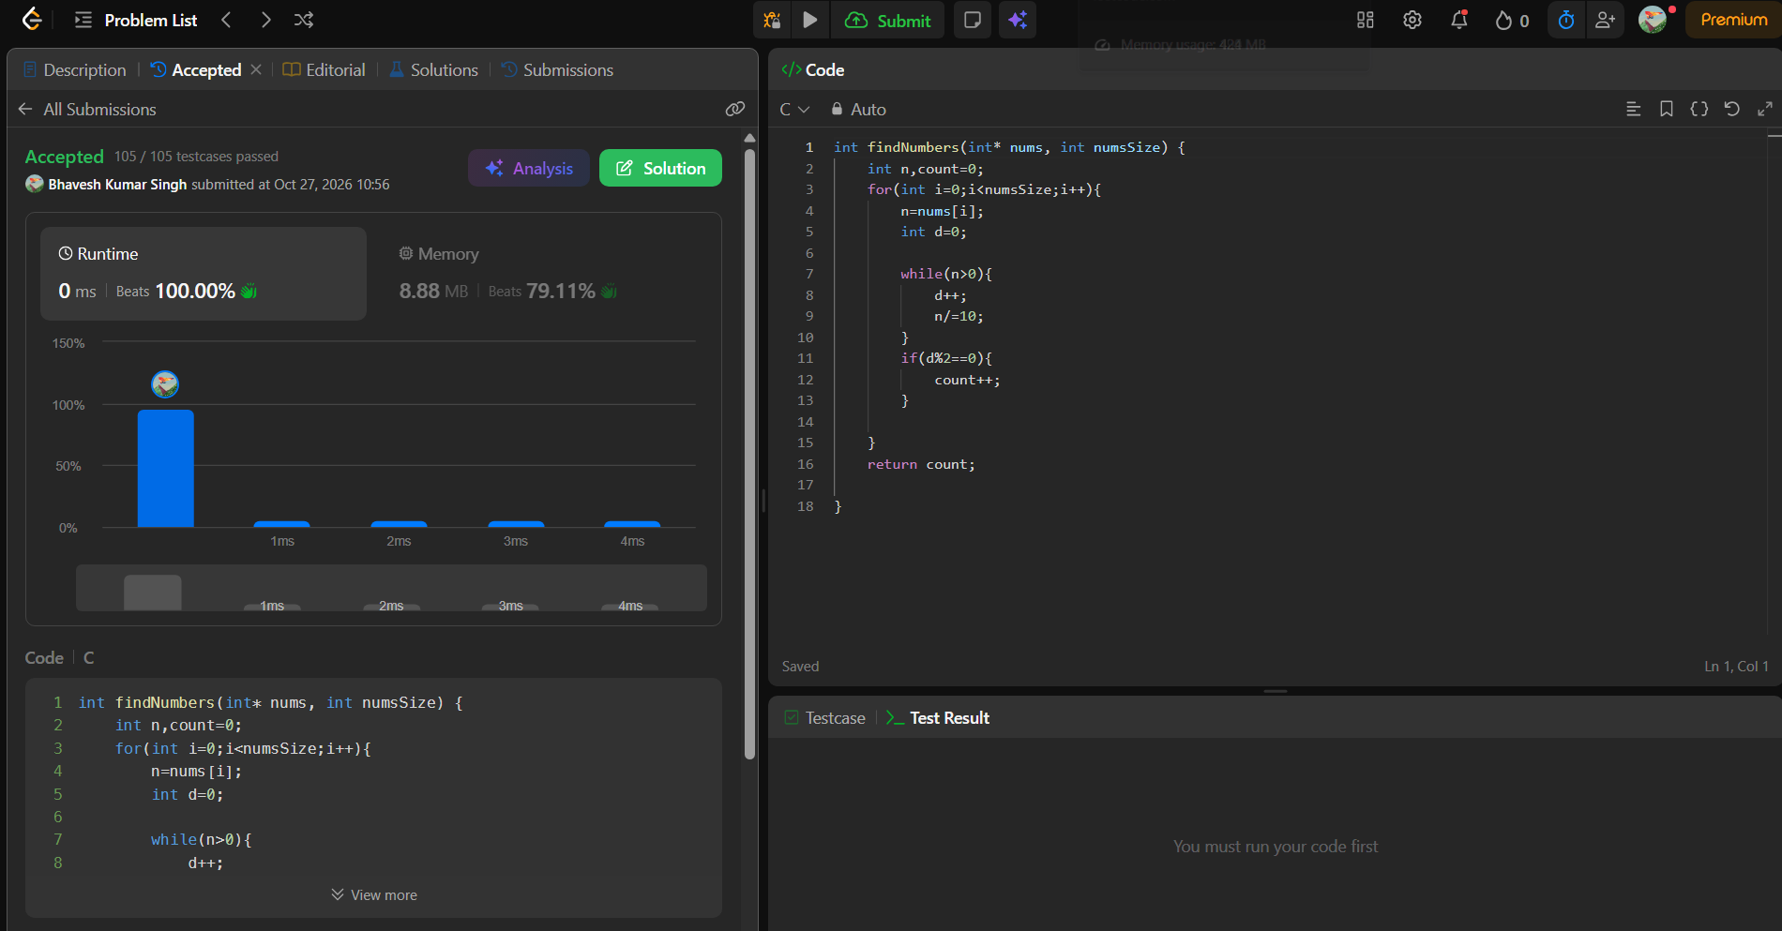
int findNumbers(int* nums, int numsSize) {
int n,count=0;
for(int i=0;i<numsSize;i++){
n=nums[i];
int d=0;

while(n>0){
d++;
n/=10;
}
if(d%2==0){
count++;
}

}
return count;}

