LeetCode: https://leetcode.com/problems/happy-number/
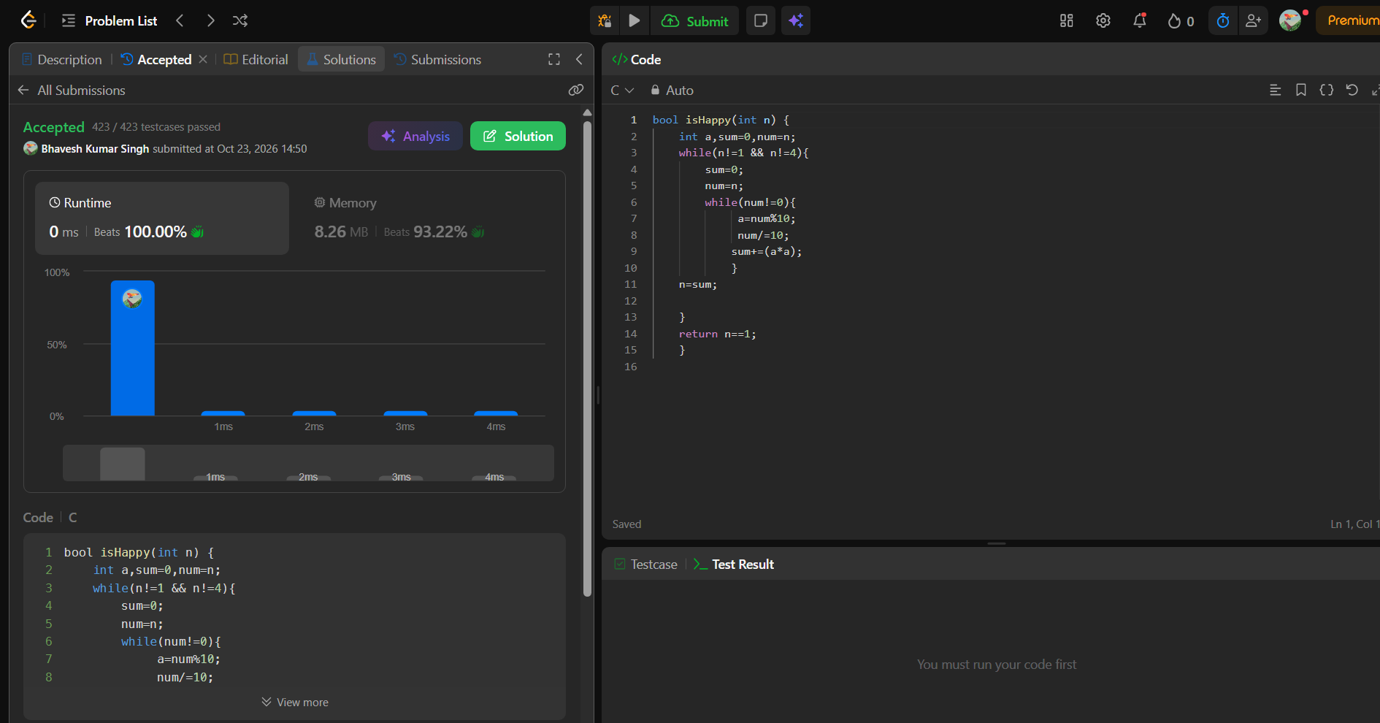
bool isHappy(int n) {
int a,sum=0,num=n;
while(n!=1 && n!=4){
sum=0;
num=n;
while(num!=0){
a=num%10;
num/=10;
sum+=(a*a);
}
n=sum;

}
return n==1;
}

