LeetCode: https://leetcode.com/problems/count-operations-to-obtain-zero/
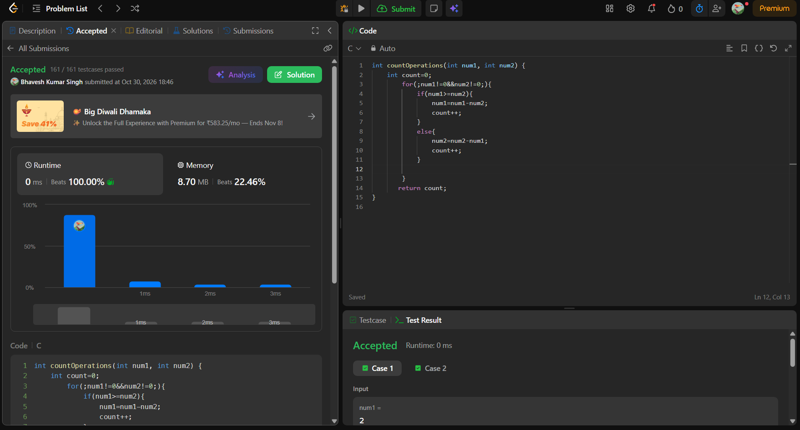
int countOperations(int num1, int num2) {
int count=0;
for(;num1!=0&&num2!=0;){
if(num1>=num2){
num1=num1-num2;
count++;
}
else{
num2=num2-num1;
count++;
}

}
return count;
}

