LeetCode: https://leetcode.com/problems/count-the-digits-that-divide-a-number/
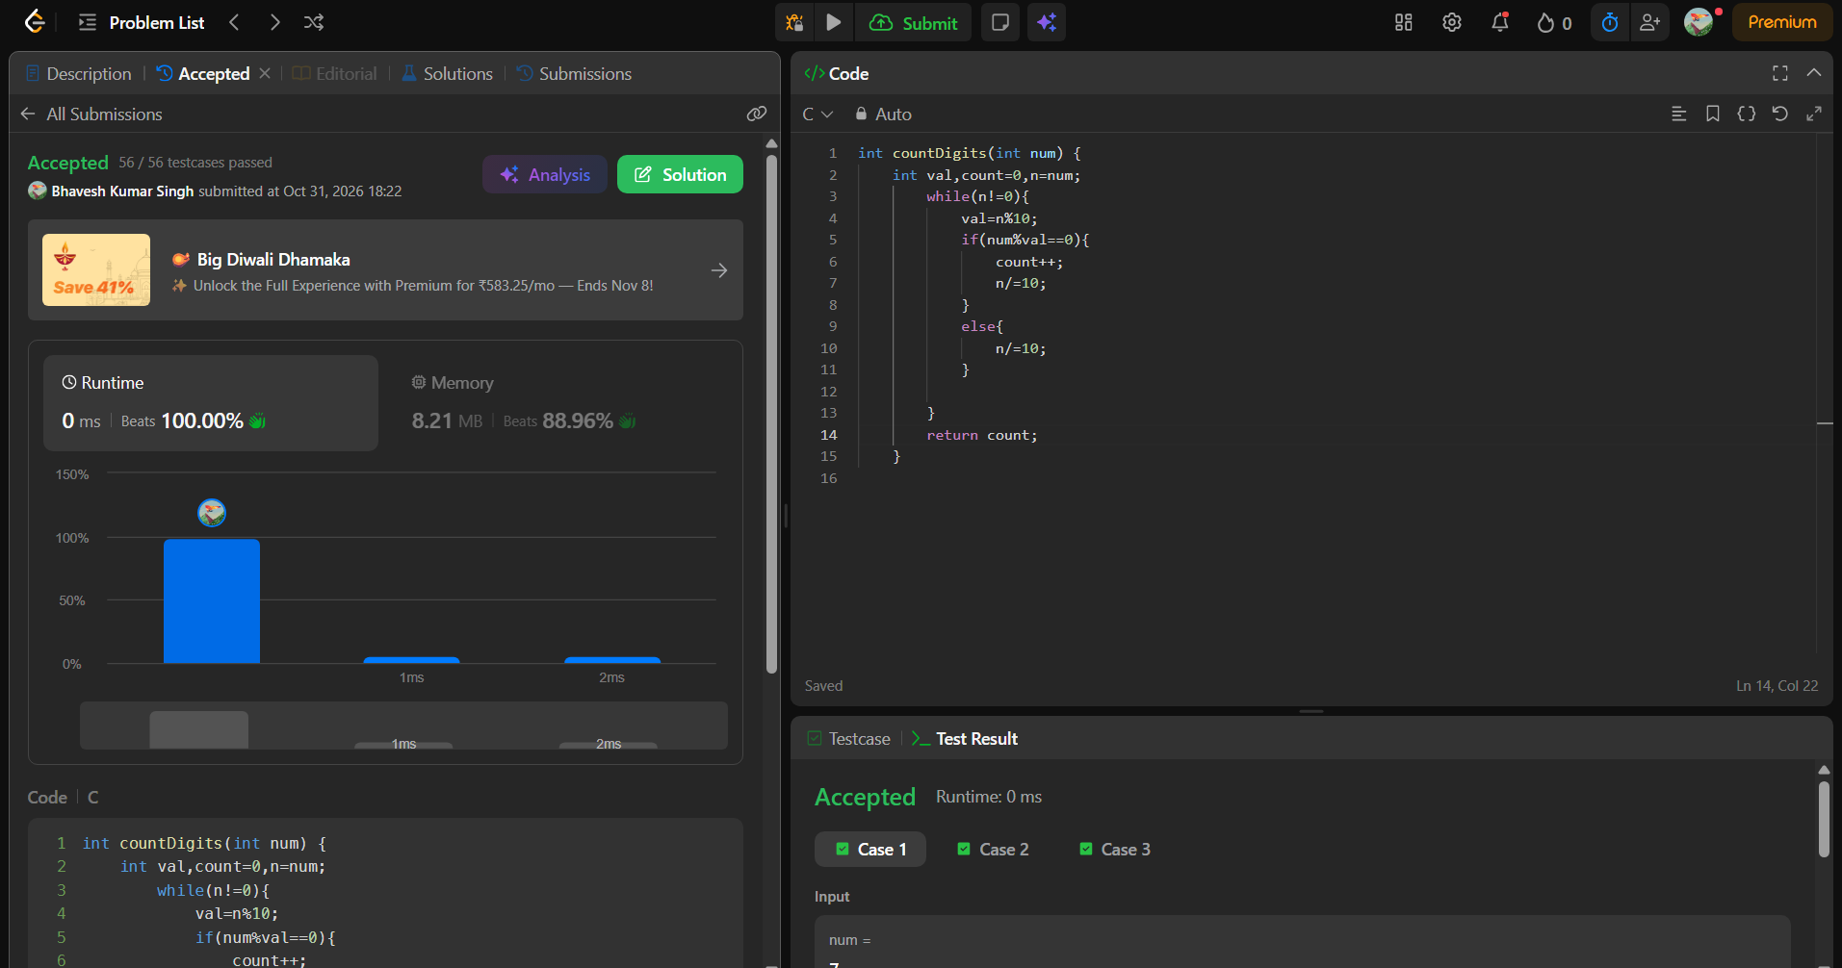
int countDigits(int num) {
int val,count=0,n=num;
while(n!=0){
val=n%10;
if(num%val==0){
count++;
n/=10;
}
else{
n/=10;
}

}
return count;
}

