LeetCode: https://leetcode.com/problems/calculate-delayed-arrival-time/
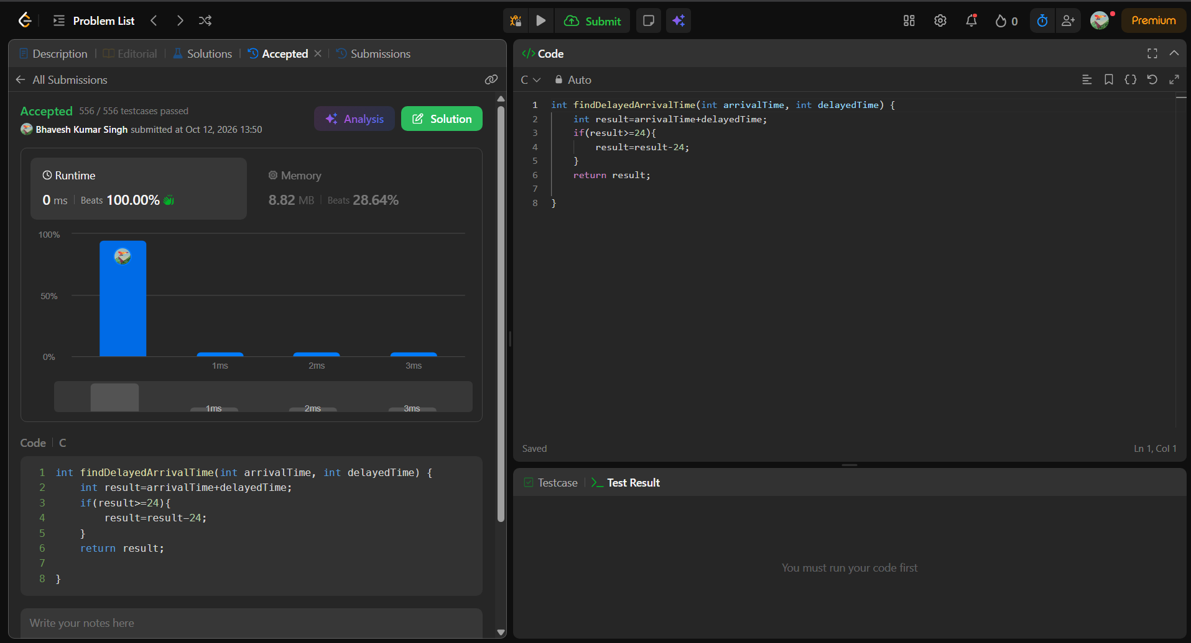
int findDelayedArrivalTime(int arrivalTime, int delayedTime) {
int result=arrivalTime+delayedTime;
if(result>=24){
result=result-24;
}
return result;

}

