LeetCode: https://leetcode.com/problems/sum-multiples/
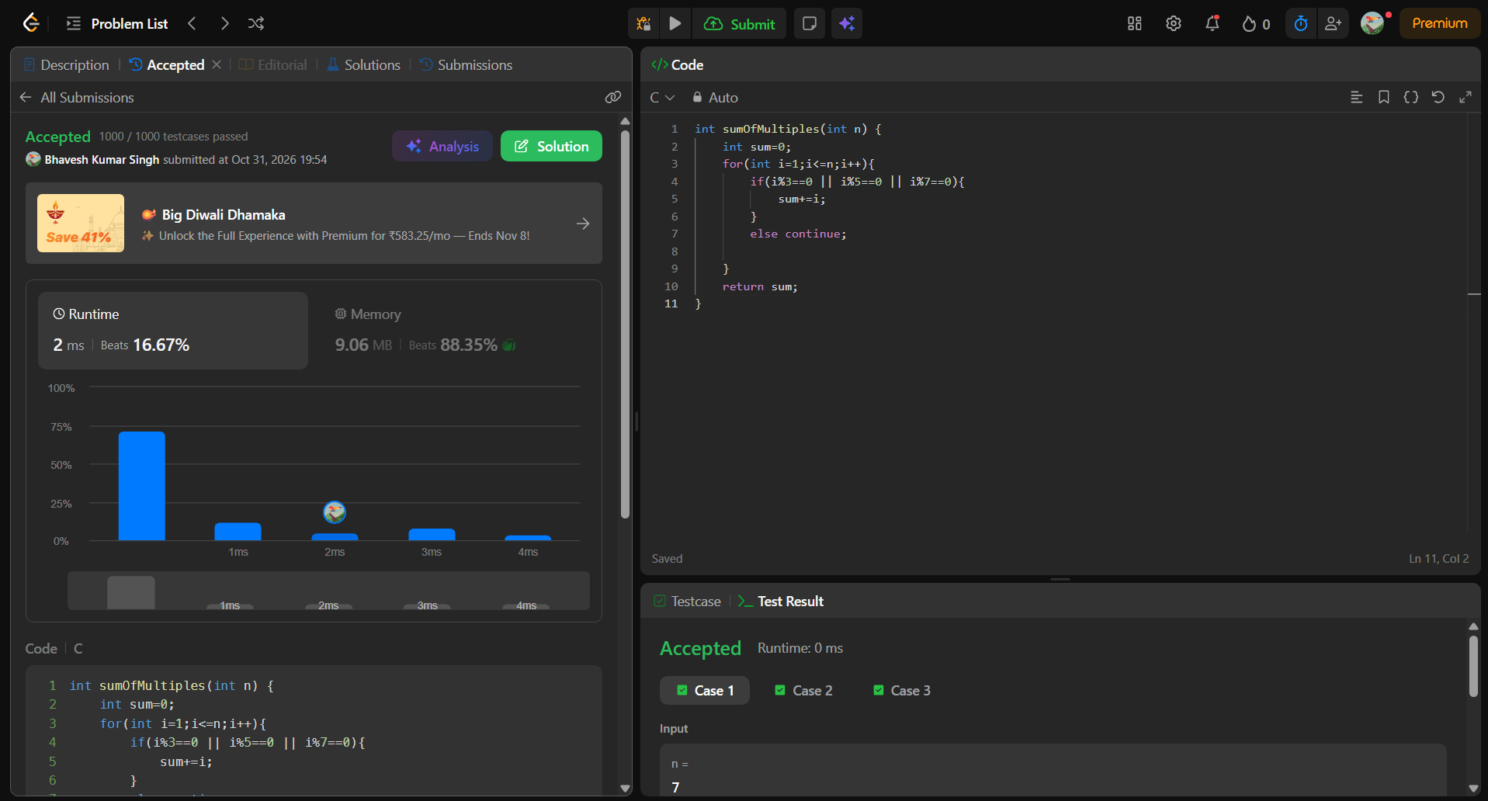
int sumOfMultiples(int n) {
int sum=0;
for(int i=1;i<=n;i++){
if(i%3==0 || i%5==0 || i%7==0){
sum+=i;
}
else continue;

}
return sum;
}

