LeetCode: https://leetcode.com/problems/total-distance-traveled/
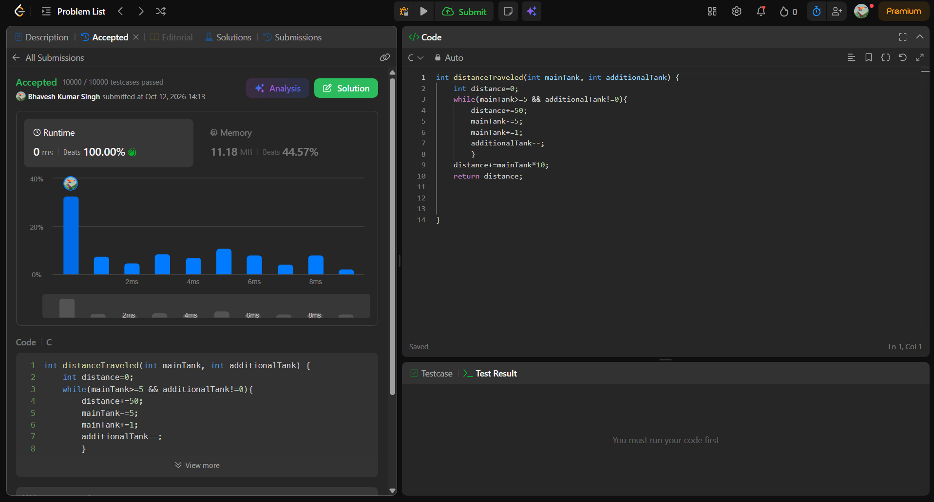
int distanceTraveled(int mainTank, int additionalTank) {
int distance=0;
while(mainTank>=5 && additionalTank!=0){
distance+=50;
mainTank-=5;
mainTank+=1;
additionalTank--;
}
distance+=mainTank*10;
return distance;
}

