LeetCode: https://leetcode.com/problems/power-of-three/
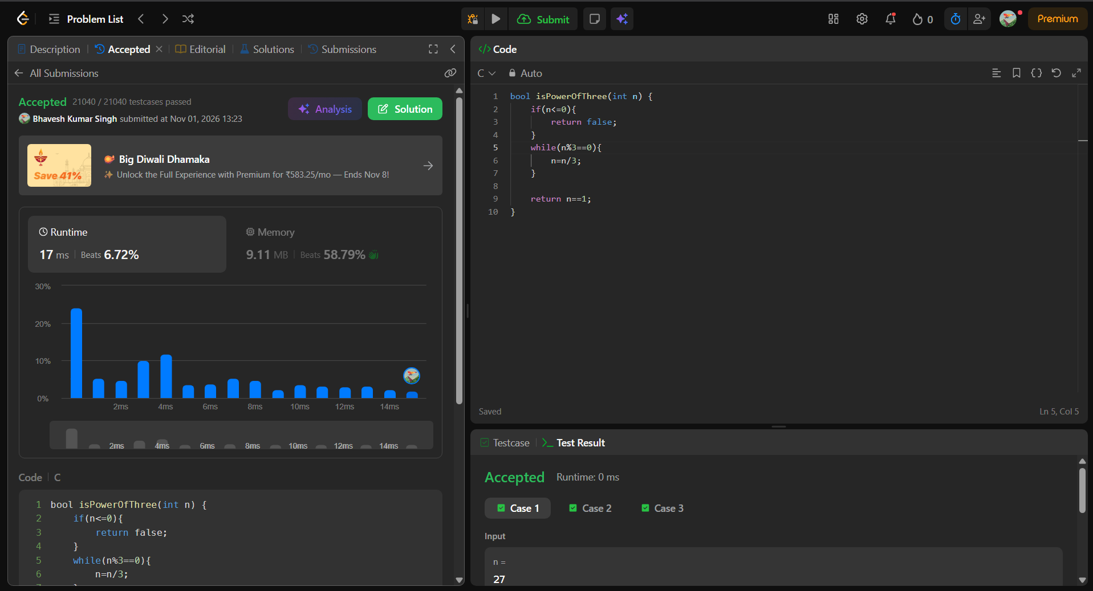
bool isPowerOfThree(int n) {
if(n<=0){
return false;
}
while(n%3==0){
n=n/3;
}

return n==1;
}

